# **Contents**

[1. Introduction 3](#_Toc254878720)

[1.1. Research questions 5](#_Toc254878721)

[1.2. Topics 6](#_Toc254878722)

[1.3. Overview 9](#_Toc254878723)

[2. Theoretical background 11](#_Toc254878724)

[2.1. Cities 11](#_Toc254878725)

[2.2. Agglomeration, innovation and growth 12](#_Toc254878726)

[2.2.1. Innovation, productivity, growth 12](#_Toc254878727)

[2.2.2. Localization and urbanization 13](#_Toc254878728)

[2.2.3. Marshall, Porter and Jacobs effects 14](#_Toc254878729)

[2.3. From a regional to a firm perspective 17](#_Toc254878730)

[2.4. Modelling agglomeration externalities and growth 20](#_Toc254878731)

[2.4.1. Knowledge 21](#_Toc254878732)

[2.4.2. Regions 22](#_Toc254878733)

[2.4.3. Extensions 24](#_Toc254878734)

[2.5. Innovation 25](#_Toc254878735)

[3. Agglomeration effects: a meta-analysis 29](#_Toc254878736)

[3.1. Introduction 29](#_Toc254878737)

[3.2. Estimating agglomeration economies 30](#_Toc254878738)

[3.2.1. Glaeser’s model 32](#_Toc254878739)

[3.2.2. Selection and first characterisation of individual studies 34](#_Toc254878740)

[3.3. Meta-analysis 35](#_Toc254878741)

[3.3.1. Vote counting 35](#_Toc254878742)

[3.3.2. Meta-regression analysis 36](#_Toc254878743)

[3.4. Conclusions 45](#_Toc254878744)

[Appendix 3.A. Studies included 47](#_Toc254878745)

[Appendix 3.B. Ordered probit 50](#_Toc254878746)

[Appendix 3.C. Marginal effects 52](#_Toc254878747)

[Appendix 3.D. Robustness test 55](#_Toc254878748)

[4. Regional wage differences in the Netherlands: micro-evidence on agglomeration externalities 56](#_Toc254878749)

[4.1. Introduction 56](#_Toc254878750)

[4.2. Sources of regional wage differences 57](#_Toc254878751)

[4.3. Data and methodology 59](#_Toc254878752)

[4.4. Agglomeration variables 61](#_Toc254878753)

[4.4.1. Specialization 61](#_Toc254878754)

[4.4.2. Competition 63](#_Toc254878755)

[4.4.3. Diversity 64](#_Toc254878756)

[4.5. Estimation of the Mincer equation 66](#_Toc254878757)

[4.6. Explanation of the spatial residual 69](#_Toc254878758)

[4.7. Aggregated data 74](#_Toc254878759)

[4.8. Conclusions 75](#_Toc254878760)

[5. The influence of firm characteristics vs. regional externalities on innovation 77](#_Toc254878761)

[5.1. Introduction 77](#_Toc254878762)

[5.2. Data 80](#_Toc254878763)

[5.3. Analysis 86](#_Toc254878764)

[5.3.1. Internal factors 86](#_Toc254878765)

[5.3.2. Internal and external factors 88](#_Toc254878766)

[5.4. Conclusions 93](#_Toc254878767)

[6. Stocking up: the influence of past innovativity in a region 95](#_Toc254878768)

[6.1. Introduction 95](#_Toc254878769)

[6.2. Theoretical background 96](#_Toc254878770)

[6.2.1. Endogenous growth modelling 96](#_Toc254878771)

[6.2.2. Defining boundaries 98](#_Toc254878772)

[6.2.3. R&D stocks 100](#_Toc254878773)

[6.3. Data 102](#_Toc254878774)

[6.4. Analysis 104](#_Toc254878775)

[6.5. Results 105](#_Toc254878776)

[6.6. Conclusions 111](#_Toc254878777)

[Appendix 6.A. Questionnaire excerpt 112](#_Toc254878778)

[Appendix 6.B. Additional regressions 114](#_Toc254878779)

[Appendix 6.C. Alternative approach 115](#_Toc254878780)

[7. Conclusions 117](#_Toc254878781)

[7.1. Results 117](#_Toc254878782)

[7.2. Implications and further research 119](#_Toc254878783)

[Appendix A. NUTS-3 (COROP) classification 122](#_Toc254878784)

[AppendixB. Pavitt and other sectoral classifications 123](#_Toc254878785)

[Appendix C. Regional distribution of Pavitt sectors and R&D in the Netherlands 124](#_Toc254878786)

[Reference list 125](#_Toc254878787)

# Introduction

“If you're born into the global core with its high-living-standard cities and high-income economies, and you start believing the world is flat (and geography is history), take a cold shower – it's the norm in the periphery, with a bucket – and take a good geography course to follow.”

­ — Harm de Blij, interviewed on *Geographic Travels Blog*,   
8 February 2010

This dissertation focuses on the themes of innovation and agglomeration in the Netherlands. Its main focus is on innovation in an urban context – are firms and people in cities more innovative than those outside cities, and if so, why? Its scope is broader: to study agglomeration in all its forms, with special attention to the use of microdata.

Microdata are data that pertain to individual persons or individual firms. When we find a high productivity level in cities, this can be because cities make employees more productive; or it can be that more productive employees prefer cities, and less productive employees don’t. Data at a regional level can’t tell us whether which is the case; but microdata allow us to look past data at a spatially aggregated level, and to analyse what happens at microlevel without being distracted by spatial sorting.

Agglomeration advantages form the *raison d’être* of cities. If these advantages would not compensate for the disadvantages of cities – congestion in traffic, in land markets and in housing markets, for example – the days of (large) cities would be numbered, and people as well as firms would move to the countryside, which in turn would become a semi-urbanized landscape. In the United States, this has happened over the past decades to some degree; with automobiles generally available, large areas of land have become part of a city: the process of urban sprawl (Hall 1996, Chapter 9).

In the Netherlands, however, such a development has not taken off, and where it threatened to set off, it was quickly channelled by strict planning into government-appointed ‘growth nuclei’, new towns. But also in the United States, cities have not ‘died’ (Glaeser 1998), and indeed continue to thrive. In fact, the 1980s and especially the 1990s have seen a revival of inner cities throughout the Western world; the old cores of cities is where ‘it’ happens (Florida 2002).

In the Netherlands, principles of concentration were extended from housing[[1]](#footnote-1) to innovation in the 2004 publication *Pieken in de Delta* of the Ministry of Economic Affairs. This publication, whose title translates as ‘(mountain) peaks in the delta’, clearly defined regional and sectoral priorities where the Netherlands has a competitive position on international markets (but cf. Krugman 1996). Special subsidies were set up for innovative projects in selected sectors inside these regions. In and around the town of Wageningen, for example, the development of a ‘Food Valley’ is stimulated, while the ‘Health Valley’ in Arnhem and Nijmegen is also supported. The report also selected ten urban regions as economic centres, and moreover appointed four ‘innovation regions’: Eindhoven and its surroundings (as part of the region Eindhoven–Louvain–Aachen), ‘the East’ (Almelo-Hengelo-Enschede, but also Arnhem-Nijmegen and Wageningen), and the North and South ‘Wings’ of the Randstad (see Figure 1.1). Transport corridors (‘mainports’ and motorways towards Germany and Belgium) play an important role, as do universities (‘brainports’).

Yet a fundamental problem with this type of planning seems to be that the spatial and sectoral extent of the defined focus points is vague. Take the case of the Eindhoven region: Philips as well as DAF, ASML and the Eindhoven University of Technology are major players there (Boekholt & van der Weele 1998). Channelling resources to electronics in this region seems a sensible move. But should the automotive industry be included as well? And should a producer of primary metals or paper be discouraged? Is it a problem if one of the big three companies moves to Venlo, 50 km to the east – will local startups from the university still be able to make contact with them then? And what if they decide to move to Aachen, still only 80 km to the south-east – but also across the German border? How far do agglomeration effects actually reach, both in space and across sectoral divides?

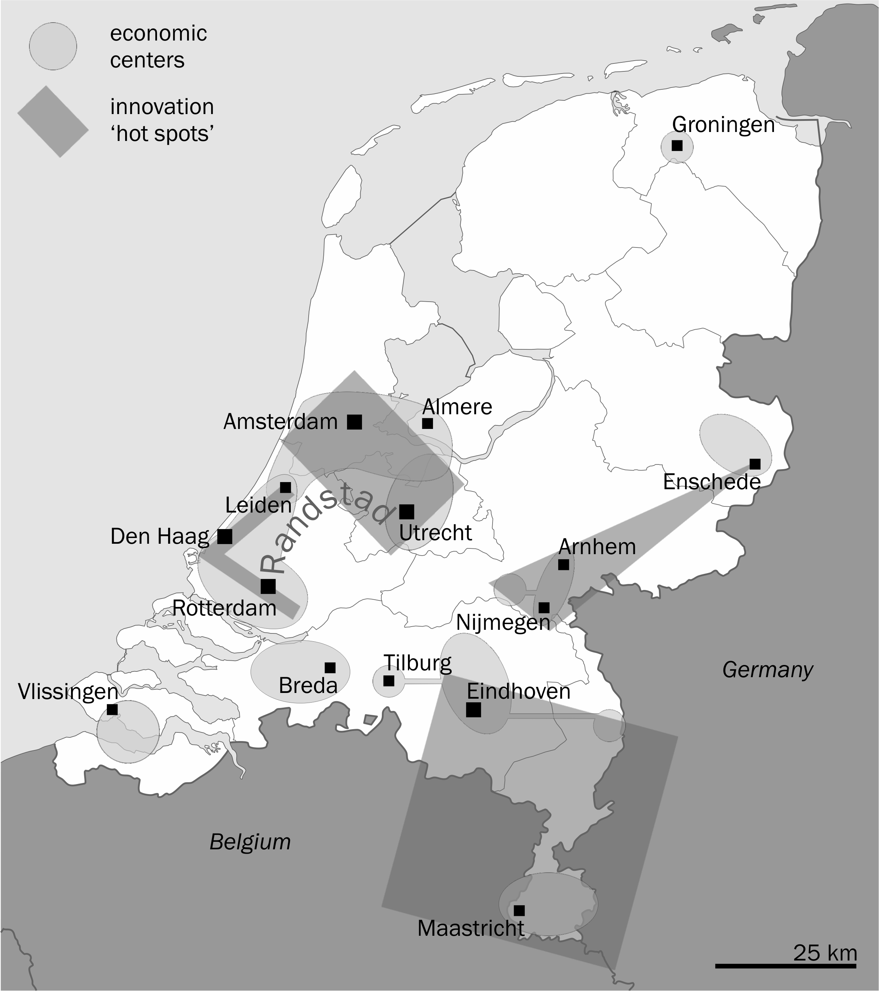

Figure 1.1: ‘Pieken in de Delta’

Note: Simplified map, based on the map on p. 10 of *Pieken in de Delta* (Ministry of Economic Affairs 2004).

## Research questions

In this thesis, we will delve into the topic of agglomeration and innovation within the Dutch context. However, we will start out by asking ourselves, in a more general sense, whether any conclusion can be drawn from the literature on the topic of agglomeration over the last decades, and more specifically since the publication of a seminal paper by Edward Glaeser and others (“Growth in Cities”, 1992). We link this question to the methodological issue whether the specification of an empirical analysis matters for its outcomes. Of course, we will use the results of this analysis in the empirical chapters that follow.

Our empirical work will circle around three main questions:

* do agglomeration forces have an influence on the productivity and innovativity of firms in the Netherlands?
* how important are these forces compared to other factors?
* at what distances (in space, time-wise and sectoral) do these forces operate?

## Topics

*Urban* contexts, which most agglomeration research focuses on,[[2]](#footnote-2) are difficult to define in the Netherlands, and at the same time the more interesting. In this small country, the distinction between cities and the countryside can be said to be clearer than in most other countries, but it is at the same time less clear: whereas centuries of meticulous planning have clearly marked the visual boundaries between built-up areas and non-built up areas (deemed ‘rural’, ‘open’ or ‘peripheral’[[3]](#footnote-3)), in a functional sense distances are so small, and transportation so easy that it is difficult to distinguish where the sphere of influence of a city ends and begins – let alone assign all places to the sphere of influence of one particular city. We therefore take ‘the city’ to refer, in the Dutch context, to the processes of agglomeration in general.

*Innovation* research has surged over the last decades, and it has in many places become a focal point of policy, where it is often labelled ‘the engine of economic growth’. Economic growth, however, is not by itself a well-defined concept in a policy context – it might mean output growth, employment growth, or welfare growth. The relationship between different types of growth and innovation is not always straightforward, and not always positive either. For example, an innovation that leads to an increase in productivity, but not to an increase in output, will lead to a loss of employment. We will return to this topic in Section 2.2, and pay special attention to productivity in Chapter 4. Innovation itself will be the focus of Chapters 5 and 6.

*Agglomeration* will form the main topic of this thesis, and we will pay attention to it in every chapter. We will focus mainly on dynamic externalities – that is, those agglomeration effects that evolve over time, for example when knowledge builds up in a city (Chapter 6). Those contrast with static externalities, which are fixed properties of a city (both positive and negative). Externalities, of course, contrast with internal characte­­ris­tics of a firm; we will compare the influence of agglomeration and that of firm characteristics in Chapter 5.

In Chapters 4 to 6 of this thesis we will be dealing with *microdata*. In contrast to aggregated data (which we might call ‘macrodata’), microdata are securely guarded by statistical institutes to protect the privacy of the individuals contained. From aggregated data, no statements on individuals can normally be deduced; doing so counts as an ‘ecological fallacy’ (Robinson 1950). There are two types of microdata: surveys and censuses. We will make use of census data in Chapter 4 (data on all individuals in the Dutch labour market) as well as Chapters 5 and 6 (data on all firms and plants in the Netherlands); Chapters 5 and 6 will in addition make use of a survey. This is the Community Innovation Survey, collected by Statistics Netherlands (CBS) in the frame­work of the EU-wide CIS4. These harmonized Innovation Surveys are held across most of the European Union, with rather similar questionnaires being undertaken in other countries, such as Canada, the USA and Australia; questions or answer options differ only to a small degree between participating countries. One of the advantages of this dataset is that it allows us to look directly at innovating firms, freeing us from some of the problems associated with patent research (Pavitt 1982).

It is the extensive use of microdata, combining different census sources and the Innovation Survey, that allows us to reach past previous work on agglomeration in the Netherlands, for example that performed by the Ruimtelijk Planbureau (now Planbureau voor de Leefomgeving; e.g. Weterings, Raspe & Van Oort 2005) and the Centraal Planbureau (e.g. Gorter & Kok 2009). Our work differs from that by Van Oort (2004), in that he used microdata but did not focus primarily on innovation;[[4]](#footnote-4) from the thesis of Neffke 2009 in that his interest is specifically in estimating the change of agglomeration effects over time and within an industry life cycle, and less with variation in spatial scope or with innovation; from recent work by Beugelsdijk 2007, who matched firm to regional data with a focus on innovation, just as we will do in Chapter 5, but used firm data from a smaller survey, and does not focus on the trifold division of agglomeration economies that we will set up; and finally, our work differs more fundamentally from that by Ponds 2008, who studied regional innovation in the Netherlands, but focused on research colla­bora­tion and networks, using copublications and patents rather than the CIS.

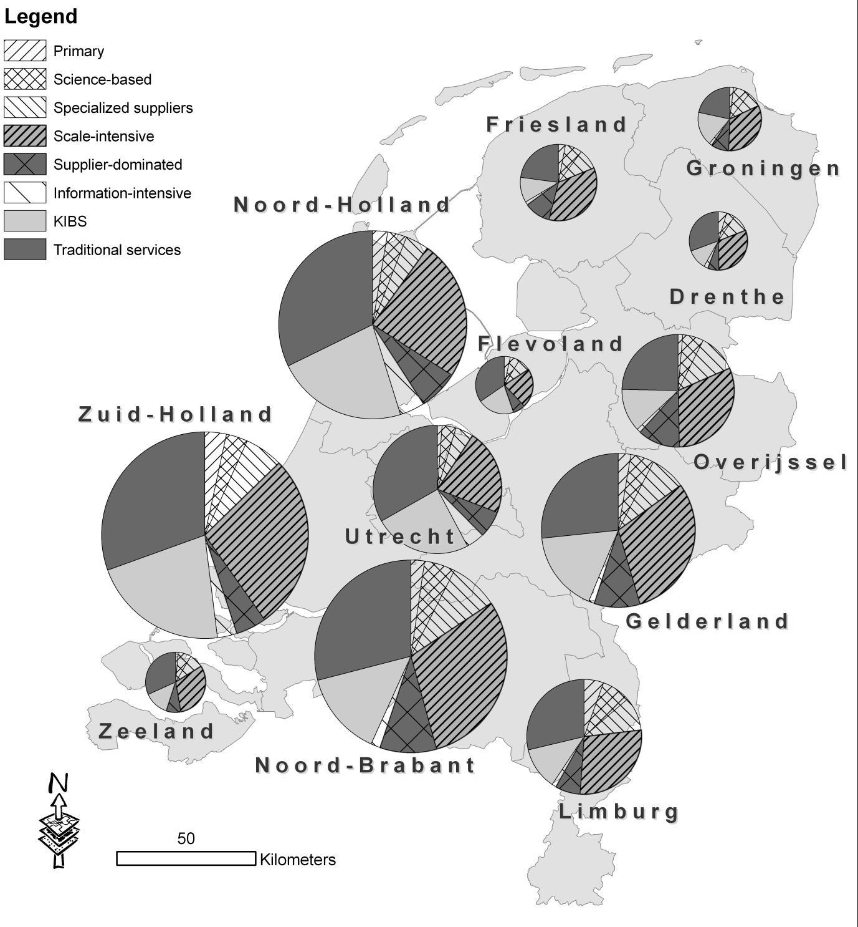

Figure 1.2: Composition of employment by province for the Netherlands, 2004.

Note 1: Based on the General Registry of Firms (ABR) provided by Statistics Netherlands.  
Note 2: Size of pies is proportional to total employment in each province, but with Flannery compensation (Flannery 1971) as implemented in the software package ArcMap 9.2.

Note 3: For the exact figures, see Appendix A. KIBS refers to Knowledge-intensive business services.

We will be looking at the Dutch context, and it might be wise to discuss in advance some of the basics about the economic layout of the country. Figure 1.2 shows the composition of employ­ment by province, with the economy divided into eight sectors. (This division into eight sectors stems from Keith Pavitt; we will discuss it in more detail in Chapter 4). It is important to remem­ber that the country has a threefold core: the Noordvleugel (North Wing) of the Randstad,[[5]](#footnote-5) which is especially strong in services (Utrecht, Amsterdam); the Rotterdam area, strong in transport and (petrochemical) industry; and the Eindhoven area in the Southeast, where a cluster of electronics and automotive industries is centred around Philips and DAF. Finally, The Hague is an important centre for the public sector, both on a national scale (parliament, ministries) and on an international scale (peace courts). The East and North of the country have a less pronounced profile, especially since the textile industry (in the East) and the agricultural sector (in the North) have dwindled in importance. Figure 1.2 shows the country divided into 12 pro­vinces, which is the NUTS-2 standard; however, in the following chapters we will often resort to the NUTS-3 classification of the country, the so-called Corop regions. A map of these is provided in Appendix B.

## Overview

This thesis consists of seven chapters, which can be divided into three blocks. The first block consists of this introductory chapter and the next chapter, which will deal with the general concepts of agglomeration, innovation, and economic growth. The second block consists of four empirical chapters, each with a different focus:

* Chapter 3 re-examines past literature on ‘growth in cities’, following up on Glaeser et al. 1992 through the use of meta-analysis;
* Chapter 4 delves into the relationship between productivity and agglomeration, estima­ting a Mincer equation for the Netherlands and connecting the results to a series of indicators for agglomeration;
* Chapter 5 looks at firm characteristics, connecting innovation to the ‘absorptive capacity’ of a firm, and the results once again to external agglomeration factors; and
* Chapter 6 explores the build-up of regional knowledge stocks, testing the temporal and spatial scope of their impact on future innovation.

The third block of this thesis of course contains the Conclusions. Schematically, the thesis looks like this:

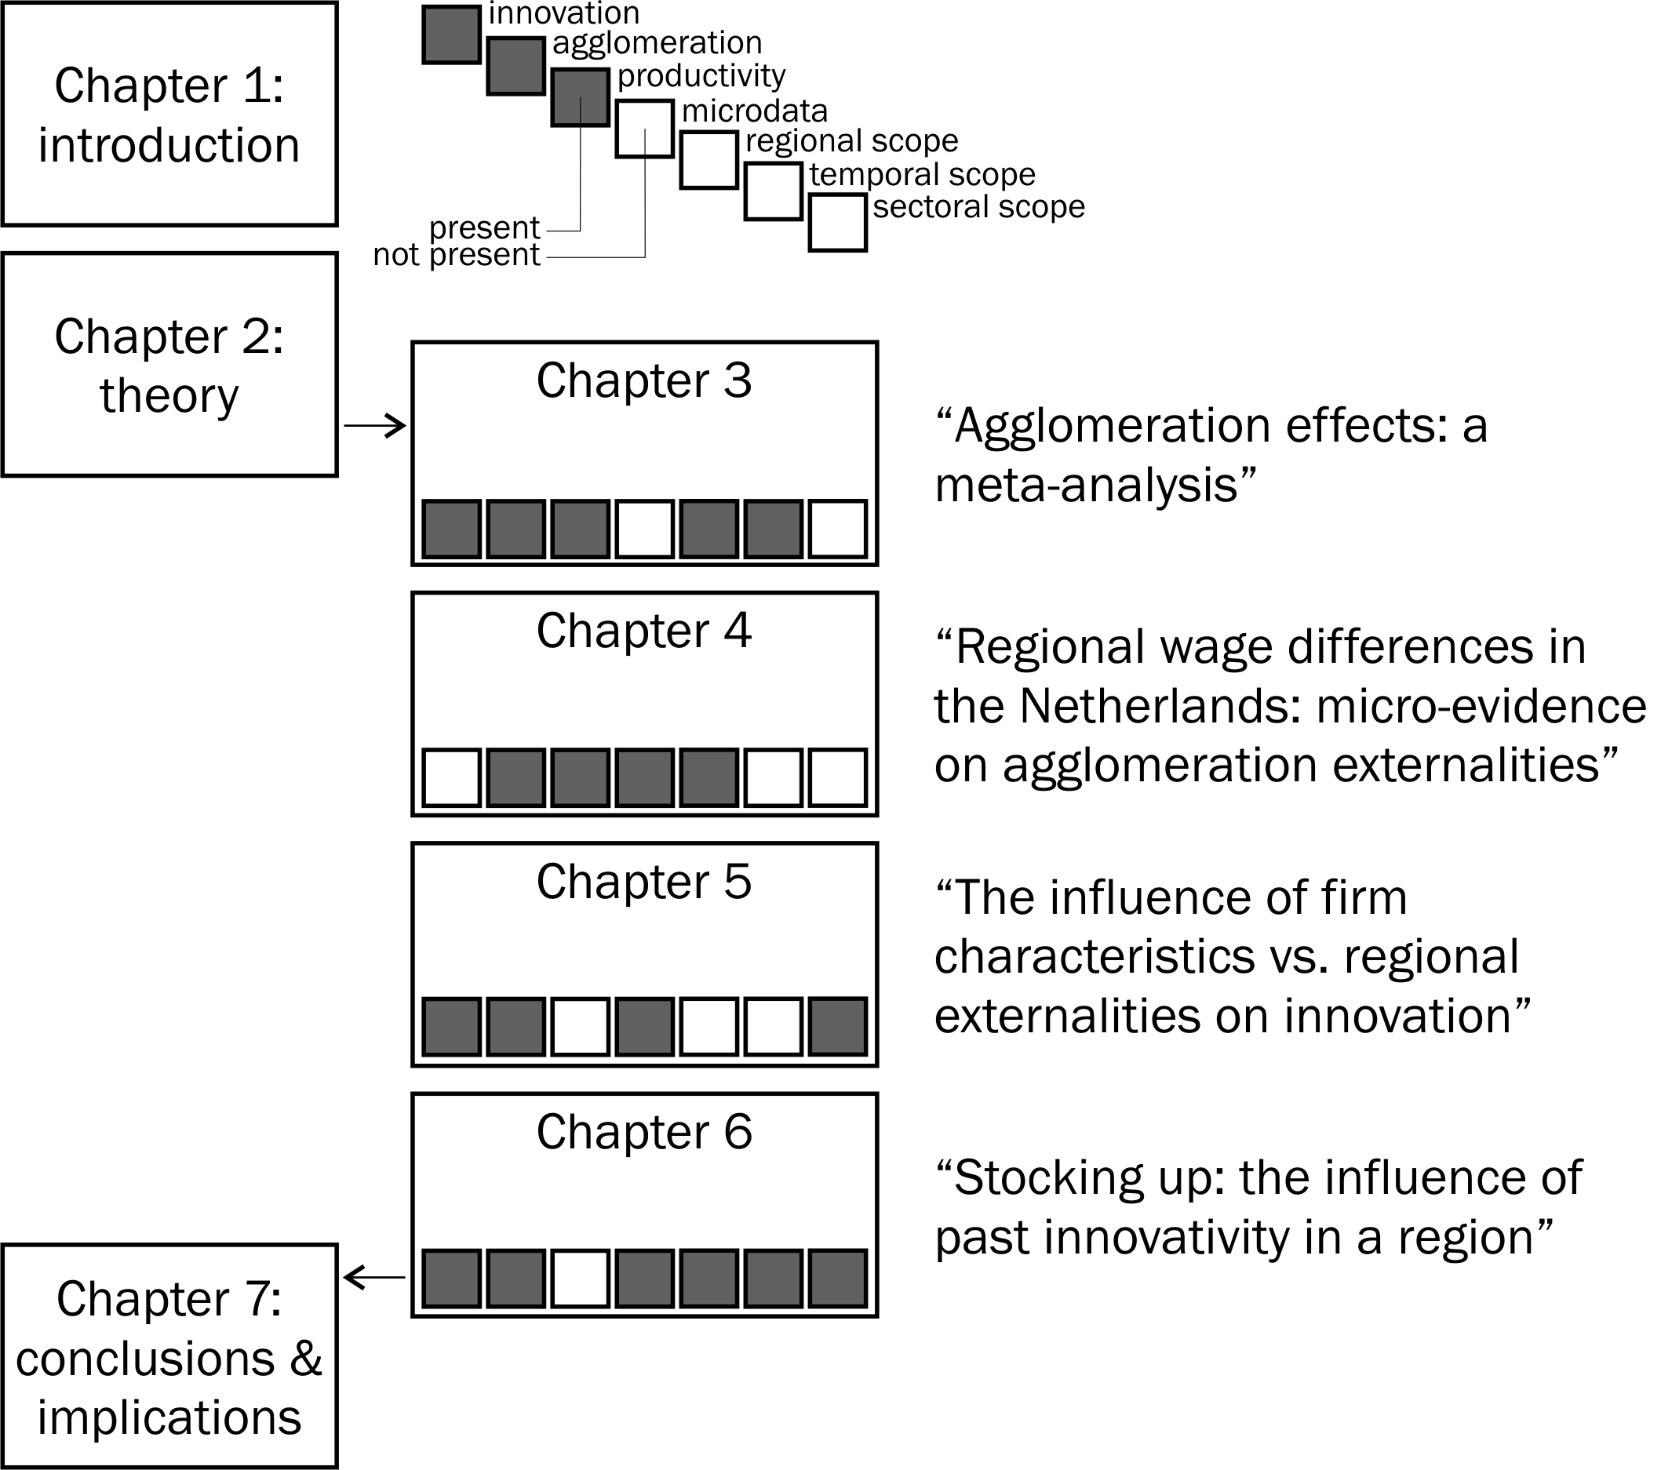

Figure 1.3: Overview of the structure of this dissertation

The next chapter will deal more extensively with the theoretical backgrounds of our empirical research.

# Theoretical background

“Great cities are not like towns, only larger. They are not like suburbs, only denser.”

— Jane Jacobs, *The Life and Death   
of Great American Cities*, 1961

οὐ γὰρ ταὐτὸν μεγάλη τε πόλις καὶ πολυάνθρωπος

[For a great and a populous city are not the same.]

— Aristotle, *Politeia*, 1326a24-25

## Cities

In the knowledge-driven globally-connected regional economy, agglomeration forces that rely on proximity continue to be important. This occurs paradoxically, despite declining real costs of information, communication and transportation (cf. Gersbach & Schmutzler 2000). The relevance of agglomeration is revealed by the continuing urbanisation of the global population. About half the world population now lives in cities and this number is expected to increase further to 60 per cent by 2030 (UNFPA 2007). Although the number of ‘world cities’ with populations of more than ten million inhabitants continues to increase, global urbanisation is primarily due through the growth of smaller cities of up to 500,000 inhabitants. While megacities have hugely diverse economies, smaller cities may find a niche in specialized economies or clusters of connected activities (see, for example, Fujita & Thisse 2002).

Understanding the existence and growth of mega- and smaller cities and their surrounding hinterlands – that together make up functional regions – requires consideration of a wide range of factors that have been elaborated in the above mentioned ‘new’ theories of innovation and growth and that have been empirically tested in a large range of studies around the world.[[6]](#footnote-6) The growth of cities results from a complex chain that starts with scale: endowments of labour, capital and knowledge. The productivity of the open urban economy depends also on spatial factors, internally through density and infrastructure and externally through spatial interaction with other cities and regions. Resources, production factors and geography then combine with an industrial structure characterised by specialisation, competition and diversity, to yield innovation and productivity growth that encourages employment expansion.

In the long run, new jobs can only be filled through natural increase of the urban population or through net inward migration. Given that rising real incomes in cities lead to lower fertility, urban population growth is in practice primarily driven by inward migration of workers who are often positively self-selected in terms of entrepreneurial abilities and skills. In the presence of economic diversity and increasing returns, capital and labour are not flowing in opposite directions, as in static neoclassical theory. Instead, the city attracts capital too. Many aspects of this self-reinforcing and virtuous process yield benefits that are external to individual market transactions and such externalities are therefore central to agglomeration processes (see Fujita & Thisse 2002).

## Agglomeration, innovation and growth

The relationships between agglomeration, innovation and growth have been studied in depth in many different contributions over the last decades, especially after the seminal article *Growth in Cities* of Edward Glaeser et al. (1992). A host of studies confirm that at least some types of agglomeration have a positive effect on innovation and/or growth. Of the three effects Glaeser focused on, diversity or Jacobs (Jacobs 1969) effects were especially found to influence innovation positively.

### Innovation, productivity, growth

Knowing that some types of agglomeration enhance innovation, the next step is to get from innovation to growth. The direct influence of innovation on (regional) growth has also been amply discussed (e.g. Acs & Varga 2002 or Acs 2002). The question ‘does innovation lead to growth’ strongly depends on the definition of innovation. Bare invention, or mere technological innovation (Ali-Yrkkö & Martikainen 2008), does not necessarily lead to growth; since Schumpeter (1934), it is well known that it is the *development* of an invention into a product (or process) that is essential for firms. Such a development includes the implementation of an invention in a production process as well as the marketing of the invention. But does the growth of individual firms, due to their innovativeness, lead to regional growth? This link is highly debatable. Hall, Lotti and Mairesse (2008) found, for example, that innovation did not lead to any significant rise in productivity in Italian firms, although half of the employment growth in the period 1995-2003 was due to product innovations. Likewise, Damijan, Kostevc and Rojec (2008) find no effect of innovation on productivity for Slovenia in 1996-2002; yet they base their methodology on Crépon, Duguet and Mairesse (1998), who did find a positive effect of innovation on productivity in France. We will return in Chapter 3 to the issue whether we can explain different findings of studies that pursue similar research questions.

A very important result in the relationship between innovation and agglomeration is that Bettencourt, Lobo and Strumsky (2007) found that the productivity of individual *inventors* does not vary between small and large cities.[[7]](#footnote-7) Instead, the disproportionally larger amount of patents in large cities is fully explained by a larger number of inventors. (These would be drawn there by the amenities the city offers; see Beckstead, Brown & Gellatly 2008.) Although they do not draw this conclusion in so many words, this leads to an important conclusion: if it is not invention itself that benefits from agglomeration effects, it must be the next stages of the innovation process that benefit: the evolution of an invention into a sellable product.

### Localization and urbanization

An important characteristic of cities is that they have always formed the hubs of the most important types of infrastructure. After roads and waterways, which often were a crucial factor around which the city grew in the first place, railroads and modern means of telecommunication followed suit and still offer the best connectivity in cities. Cities have formed the setting for physical markets since ancient times – most towns even originate from this market function (Braudel 1979 supports this view; but cf. Jacobs 1969). In addition, cities offer access to public institutions such as economic development agencies (Kaufmann 2007; Crevoisier 1999). This hub position combines with the often-quoted density aspect of a city to form the two possibly most easily distinguishable characteristics of a city – its outside and inside networks (cf. Athey et al. 2007). Relating the city’s hub position to inno­vation, we think of different people meeting one another and exchanging knowledge; in cities, different flows meet, and different pieces combine to complete a puzzle. Sheer geographical proximity is not the only factor: other types of proximity (organization, social, etc.) are important for knowledge exchange as well (Boschma 2005a), but these often coincide with geographical nearness. Even though nowadays a large part of communication is done by electronic means, which development lead to predictions about the ‘death of distance’,[[8]](#footnote-8) these electronic routes again have an urban focus, at least in their early development: broadband infrastructure, for example, has a strong city bias (Dodge & Kitchin 2004). The benefits of such spatial concentration of economic activity in which all economic agents benefit from lower transaction and coordination costs are referred to as *localisation* externalities.

The second type of externality is that of urban scale and density. An increase in population increases aggregate demand and enables firms to expand output without efficiency or productivity improvements. In this respect, scale and density are interrelated but not identical. A greater scale of activity may be accommodated by increasing urban sprawl at constant density, while alternatively the current tendency for a return of knowledge workers to inner city living and working may increase urban core density without changing scale. Scale and density effects may be referred to as *urbanisation* externalities. The importance of these may be gauged from the ease with which, through demand effects, cities can absorb large numbers of immigrants over a very short period of time (such as in the Mariel boatlift[[9]](#footnote-9)). A fiscal externality also exists in that public goods can be funded through a lower per capita lump sum tax when the urban population increases. On the other hand, urbanisation externalities can also be negative and determine the limits to urban growth through pollution and congestion effects with respect to infrastructure and land use (e.g. Glaeser 1998).

### Marshall, Porter and Jacobs effects

Glaeser et al. (1992) refer to the above externalities as *static* in that they explain the cross-sectional distribution of economic activity, levels of productivity and amenities, but not *changes* in sector-specific productivity due to, for example, knowledge spillovers. The latter are referred to as knowledge externalities and these *dynamic* externalities are the focus of the empirical analysis of Glaeser et al. (1992).

In the first class of dynamic externalities, the so-called Marshallian effects, local knowledge spillovers feature prominently (Döring & Schnellenbach 2006). These operate both within firms, between firms, and between firms and other parties. Kaufmann (2007) divides the external relationships of firms into four categories of relationships: with other businesses (competitors, customers, suppliers), with financial institutions (banks, venture capital providers), with research institutes (universities, colleges; Florax 1992), and with technological partners. According to Kaufmann, especially technological partners are important for these knowledge spillovers; they might be commercial providers of technology, technology transfer offices, or incubation centres. The links firms have with them are the so-called *filières*, and these are (still according to Kaufmann) more important than direct contact with competitors – who of course in turn benefit from similar relationships with the same partners. But for knowledge spillovers and creativity, not only formal relationships count. Often, it is the employees of different firms that share all kinds of knowledge, even when it is supposedly secret (Reinau 2007; Von Hippel 1986). Social networks and relationships of trust are essential (cf. Malecki 1994; Bergman, Maier & Toedtling 1991). What exactly counts as ‘local’ for these knowledge spillovers has been a point of discussion for quite some time; various distances have been proposed, and even international networks play a role (De Bruijn 2004). We will get back to this problem of regional definition below.

On the other hand, mere co-location is not a sufficient condition for successful networks (Phlippen & Van der Knaap 2007). It is especially the firms that already possess a large stock of internal knowledge that are likely candidates for other firms to form networks with (Simmie & Martin 2007, citing Lane, Koka & Pathak 2006). At the same time, moving a new, innovation-focused department away from the existing networks and knowledge stocks within a firm can be a strategy to foster independent and creative thinking.[[10]](#footnote-10) We could see this as a kind of internal competition – which leads us to the work of Michael Porter.

Porter (1990; 1996) stresses the importance of a host of different advantages in competition. Apart from his frequent plea against firms that focus solely on the costs of production factors (stressing *differentiation* as the omnipresent alternative), he notes the inherent inertia of indus­tries which are already in the lead: conservativeness, unwillingness to take risks, and sheer complacency (1990, p. 52) will all too often make them loose the edge and be overtaken by new competitors. These new competitors are often either offspring of themselves (their own ‘senior employees’) or firms with their roots in other sectors that are expanding into new products and markets. Note that Porter’s work focuses on firms, not regions, and in fact regional economics play only a minor role in his works. His theories were, however, easily integrated into the Marshall and Jacobs framework in Glaeser et al. 1992.

A strong focus on geography, but also on history, we find in Jacobs (1969). The externalities which carry her name concern cross-sectoral diversity; cross-fertilization leads to new ideas. Jacobs’ reasoning is in fact an expansion upon Schumpeter’s idea of creative destruction (‘Schumpeter Mark I’, 1934[[11]](#footnote-11)). She starts out from the principle that innovation matters for the growth of cities, and that growing cities become more and more diverse as existing activities (‘Old Work’) form fertile soil for New Work (Jacobs 1969, Chapter 2). She stresses the importance of external supporting suppliers of services and goods during a process of innovation, giving the example of Mrs Rosenthal inventing the brassiere in New York (p. 56):

There were all the tasks of designing, […] making, packing, selling, advertising, and distributing, […], financing the work, printing labels, and providing hooks, eyes, elastic and cloth. One reason Mrs Rosenthal, her partner and their initially small staff of workers were able to manage all this was that in New York they could use many suppliers of goods and services to help them out […].

Yet Jacobs’ current popularity in the field of urban economics is mainly due to her plea against specialization and in favour of diversity: she favours parallel development, trial and error, and takes for granted the associated inefficiency (pp. 90-93). A secondary advantage of such a broad, open approach to innovation, is that it offers a city (region, country) resilienceto outside shocks: a city that is dominated by a few sectors can suffer greatly if these sectors shrink or disappear. A diversified city, on the other hand, enjoys a so-called portfolio effect, offering stability in the same way a stockbroker would achieve it: by spreading his investments. This advantage of diversity is not limited to Jacobs’ thinking; Alfred Marshall did not ignore the value of variety either, as he too clearly saw the advantage of a resilient economy (Glaeser 1998). Michael Porter, likewise, predicted that old clusters are not likely to innovate again (1990, p. 52), and therefore advocates that governments should create circumstances favourable to many diverse clusters. Doing so also helps to circumvent the problem that governments (and other settled actors) are rarely able to foresee which sectors will innovate or boom. Of course, shock-resistance also means increased resistance to *positive* shocks, just as a balanced portfolio of shares precludes excessive profits if only one company or one sector starts booming.

In recent years, the concept of sectoral diversity has been expanded to include the importance of cultural diversity and diversity of people for innovation as well (Niebuhr 2006; Wedemeier 2009), culminating in the theory of Richard Florida (2002) that it is a broadly defined ‘creative class’ that is the engine for the growth of cities. Florida’s theme in recent years has become ‘a mantra for public officials aiming at fostering urban resurgence’ (Fainstein 2005, p. 12).

Another popular concept among policy makers has become the idea of ‘innovative milieux’, ‘industrial districts’, or ‘regional innovation systems’; there are many names for these rather similar concepts.[[12]](#footnote-12) Soete, Verspagen and Ter Weel (2010) favour a move towards more quantitative approaches in assessing these concepts, which they put under the common header ‘systems of innovation’. Beugelsdijk (2007) is rather critical of all these ‘systems’, favouring firm-level approaches over aggregated analyses. He claims researchers need to include ‘firm-level strategy and structure’. Translating what happens at the firm level to the aggregated level is not always straightforward (e.g. see Bartelsman & Wolf 2009 on productivity statistics).

## From a regional to a firm perspective

A regional perspective on growth, and especially modelling of regional growth often implies working with a ‘representative firm’, a firm with average properties, perfect rationality and complete information. This is for example the case in the famous ‘work­horse model’ of the New Economic Geography (Brakman, Garretsen & Van Marrewijk 2001), when Martin and Ottaviano (1999) combine New Economic Geography and Endogenous Growth models, or in the basic model we will develop in the next section. In these kinds of models, firm (and employee) dynamics result in an equilibrium situation, which is characterized by certain parameters, and where push factors offset pull factors.[[13]](#footnote-13) An important centrifugal push factor is land prices. Somehow an equilibrium will be reached, which we can think of as a distribution over regions (as in Krugman’s models) or a spread over cities (most famously in Christaller’s model (1933)).[[14]](#footnote-14) However, in the real world, parameters change continuously, as the world changes (Friedman 2005, Castells 1996, etc. etc.). At any point in time we can take those parameters as given, calculate the size of all forces, and determine an equilibrium; and the current dynamics aim towards this equilibrium. With changing parameters, the target is constantly on the move, and this keeps the world in continuous movement. The concept of path dependency helps to realize that a choice made in a region or city at one point of time, or a force that pushed that region or city in a certain direction, may mean that at a later point in time certain developments are no longer feasible or even possible. This line of thought basically follows the direction of evolutionary economics (Boschma & Frenken 2006), where short-term developments and long-term history (as in Hall 1998) meet.[[15]](#footnote-15) Evolutionary economics also allows for greater heterogeneity among firms, stressing the role of individual choices (Wennekers & Thurik 1999).

The attitude towards agglomeration of the region (or regional government) and that of a firm do not always match. If the effects of agglomeration would always be positive,[[16]](#footnote-16) then from a policy perspec­tive, any agglomeration force would be encouraged. The willing­ness to pay for agglome­ration would then depend on the size of an effect; public authorities will have a willing­ness to pay commensurate with the expected effect size, if we assume a fixed portion of any gain in employment and/or output flows back in the form of an increase in taxes and a decrease in spendings on welfare.[[17]](#footnote-17) However, some factors may be advantageous for a firm, yet not for the city. A thick labour market, for example, has the advantage for a firm that an expert who leaves can easily be replaced by another; but as such this is not an advantage for the city, which just has to cope with a large number of highly or even over-specialized jobseekers. On the other hand, portfolio effects, where the city economy is more resistant to sector-specific shocks, are hardly of importance to individual firms; for them, their sector can be hit or not.

The effects described above could all be considered by individual actors from a static perspective (i.e. taken ‘as is’), even those that are dynamic effects from a regional perspective. Regional policy and firm management are different things, though, and as we will be focusing on microdata, it is important to pay a small amount of attention to the importance of agglomeration economies for individual firms. Firms expand, move, merge and reproduce:[[18]](#footnote-18) and when speaking of the qualities and attractions of the city, we can consider their effects on the location decisions of firms. But how do firms approach agglomeration economies? Is it a determined strategy on the part of firms to seek out locations with strong agglomeration effects? Are agglomeration effects only an outcome of clustering processes, or are they a reason for the existence of these clusters – that most well-known system of concentrated spillovers, a term much favoured by Michael Porter (1990; 1996)? More in general: do firms consider innovation in their location choices, and do they use agglomeration as an argument in favour of certain choices? Those are important questions, often overlooked in innovation research.

Even in long-term firm panel research, such as that done at the University of Groningen by Pellenbarg et al., these questions are at most cursorily addressed. A recent overview of their long-term research into firm migration and regional perceptions does not mention agglomeration at all (Pellenbarg, Van Steen & Van Wissen 2005). Instead, it mentions as the most important pull factors for a moving company (citing Kok et al. 1999) some rather more down-to-earth conditions: office buildings, room for expansion and the availability of premises, plus good accessibility and proxi­mity to suppliers and demand. Similarly, Armstrong and Taylor (2000) give an overview of location decisions for location decisions of foreign firms in the UK. Neither their over­view of potential determinants nor an overview of stated reasons include knowledge spillovers or innovation. Instead, they mention the availability of a site or premises, the presence of a pre-existing company, and plenti­ful, skilled, cheap labour. Armstrong and Taylor do, however, point at a tendency among *foreign* firms to agglomerate. Ó hUallacháin and Reid (1997) find that foreign firms agglomerate because of the proximity material inputs, markets, pools of skilled labour and well-developed physical infrastructure; knowledge spillovers are absent from their list. In a similar vein, Head, Ries and Swenson (1995) find agglomeration resulting from conscious location choices among Japanese investors in the United States. Their location choice is modelled as the maximization process of a pro­duction function, which includes agglomeration effects ‘stemming from nearby eco­no­mic activity of similar firms’ (p. 228); they find a notable ‘follow-the-leader’ pattern or, in other words, a location cascade (p. 233), which they manage to replicate in a simu­lation model.

A rather different approach to assessing the value of a location for firms is to look at real estate prices. These can be seen as revealed preferences, as opposed to the stated preferences reported in the articles mentioned before. In a recent report of the Nether­lands Environmental Assess­ment Agency, Weterings et al. (2009) perform a hedonic pricing analysis of office space in the Netherlands. They list and investigate four possible locational advantages: accessibility, other firms nearby, services, and quality of the environment (p. 12). Of these four, the proximity to other firms includes more than just agglomeration effects: some types of firms have a general deterring effect on office locations, such as logistics or manufacturing firms. However, agglomeration forms the bulk of this type of advantages, and Weterings et al. mention proximity to customers, suppliers and competitors as possible forces. Yet they also state that these agglo­me­ra­tional advantage do not occur at a neighbourhood level (following Van Stel & Nieuwen­huijsen 2004), and in their empirical analysis, they conclude that although office space is valued higher when it is located close to other offices, this must be an effect of perceived quality of the location (p. 55).

Although it would be possible to model the perception agglomeration from a firm perspective,[[19]](#footnote-19) we will not take that road here, sticking instead to the beaten path: in the next section, we will present a simple model of agglomeration processes at the regional level. In Chapter 4-6, however, we will make use of microdata at the level of the individual and of the firm, and when interpreting those, we should always keep in mind that actions and beliefs don’t always result from conscious actions and choices.

## Modelling agglomeration externalities and growth

Considerable effort has been devoted in recent years to modelling the nature and impact of agglomeration (e.g., Fujita & Thisse 2002). To provide a basic framework for analysis, we will now turn to an illustration of the main dependencies between inputs, productivity, and utility using a simple model. Most modern modelling of economic development starts from a general equilibrium perspective in which profit-maximising firms in any given region and sector determine output and inputs based on the productivity of resources and given factor prices. Specifically:

|  |  |  |
| --- | --- | --- |
|  | $$w_{irt}=π_{it}MPL\left(L_{firt},K_{firt},A_{firt}\right)$$ | (1) |
|  | $$ϱ_{t}=π_{it}MPK\left(L_{firt},K_{firt},A_{firt}\right)$$ | (2) |

in which *f* indexes the firm (1,2,..,*Firt*), *i* indexes the industry (1,2,…,*I*), *r* indexes the region (1,2,…,*R*), $w_{irt}$ refers to the wage paid to workers in industry *i*, region *r* at time *t* (each firm in a given local labour market pays the ‘going’ wage)[[20]](#footnote-20), refers to the price of a product (assumed to be traded in global markets so that it is equal for each firm and region), $ϱ_{t}$ is the price of capital (which is equal everywhere due to the assumption of perfect international and inter-sectoral capital mobility), $L_{firt}$ refers to the labour input, $K_{firt}$ refers to the capital input, $A_{firt}$ refers to the knowledge input, and *MPL* and *MPK* refer to the physical marginal products of labour and capital, respectively, which are functions of the inputs. These functions have the usual partial derivatives, i.e. *MPLL* < 0, *MPLK* > 0, *MPLA* > 0, *MPKL* > 0, *MPKK* < 0 and *MPKA* > 0. Capital is perfectly mobile and allocated such that the rate of return is equalised across sectors and regions. Workers are also perfectly mobile such that utility is equalised across space, and wage differentials reflect amenity differentials. Hence,

|  |  |  |
| --- | --- | --- |
|  | $$U_{irt}={\overline{U}}_{it}=ϕ\left(w_{irt},Q_{rt}\right)$$ | (3) |

where *Q* refers to amenities; workers of industry *i* reach the same utility ${\overline{U}}_{it}$ everywhere. Combi­ning this supply side with demand equations for the *I* commodities, and with given nation­wide factor endowments, an equilibrium can in principle be determined.

In order to study the dynamics of such an economy, it is clear that it is not appropriate to use the Solow-Swan neoclassical model of long-run growth, in which the long-run steady state is determined by a given technology, by investment funded from local savings and by natural in­creases in the work force (Solow 1956; Swan 1956). Among the most important problems is the fact that we have an open system in which capital accumulation and spatial reallocation of workers depend on the development of knowledge across all regions. The long-run tendency of such a system depends on the endogeneity of technological change and the nature of the spatial interaction and spillovers (e.g., Nijkamp & Poot 1998).

### Knowledge

First we can consider the growth in knowledge at the level of the firm. As in agent-based modelling (e.g., Zhang 2003), the micro-level employment response of employers, following a pro­duc­tivity increase, determines one side of the motion in the system. Formally, the produc­ti­vi­ty growth can be described by:

|  |  |  |
| --- | --- | --- |
|  | $$A_{fir(t+1)}=A_{firt}+∆A_{firt}\left(t,L_{t},{\overline{A}}_{t}\right)$$ | (4) |

in which $∆A_{firt}$ refers to the shift in the firm’s knowledge input, which is a function of time (*t*), the distribution of employment across firms, industries and regions at time *t* represented by the three-dimensional array $L_{t}$ with elements $L_{firt}$ representing employment by individual firms in that industry-region at time *t*, and the economy-wide level of knowledge ${\overline{A}}_{t}$. The arguments of the function $∆A_{firt}$ are external to firm *k*’s actions, except for $L_{kirt}$. The partial derivatives of $∆A_{firt}$ with respect to *t* and ${\overline{A}}_{t}$ are positive. The first of these relates to exogenous long-run tech­no­logical change and the second to the economy-wide benefits of, e.g., a high level of education. There are theoretically several mechanisms through which the array ***L****t*, the configu­ration of employ­ment across firms, industries and regions, can affect productivity growth. These in­clude the MAR, Porter and Jacobs externalities discussed in Section 2.2.3. The extent to which any of these externalities, or a combination, has a statistically significant impact on productivity growth (or its proxy) is the primary objective of the meta-analysis to which we turn in Chapter 3.

However, the actual employment decision of the firm is also a function of another set of externalities, namely those that affect the utility of workers (e.g., Glaeser 1998). These can be positive or negative. Positive externalities of urban growth include the benefits of urban amenities, the enjoyment of cultural diversity and the fiscal externality of larger local tax revenues that enable lower local tax rates or higher quality recreational amenities (e.g., Florida 2002). Negative externalities of urban growth include conges­tion, pollution, and a decline in social cohesion and an increase in social problems. Formally,

|  |  |  |
| --- | --- | --- |
|  | $$Q_{r(t+1)}=Q_{rt}+∆Q_{rt}(t,L_{t},∆K_{rt},{\overline{A}}_{rt})$$ | (5) |

The partial derivatives of the function $∆Q_{rt}$ may be expected to be negative with respect to *t* (depreciation of existing amenities), positive or negative with respect to regional investment $∆K_{rt}$ (dependent on whether this generates more amenities and infrastructure, or disutility, e.g. through visual pollution), and positive with respect to the local overall level of knowledge ${\overline{A}}_{rt}$ (education may reduce crime and improve social cohesion). It is hard to say *a priori* how a change in the array **L***t* would affect the quality of life in region *r*. Greater employment in ‘clean’ service sector firms might improve the quality of life, whereas greater employment overall may generate pollution and congestion externalities. On balance, we are assuming a negative net amenity externality of city output growth, which is consistent with much of the available empirical evidence. This implies that nominal wages must increase to compensate. The net effect on employment depends on the compensating growth in nominal wages. If the negative externality effect is relatively small, the firm’s employment will increase. If the negative externalities are substantial, firms can only attract workers when the offered wage increases substantially and employment will decline.

### Regions

In order to describe the dynamics of the multiregional system in the simplest possible way, we consider a two-region case in which one of the two regions is affected by such positive and negative agglomeration externalities. The adjustments along the equilibrium growth path are illustrated in Figure 2.1.

*S*1

*S*1

*S*2

*S*2

*E*2

*E*2

*E*1

*E*1

*E*2

*E*1

*E*2

*w*0

*w*0

*w*0

*w*0

*E*1

*E*1

*S*1

*S*1

*S*1

*S*2

*S*2

*D*1

*D*1

*D*2

D1

*D*2

*w*0′

*E1*

Figure 2.1. The dynamics of agglomeration externalities and interregional equilibrium

The top half of the figure depicts the impact of the positive production externality. The bottom half depicts the impact of a negative utility externality. The left side depicts the agglomerated region (region 1) and the right side a region without agglomeration-linked externalities (region 2). The demand curves *D*1 and *D*2 are the horizontal aggregation of the value of marginal product curves represented by Equation (1). Labour supply is given by *S*1 and *S*2 respectively. In any period, profit maximisation implies equality of the wage and the value of the marginal product. Initial employment is *E*1 and *E*2 in regions 1 and 2, respectively. We are assuming that initially the real wage is $w_{0}$ everywhere, i.e. let us initially consider a situation with equal amenities in both regions and a labour market that is in equilibrium. This is depicted in the top-half of Figure 2.1 by the curves *D*1, *S*1, *D*2, and *S*2. Starting from this situation, region 1 benefits from a positive productivity shocks per period, for example due to the greater scale of the agglomerated region yielding benefits from specialisation. This leads to a shift of region 1’s demand curve to the right, to $D_{1}^{'}$ which puts upward pressure on the wage. As in standard labour market analysis, and assuming costless mobility, this generates both increasing labour force participation, hours worked and inward migration that offsets some of the upward pressure on wages (top half of Figure 1). Net migration equals $E_{1}^{'}-E_{1}=E_{2}-E_{2}^{'}$. In the new equilibrium, real wages are again equal and higher than initially (by $w_{0}^{'}-w_{0}$) due to the increase in productivity. Employment and the size of the economy of region 1 have increased; those of region 2 have decreased. It should be noted that this expansion of population and employment in region 1 may generate further dynamic externalities, which in turn may yield additional productivity growth, resulting in a further expansion of employment – a virtuous circle of urban expansion.

### Extensions

The basic story can be complicated along various dimensions. Let us, for example, look at a situation in which the expansion of employment in region 1 on balance has a negative effect on the utility in this region (but we will assume such effects absent in region 2, for ease of exposition). Workers in region 1 demand compensation for this negative externality effect; we therefore see a leftward/upward shift in the labour supply curve of region 1 (bottom left of the figure) to $S_{1}^{*}$. The vertical shift in the supply curve is equal to the size of this compensating (equilibrium) differential. This pushes up wages in region 1 to some extent, and will lead to some withdrawal of labour, but it is not enough: utility is subsequently still higher in region 2. The consequence is outward migra­­tion from region 1 to region 2 and a shift in region 1’s supply curve to $S_{1}^{**}$. In the new equilibrium, the wage in region 2 has declined somewhat from $w_{0}$ to $w_{0}^{*}$ and the wage differential between the regions $w_{0}^{*}-w_{0}^{**}$ is exactly the compensating differential that leads to equal utility everywhere.

The combined effect of the positive and negative externalities (excluding further flow on effects of migration on productivity) in any given period is the sum of the shifts in the top half and bottom half of Figure 1. It can be seen that in the example there is overall an employment decline in region 2, given by $\left(E_{2}-E_{2}^{'}\right)-\left(E_{2}^{*}-E_{2}\right)$, while employment in region 1 is growing, given by $\left(E_{1}^{''}-E_{1}\right)-\left(E_{1}-E_{1}^{**}\right)$. Wages in the agglomerated region will increase by $\left(w_{0}^{'}-w_{0}\right)+\left(w_{0}^{*}-w_{0}\right)$, while those in the non-agglomerated region may increase or decline slightly by .[[21]](#footnote-21)

In summary, we expect in the real world that the positive effects in the agglomerated region outweigh the negative effects on balance, as is consistent with the continued urbanization observed worldwide. The combination of the effects then leads to both greater employment (due to the demand effect of the positive agglomeration externalities) as well as higher wages (to compensate for the negative externalities).

The productivity shift on the right hand side of Equation (4) has one component that depends on time only. Neoclassical growth theory considers this to be the secular rate of technological change that applies throughout the economy and assumes this rate constant over time and space. However, this is also the component where technological change is represented (see Chap­ter 6). There is increasing recognition that major innovations do not occur at equally spaced moments in time, but that general purpose technologies emerge at discrete and un­pre­dictable points in time. Examples of these are the introduction of programmable computing networks in the 20th century and of biotechnology and nanotechnology in the 21st century (Lipsey, Carlaw & Bekar 2005). We will therefore now turn to the last central topic of this thesis: innovation.

## Innovation

Innovation can be defined as the implementation of a new idea. We will take it to mean *‘any improvement in technology’*, where technology is defined (following Jones 1998, p. 79) as *‘the way inputs to the production process are transformed into output’*.

We emphatically formulate innovation with regard to technology as an improvement, and not *change*. Technology by itself will only rarely become less, as it is an abstract non-rivalrous good; compare this with more concrete non-rivalrous goods (of which stock examples are clean air and street lighting), which can both diminish and grow. Obviously, technology can diminish in the sense that less of it is *used*; adoption is, as often, the key concept here. Moreover, social and political circumstances (e.g., war) might lead a country to fall back in technology. Likewise, non-codified, ‘tacit’ knowledge can be forgotten.[[22]](#footnote-22) We define tacitness, following Polanyi (1967) and Dosi (1988, pp. 1126), as:

those elements of knowledge, insight, and so on that individuals have which are ill defined, uncodified, unpublished, which they themselves cannot fully express and which differ from person to person, but which may to some significant degree be shared by collaborators and colleagues who have a common experience.

Non-rivalrousness means that a good, or in this case an idea, can theoretically be used by more persons or firms at the same time. As for ideas, this means there are no restrictions because of their use by others: that is, there are no restrictions in time, except where humanity has chosen to do so by introducing patents. There are, however, restrictions that we might characterize as re­stric­tions of space. Public knowledge is mainly non-regional. It is generally codified in jour­nals and other publications – nowadays electronically accessible, so what distance effect existed due to the physical location of public, private, or university libraries can be said to have more or less vanished. Patents are published online by Google, and the same company even offers an instant rough translation of foreign material.

Tacit knowledge, however, is extremely localized, being embodied in individuals, who, as their name says, cannot be divided in space, except across time. Hence it is there where individuals with this knowledge happen to be (e.g. at Philips in Eindhoven) or where many of them are together, heightening the probability of something happening (e.g. at MIT, in Cambridge); or of course where different types of people come together, meet up, and are able to combine ideas into new knowledge.

It was Joseph Schumpeter (1934) who first emphasized the distinction between invention and innovation. Invention is the mere creation of new knowledge; Joel Mokyr (1990, p. 10) defines it as *‘an increment in the set of the total technological knowledge of a given society, which is the union of all sets of individual technological knowledge’*. An invention becomes an innovation when it is successfully transformed (by an entrepreneur, to whose role Schumpeter paid a lot of atten­tion) from abstract knowledge to concrete new products, new processes, and even new forms of organization and marketing.

Innovations can be categorized along different axes. In the first place, we contrast imitative innovation (innovations new to the firm) with breakthrough innovations (which are new to the world; see Capello 2001, p. 198). Imitative innovation is a ‘defensive’ strategy in the sense that it means keeping up with the neighbours, staying as efficient and productive as they are, and to offer the same novel goods (Dosi 1988, p. 1152). These latter two aspects relate to the second distinction within innovation: that between product and process innovations. Product inno­va­tions, which are the introduction of a new product (good or service), are sometimes closely related to marketing – firms develop new products that are actually very similar to previous versions just because the consumer expects them. Process innovations, on the other hand, relate to lowering production costs, which is also imperative if the competition produces ever cheaper. In that sense, knowledge pertaining to process innovations can be even more valuable than a product innovation.[[23]](#footnote-23) There is yet a third category, studies of which have slowly gained ground over the last years: management and organizational innovations, where production structures are reformed. Of these it is sometimes jokingly said that only management itself thinks these to be necessary, in order to keep the firm dynamic; yet in Chapter 5 we will show that organizational structures matter for innovation.

A third distinction between types of innovations is that between micro-innovations and radical innovations. Micro-innovations are those where something is improved, adapted or streamlined; those inventions are necessary to make macro-inventions, the radical new ideas, workable (Mokyr 1990, p. 12-13). Radical innovations are founded as much as or even more than micro-innovations (or incremental innovations) on existing knowledge. It is the combining of existing knowledge that makes them special: Schoenmakers, Duysters & Vanhaverbeke 2008 found, for example, that much-cited patents (which they classify as ‘radical’) themselves cite more patents and use knowledge from more different sectors than less-cited patents.

These dichotomies are not absolute, and often complement each other: radical and incremental innovations, for example. A radical innovation implies creativity, out-of-the box thinking; this is why it is often associated with young entrepreneurs and small businesses. Such creativity can take as little as ten minutes, and might need no more than a bright insight and the back of a the back of a beer mat. Yet to make it from an invention into a product that can be sold, a lot of work is often needed, as well as many different skills. Producing a radically new product often requires changes to existing production processes; unexpected hitches occur in a new process, and solving those constitutes yet another process innovation. A case in point of such thinking is the story of Rabo Mobiel,[[24]](#footnote-24) which the Dutch Rabobank purposely created as a small separate entity, with a separate office, in order to facilitate out-of-the box thinking and to allow space and time for creativity.

A concept that has been closely related to innovation since antiquity is imitation (Godin 2008). In ancient Roman thought, *imitatio* might lead to *aemulatio*: the Romans saw imitating as a good practice on the way to surpass someone else (Reiff 1959). In a competitive system, imitation and diffusion (Fuentelsaz, Gómez & Palomas 2009; Silverberg, Dosi & Orsenigo 1988) are even more important for economic growth than innovation. Some firms are content with just imitating other firms, pursuing existing innovations, thereby maximizing their returns without reaching the highest possible profit (Geisendorf 2007); but even in those firms, the implementation of an innovation into an existing production process requires adjustments. The degree to which a firm is able to gather, appropriate and use integrate knowledge that comes from outside, is sometimes called the *absorptive capacity* of a firm (Cohen & Levinthal 1990; Simmie & Martin 2007). The concept is also employed at the regional level (Caragliu & Nijkamp 2008). These ideas are related to the writings of Abramovitz (1986); he relates the theory of the technological frontier (catching up, closing the gap) to the capabilities of a region to do so – its “potential for rapid advance” (p. 386). In this context, he talks of societal characteristics, which he then labels “social capability” (following Ohkawa & Rosovsky 1973), stating that the combination of high social capability with a large technological gap would be ideal for quick growth. We will return to absorptive capacity in a regional setting in Chapter 5.

The next chapter will extend the theoretical overview of this chapter by means of a quantitative literature review: a meta-analysis.

# Agglomeration effects: a meta-analysis

## Introduction[[25]](#footnote-25)

During the last two decades there has been a remarkable volume of research devoted to both theoretical modelling and empirical verification of the causes of long-run economic development at spatial scales ranging from the global economy down to a local community (see, for example, Barro & Sala-i-Martin 2003, for an overview of the field). One of the major drivers of this research activity was the realisation that development cannot be understood without investi­gating the characteristics, geography, causes, and consequences, of *innovation* – viz. the imple­mentation of new or significantly improved products, processes, business practices, work­place organisation or external relations (OECD & Eurostat 2005). Innovation takes place in dyna­mi­cally diverse, geographically concentrated and imperfectly competitive spaces that can only be analysed by abandoning conventional assumptions of perfectly competitive markets and con­stant returns to scale. This realisation led to the development of “new” theories of growth, econo­mic geography, trade and industrial organisation (see, for example, Krugman 1995, and Brakman & Heijdra 2004).

This chapter revisits the issue of the importance of externalities that have provided alternative ex­pla­nations for innovation and urban growth. Following the seminal contribution by Glaeser et al. (1992), a large volume of empirical research has tried to identify the roles of industrial concentration and specialization, economic and social diversity leading to cross-sectoral spillovers, and the intensity of competition; we discussed these three factors in Section 2.2. However, this research endeavour has only been partially successful. Glaeser (2000) concluded that the relative importance of such externalities remains largely unresolved; Glaeser and Gottlieb (2009) conclude, seventeen years after Glaeser et al. 1992, that estimating the magnitude of agglomeration economies is still difficult.

In their review of growth, development and innovation, Cheshire and Malecki (2003, p. 263) noted that “an important element in any research agenda is a job of synthesis”. In this chapter we therefore evaluate the statistical robustness of evidence for agglomeration externalities by means of a form of quantitative literature review, commonly referred to as *meta-analysis*, of 73 published articles that provide empirical evidence on the impact of agglomeration and inno­vation on the growth of cities. Meta-analysis is becoming increasingly popular in economics after having a longer tradition in bio-medical and behavioural sciences.[[26]](#footnote-26) The analysed articles yield 786 indicators of the statistical significance of agglomeration externalities on growth. These so-called effect sizes are linked to study characteristics by means of an ordered probit analysis. The evidence in the literature on the role of the specific externalities is rather mixed, although for each type of externality we can identify clearly how various aspects of primary study design, such as the adopted proxy for growth, the data used, and the choice of covariates influence the outcomes. We find most clear-cut evidence for a positive effect of diversity, supporting Jacobs’ view. Somewhat less conclusive evidence was found for a positive impact of competition on city growth; the evidence regarding the effect of specialization is largely mixed.

In the next section we review, following up on Chapter 2, the research strategies that have been adopted in the empirical literature to estimate the impact of agglomeration externalities on (urban) growth and development. Central to this review is the approach adopted in the seminal paper by Glaeser et al. (1992), which has triggered the research agenda in this area and there­fore deserves a relatively more detailed review than other contributions. From this literature, several testable hypotheses can be derived. In Section 3.3, we provide a statistically-based description of the available evidence using tools developed under the heading of meta-analysis. The final section sums up and suggests ways in which this literature can be fruitfully developed further.

## Estimating agglomeration economies

This section first discusses the way in which Glaeser et al. (1992) have simplified the model discussed in the previous section in order to arrive at a reduced-form equation that can be tested empirically. Next, we turn to a first description of the studies that were conducted following the seminal contribution by Glaeser et al. Apart from discussing the criteria that we adopted for including papers in the database underlying our meta-analysis, we also characterise those papers in terms of their outcomes, regional scope, and the operationalization of the dependent variable in the analysis (viz. urban growth).

Given the model we described in Section 2.4, the composition of the labour inputs in a region provides proxies of measures that might be indicative of MAR, Porter and Jacobs externalities. We might say that simplest measures of specialization (*Sirt*), competition (*Cirt*), and diversity (*Dirt*) are, respectively, a location quotient, inverse firm size, and a Hirschman-Herfindahl index across sector shares.[[27]](#footnote-27) These ‘simple’ measures read as follows, in relation to firm *f*, industry *i*, region *r* and time *t*:[[28]](#footnote-28)

|  |  |  |
| --- | --- | --- |
|  |  | (6) |
|  |  | (7) |
|  |  | (8) |

Note that in equation (8) we chose to write *one minus* the Herfindahl index of regional concentration of employment across sectors, to correct the direction: the straight Herfindahl index has a *higher* value for *lower* diversity. In each region, this diversity measure is identical across industries. However, there are also industry-specific measures *Dirt*. Glaeser et al., for example, use the fraction of region *r*’s employment in the five largest industries other than industry *i* (see below). It should also be noted that the measures above are essentially non-spatial (or, more precisely, topologically invariant) and that spatial interaction in the model is entirely by means of factor mobility (which is assumed costless).[[29]](#footnote-29) Naturally, a process like innovation diffusion is an explicitly spatial process that is not adequately captured in the simple measures above.

### Glaeser’s model

Glaeser et al. (1992) argue that the way in which specialization, competition and diversity affect employment growth depends on the type of externality considered. For example, under MAR externalities specialization has a positive impact on productivity. Moreover, in these theories innovation is typically undertaken by large and dominant firms that can internalise the knowledge externalities. The impact of competition and diversity on growth would then be negative. In the context of Porter externalities, specialization and competition are both positive forces, but diversity is not. Jacobs 1969 emphasised the importance of competition and diversity, while downplaying specialization. These ideas are summarized in Table 3.1. The expected effects of localization and urbanization externalities (which include fiscal and environmental externalities) are also included in this table and are static in nature. Localization externalities are not expected to create productivity growth in mature industries, but are at the heart of explanations for why cities grew large in the past and why they exist in the first place. This also holds for urbanization externalities (including fiscal externalities), which typically have had a positive effect on employment, although they are increasingly dampened by congestion and pollution effects.

Table 3.1: The effect of agglomeration externalities on employment

|  |  |  |  |  |  |
| --- | --- | --- | --- | --- | --- |
| Type of externality | | Measured by | Effect on employment growth | | |
| MAR | Porter | Jacobs |
| Dynamic | Knowledge externality | Specialization | + | + | − |
| Competition | − | + | + |
| Diversity | − | − | + |
| Static | Localisation externality | Geography; Infrastructure | + | | |
| Urbanisation externality | Aggregate demand, metropolitan population | + | | |

The study by Glaeser et al. (1992) builds on a very simple neoclassical model describing the functioning of an economy. The model can be seen as a simplified version of the general equilibrium model described in Section 2.4. Central in their approach is a production function with ‘technology’ (*A*) and ‘labour’ (*l*) as inputs. Under perfect competition, profit maximisation of individual firms results in equality of the marginal value product and the wage rate. Under the assumption of a simple Cobb-Douglas production function for individual firms[[30]](#footnote-30)

|  |  |  |
| --- | --- | --- |
|  |  | (9) |

(with *i* and *r* referring to industry and region respectively, as before), one arrives at the labour demand function of a firm:

|  |  |  |
| --- | --- | --- |
|  | $$l_{irt}={\left(\frac{\left(1-α\right)A_{irt}}{w_{irt}}\right)}^{1/α}$$ | (10) |

Taking logs on both sides, we easily arrive at an expression in growth rates:

|  |  |  |
| --- | --- | --- |
|  | $$α\log\left(\frac{l_{ir(t+1)}}{l_{irt}}\right)=\log\left(\frac{A_{ir(t+1)}}{A_{irt}}\right)-\log\left(\frac{w_{ir(t+1)}}{w_{irt}}\right)$$ | (11) |

This equation simply states that the growth rate of employment – ceteris paribus – positively depends on the growth of the state of technology and negative on the growth rate of wages. The growth rate of technology is subsequently assumed to depend on a national and a local component. The latter is explained from the three externalities identified above, describing the impacts of specialization, competition and diversity. So we arrive at:

|  |  |  |
| --- | --- | --- |
|  | $$\log\left(\frac{A_{ir(t+1)}}{A_{irt}}\right)=\log\left(\frac{A_{i*(t+1)}}{A_{i*t}}\right)+g\left(specialization, competition, diversity\right)$$ | (12) |

which can be substituted into equation (11) to yield:[[31]](#footnote-31)

|  |  |  |
| --- | --- | --- |
|  |  | (13) |

The wage growth term is assumed to be the constant (i.e. real wages grow equally across industries and regions) and changes in nationwide technology (and prices) are assumed to be captured by growth in nationwide industry employment. In order to test the empirical relevance of the various externalities, a dataset is constructed of growth rates of employment in a range of cities (MSA’s) and mature industries.[[32]](#footnote-32) These growth rates are subsequently regressed on a range of explanatory variables, among which the proxies for the three externalities are of key interest. Other explanatory variables are the aggregate growth of the industry considered at the national level, initial employment in the city-industry, and a dummy indicating presence in the south to allow for some sort of spatial heterogeneity. Overall, the results of the Glaeser study appear particularly consistent with the Jacobs perspective. The effect of specialization as proxied by the location quotient of the city-industry is significantly negative. The effect of competition is positive, which is in line with both the views expressed by Jacobs as well as Porter.

The study by Glaeser et al. (1992) was extended in a wide array of directions. It has been applied to different regions and different time periods, different proxies for the externalities have been used, growth has been operationalized in different ways, different estimation techniques have been used, etc. etc. Not surprisingly, these different approaches have led to different conclusions on the relevance of the various externalities in explaining growth. The aim of the remainder of this Chapter is to provide an up-to-date account of the available studies and their results. Subsequently, we will try to get a hand on the sources of variation in the observed outcomes.

### Selection and first characterisation of individual studies

In order to acquire a systematic and representative set of journal articles, we used Web of Science (www.isiknowledge.com) to select all articles that cited either Glaeser et al. 1992 or both Porter 1990 and Jacobs 1969. Our selection method resulted in a well-defined list, collected in a quick, efficient, and reproducible manner; but a consequence of this selection procedure is that it resulted in a list containing only journal articles. Hardly any (as yet) unpublished articles, books or book chapters were included. Furthermore, Web of Science has a bias towards journals written in the English language. To reduce these two disadvantages of our selection method, we used the technique of snowballing, viz. carefully scanning through the references of the articles included. Moreover, other researchers kindly notified us by e-mail of further studies that had been missed out.[[33]](#footnote-33)

We chose to include in our database only those articles which adopted a quantitative approach and included (equivalents of) at least two out of the three variables for specialization, diversity and competition that Glaeser et al. (1992) introduced. (In most cases, competition was the factor omitted.) In total, 73 articles were found to match Glaeser et al.’s methodology to a sufficient degree, yielding 786 different estimates.[[34]](#footnote-34) They show considerable variation in the direction and significance of the effects found. Table 3.2 provides information on the studies included, the country to which the analysis pertains, the number of estimates provided by each study, and some characteristics of the dependent variable (viz. whether growth is defined in terms of employment, innovation, productivity, or otherwise). The Table provides a first impression on the variation that is present in the studies. In the next section, we turn to a more elaborate statistical analysis of the available evidence.

## Meta-analysis

Meta-analysis provides the researcher with a useful toolkit to study the sources of variation of study outcomes on particular topic. For overviews of meta-analysis as a tool as well as for recent applications, see Florax, De Groot & De Mooij 2002 and Stanley 2001. This section will proceed by first summarizing the available evidence by means of a simple vote count. Subsequently, we describe the results of our attempt to explain the observed variation in outcomes.

### Vote counting

In order to get a first impression of the estimated effects of specialization, competition and diversity, we have categorised all the available estimates into four classes, viz. significantly negative, insignificantly negative, insignificantly positive and significantly positive. Ideally, we would have used a more refined effect size such as a (semi-) elasticity capturing the effects of spe­ciali­zation, competition and growth. In the research under consideration, the heterogeneity in terms of both the dependent variable as well as the proxies used for our key variables of interest is so large that it is not feasible to construct a common metric to characterise the available empirical evidence (or, stated differently, doing so would result in rather small samples). As an aside, our approach implicitly builds on the assumption that all studies – regard­less of the exact definition of their dependent variable – are informative on the determinants of growth. In other words, they require a belief in a positive (possibly sequential) relationship between innovations,[[35]](#footnote-35) patents, productivity and employment growth, as discussed in Section 2.2. For the moment, we will just make this assumption notwithstanding the fact that there is substantial theoretical literature on the relationships between growth, productivity, R&D, etc.

Table 3.2. Vote counts

|  |  |  |  |  |  |  |
| --- | --- | --- | --- | --- | --- | --- |
|  | **Specialization** | | **Competition** | | **Diversity** | |
|  | count | percent | count | percent | count | Percent |
| Negative significant | 90 | 28% | 28 | 16% | 42 | 14% |
| Negative insignificant | 72 | 23% | 23 | 14% | 77 | 26% |
| Positive insignificant | 49 | 16% | 38 | 22% | 79 | 26% |
| Positive significant | 105 | 33% | 81 | 48% | 103 | 34% |
| total | 316 | 100% | 170 | 100% | 301 | 100% |

The results of this vote-counting exercise are given in Table 3.2 and Figure 3.1. Several results emerge. First, regarding specialization there is no clear-cut evidence in the literature regarding its impact on the growth of cities. Although over 60% of the available estimates are statistically significant, of those about half are negative, and the other half positive. Regarding competition, results are somewhat clearer. Here 70% of the estimated effect sizes are positive and about two-thirds of these are statistically significant, which is in line with Porter’s hypothesis on the impor­tance of competition in promoting urban growth. Finally, we consider the effects of diversity. Here, less than 50% of the estimates are statistically significant. Out of those, however, over 70% point at a positive effect of diversity on urban growth.

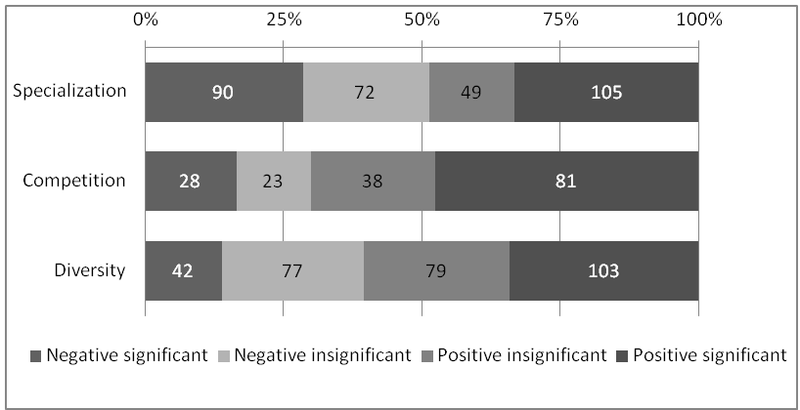

Figure 3.1: Vote counts

Taken together, the first results of our meta-analysis tend to re-confirm the conclusions in Glaeser et al. 1992. There is substantial evidence for positive and significant effects of diversity and competition on urban growth, whereas the results regarding the effects of specialization are highly ambiguous. In the next sub-section, we will provide a more detailed statistical analysis of the estimates that have been found in the literature and we will aim at explaining the sources of the variation that is present.

### Meta-regression analysis

The previous discussions have pointed at the fact that both theoretically as well as empirically, there is lack of clear-cut evidence on the importance of the three dynamic externalities driving economic growth. This sub-section aims to take the descriptive analysis in the previous section one step further by considering the relevance of several sources of heterogeneity. We proceed by first describing the potential sources of heterogeneity in study outcomes. Next, we describe the results of an ordered probit analysis and conclude with a discussion of the main results.

#### Sources of variation in estimated effect sizes

Some of the sources of variation were already identified in Table 3.2. They relate to the way in which the dependent variable in the analysis has been measured (viz. employment growth, output growth, productivity growth, patents or innovations, or other measures), the level of regional aggregation and the country covered in the analysis. Further heterogeneity is present in the sectoral coverage in the analysis. In fact, we will start out including all estimates found, disregarding the level of sectoral aggregation, and continue our analysis with only the estimates at a more aggregated level.[[36]](#footnote-36)

In our meta-analysis, we operationalize the characteristics of the dependent variable by means of several dummies and a continuous variable. The dummies measure whether the dependent variable is measured in terms of employment, patents or innovations, output, or productivity. Sectoral coverage is measured by two dummies that indicate whether the analysis is exclusively focused on the high-tech sector and whether the service sector has been included. Finally, we add a variable capturing the average population density of the units of observation included in the primary analysis. This captures in a simple and fairly comparable way an essential element of the regional aggregation of the analysis.[[37]](#footnote-37)

A second set of factors that might affect the outcomes of the analyses concerns the empirical operationalization of the key variables of interest, viz. specialization, competition and diversity. First, the results for, for example, specialization might be affected by the inclusion (or not) of a proxy for competition or diversity. Second, the exact empirical operationalization can matter. Considering specialization, it is likely to matter whether specialization is measured as a location quotient (viz. the share of a sector in regional employment relative to the national average) or just as a share in regional employment or total sectoral employment. For competition, different measures are used, among which number of establishments in a sector and the inverse of the average firm size in a sector feature most prominently. Regarding diversity, the crucial distinction is between studies that use the share of, for example, the five largest sectors and studies that use more continuous variables such as a relative diversity index, a Herfindahl index or a Gini coefficient. All these differences are captured by simple dummy variables.

A final set of factors that we consider relates to other data-characteristics and the presence of additional control variables. These are the period covered by the analysis (captured by the mean year of the analysis to which the data pertain), the length of the period covered (to distinguish between more long-run and short-run effects), the region covered in the analysis (taking Europe as the omitted category and considering Asia and the USA by means of dummies), the inclusion in the analysis of control variables for investments, educational variables, wages as well as the presence of regional dummies of some kind. We also include the (adjusted) R2, where available, to control for the overall fit of the estimations.[[38]](#footnote-38),[[39]](#footnote-39) Finally, we add a dummy for the estimation technique (distinguishing between panel and cross-sectional approaches), the year of publication of the study, and whether the study is a working paper or has been published in a journal or book.[[40]](#footnote-40)

We will not be able to test for publication bias (Stanley 2005) in the regular way, viz. by checking whether significant results suspiciously dominate the literature. We are not estimating one common metric for our three dependent variables, nor does our ordered probit allow the type of tests commonly performed. However, we are somewhat reassured by the fact that we tackle three variables at the same time, from studies where the variable of interest often was yet another variable. This makes it less likely that an unexpected result would not be published, and disappear in a file drawer. However, we do include a dummy for working papers, and we control for the year of publication separately from the year of the data, as in Koetse, De Groot & Florax 2009. We have also performed robustness tests to check whether specific studies overly influence the estimated coefficients, and report on one of those tests in appendix 3.D.

#### Ordered probit analysis

We will estimate an ordered probit model distinguishing between the four ordered categories that were introduced in Section 3.3.1. It is important to note that the interpretation of the estimated coefficients of an ordered probit analysis is not straightforward; see Appendix 3.B for a quick guide or Greene 2000, p. 878. In order to facilitate the interpretation, marginal effects can be used: these represent the change in the probably of finding an estimate in one of the four categories in response to a change of one of the explanatory variables. We report marginal effects (taken at the mean value of all other variables [[41]](#footnote-41)) for our second, preferred specification in Appendix 3.C; this is the specification that includes only estimations at an aggregated level, excluding sector-by-sector estimations.[[42]](#footnote-42) Interpretation of those results would not lead to different conclusions than those we will draw based on the estimated coefficients of Table 3.3 and Table 3.4.

We present two sets of estimation results aimed at uncovering the factors explaining the direction and statistical significance of estimates obtained from the primary studies on the impact of specialization, competition and diversity on urban growth. The explanatory variables capture the sources of variation that were discussed in Section 2.2.3. The results of the first ordered probit analysis are given in Table 3.3, which shows explanations for the variation in the effects of specialization, competition and diversity side-by-side.[[43]](#footnote-43)

Let us first turn to the results regarding the characteristics of the dependent variable. For specialization, the chance of finding a significantly positive effect are substantially smaller when measuring growth in terms of employment or output than when it is measured otherwise. For diversity, the effects are found to be larger when using employment growth. This casts some doubts on the appropriateness of using employ­ment as a proxy for technological development, except where competition is concerned; for competition, there is no discernible effect of the use of different dependent variables.

Regarding the regions that are considered, we find that the average population density of the regions studied has no significant influence on findings.[[44]](#footnote-44) This implies that results from an urbanized region – say, the Netherlands – are generally comparable to results from less densely populated regions – say, Australia[[45]](#footnote-45). However, the dummies for Asian and American data come up significantly: positive competition effects are more likely to be found in both continents.

Table 3.3: Meta-regression analysis

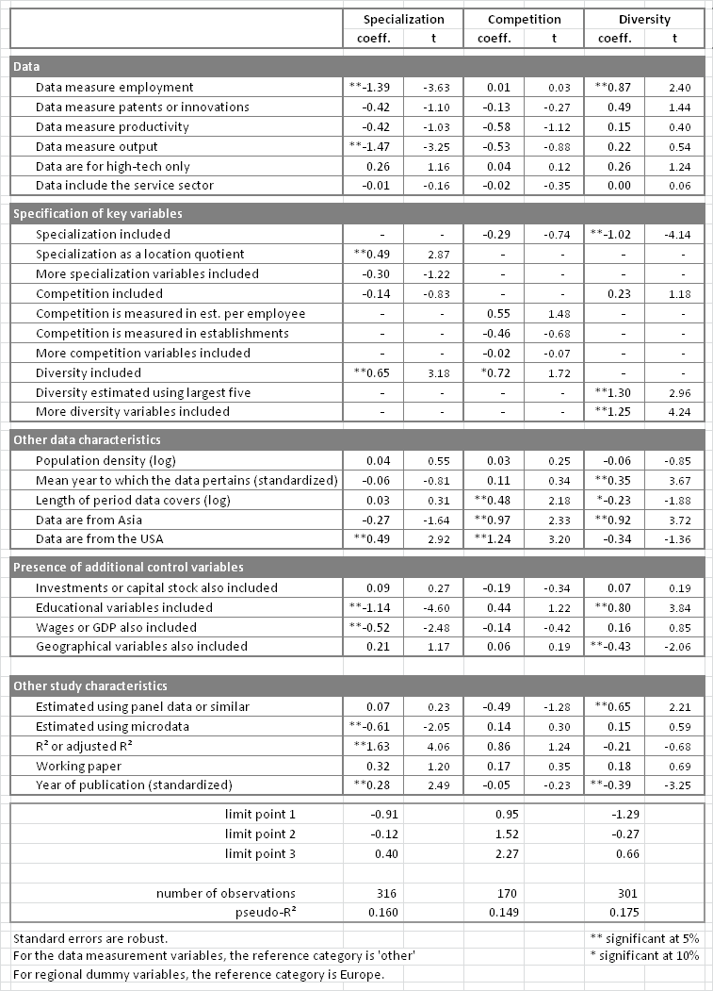

Note: The non-dummy variables are standardized in such a way that their mean is 0 and a value of +1 represents a value one standard deviation above the mean. For the mean year to which the data pertains, one standard deviation is 6.96; for the year of publication, it is 3.29.

A third set of results points at the potential importance of the time dimension. We control for the mean year to which the data of an estimate pertains, and this provides us with a rough estimate whether an effect is stable over time. Both the effect of the length of the period covered in the analysis as well as the use of panel techniques (as opposed to pure cross-section techniques) are indicative in this respect. For diversity, for example, we see that the use of panel data and shorter time periods tends to increase the chances of finding significantly positive effects. Especially the short-run effect is disconcerting: a long-run portfolio effect of diversity apparently does not hold; but the results may be driven by sector-specific estimations here, as the expected result returns in our other estimation below.

A fourth set of results relate to the specification of the key variables of interest. Apart from the fact that the mutual inclusion of specialization, competition and diversity often has an impact on the estimated effects of the key variable of interest, two results stand out in particular. First, measuring specialization as a location quotient (viz. relative to a national average) has a significantly positive effect on the chance of finding a positive effect of specialization. This brings us to a more theoretical discussion as to whether it is absolute or relative size that matters in explaining variation in urban growth. It is not evident which is the preferable proxy for specialization and scale. What is clear, however, is that the choice that is made tends to affect the outcome of the analysis. Second, it stands out that studies that proxy diversity by means of a simple measure capturing the employment share of the five largest sectors tend to find more positive effects of diversity than studies that use more refined measures to characterise diversity.

Finally, the inclusion of proxies human capital and wages affect the outcomes for especially specialization and also diversity, whereas the inclusion of a dummy for physical capital has hardly any limited effect on the variation in outcomes in the primary studies. There are small effects of the year of publication, to which we will return below.

#### Results using a subset of aggregated estimations

We will now re-estimate the same ordered probit analysis, using as our data only those estimates that concern the whole economy or all manufacturing sectors – that is, estimations at an aggregated level, which are therefore not driven by sector-specific characteristics. This ensures a better comparability of the estimates included.[[46]](#footnote-46),[[47]](#footnote-47)

Table 3.4: Meta-regression analysis, including only aggregated estimations (preferred specification)



Note: The non-dummy variables have been standardized as in Table 3.3.

Looking at the dependent variables, we see that the results for specialization differ markedly for those studies that focus on employment, just as they did in our first analysis. We could interpret this as a statement that specialization has a negative effect on employment, but not on innovations (where the coefficient is positive, though not significantly different from zero at a 10% significance level). We noted in our previous study that diversity tends to have a strongly significant positive effect if growth is measured in terms of innovation, underlining the theory of Duranton and Puga (2001), who argue that innovation benefits from diversified or ‘nursery’ cities. Our expanded dataset did not confirm that result, but we see that it reappears here in our preferred specification. The chances of finding a positive effect for diversity are lower in studies that include the service sector; based on this, we might hypothesize, contrary to the *communis opinio*, that diversity apparently is less beneficial for services. In fact, when we preform separate vote counts for studies with and without the service sector, 47% of the 89 estimations including the service sector found a positive outcome for diversity, against 29% of the 209 estimations that didn’t. However, the result we found in the meta-analysis is a result after controlling for other variables, and apparently the many positive outcomes in those studies that included services are mainly due to other observed factors.

As for the specification of variables, we see that estimates for diversity are smaller in those cases where specialization is not controlled for, and larger when competition is not controlled for. This points out the importance of studying agglomeration effects together. The specification of the competition variable has a significant influence on the results found: measuring competition in establishments per employee results in higher estimates than measuring it as an absolute number of establishments. (We will, however, find the reverse effect in Chapter 4, where we test both specifications on the same dataset.)

As for the area and timeframe under study, we see that the effects of specialization, competition and diversity are hardly different between Europe and the USA. This result suggests that flexi­bili­ty of goods and labour markets that differentiates – among many other factors – the USA from Europe has limited impact on the strength with which agglomerative forces function. These similarities are in contrast to Asia where the chances of finding positive effects for specialization are lower, whereas the chances of finding positive effects for competition[[48]](#footnote-48) and diversity are larger. We can conclude from these results that specialization plays a less important role in Asia; this may be related to the types of industries active in Asia, and to the age or maturity of these industries (see Neffke et al. 2008 for a study into the different effects of agglomeration in different stages of the industry life cycle). We also note that the effects of diversity are stronger for more recent years; it is also more likely to be positive when longer periods are considered, which might point to a portfolio or resilience effect.

Furthermore, we see that estimations using microdata are less likely to find significant results for specialization. We believe this result shows that specialization effects might be less important at firm level, and that the use of aggregated data can result in false positives, confusing pure agglomeration effects with sorting mechanisms.

Finally, we note that the year of publication is significant for specialization and diversity. More recent papers in our set are less likely to conclude that diversity matters (as Glaeser (1992) concluded) and more likely to conclude in favour of specialization. There might be a selection process at work, where journals are less likely to accept papers that confirm Glaeser’s accepted view – but the effect is not restricted to published papers, and is as valid for working papers.[[49]](#footnote-49)

Table 3.5: Goodness of fit: Count R² and Adjusted Count R²

for the two models presented in Table 3.3 and 3.4.

|  |  |  |  |
| --- | --- | --- | --- |
| **unadjusted** | SPEC | COMP | VARY |
| only aggregated | 0.748 | 0.596 | 0.701 |
| whole set | 0.509 | 0.559 | 0.502 |
|  |  |  |  |
| **adjusted** | SPEC | COMP | VARY |
| only aggregated | 0.630 | 0.294 | 0.500 |
| whole set | 0.265 | 0.157 | 0.242 |

For specialization, competition and diversity, respectively, 51%, 56% and 50% of the observations are predicted correctly by this model – but this figure ought to be adjusted for success rate that would be obtained by predicting all observations to fall in the largest category. Therefore, an Adjusted Count R² has been developed (UCLA Academic Technology Services 2010), which is defined as

|  |  |  |
| --- | --- | --- |
|  | $$R^{2}=\frac{Correct-n}{Total-n}$$ | (14) |

where *n* represents the count of the most frequent outcome. Unadjusted and adjusted count statistics are found in Table 3.5. Our estimations on the smaller dataset perform best, looking at the adjusted figures; specialization and diversity perform better than competition. Figure 3.2 shows actual outcomes (displayed on the horizontal axis) and predicted outcomes (bars) in one graph. For specialization and diversity, the actual outcome is almost everywhere the largest predicted category. For competition, there is a clear tendency to predict extreme values.

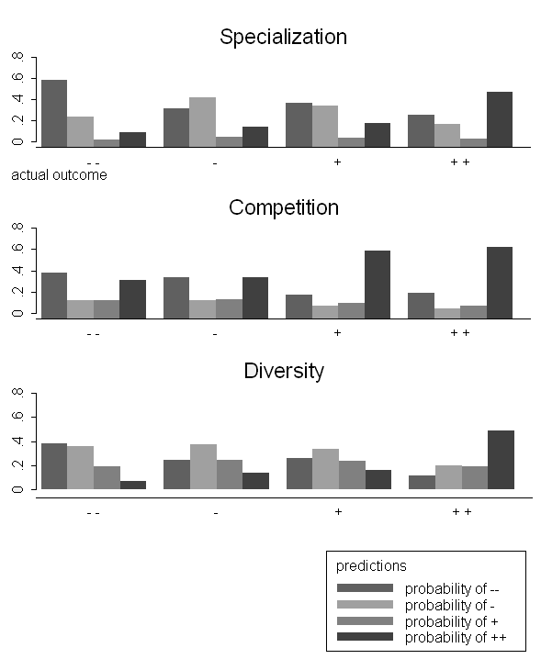  
Figure 3.2: Predicted vs. actual outcomes for non-sectoral estimates

## Conclusions

This Chapter has looked into the available empirical evidence on the importance of three externalities in explaining urban growth, viz. MAR externalities, Porter exter­nali­ties and Jacobs externalities. The latter was done by means of a meta-analysis. The over­all evidence of the meta-analysis based on a simple counting of conclusive effect sizes reveals that relatively many primary studies conclude in favour of significantly positive effects of competition on growth, and to a lesser extent in favour of diversity. For diversity, however, we found the smallest share of negative significant findings. No clear-cut evidence was found for the effects of specialization, where positive and negative estimations are of equal size. Apparently, both effects exist, but under different circumstances. This underlines the value of conducting a meta-analysis.

Our analysis points at several fruitful directions for further research. First, we found quite some strong indications for sectoral, temporal and spatial *hetero­geneity* of the effects of specialization, competition and diversity on urban growth. For example, more recent data find stronger effects for diversity, and studies using data from (mainly east) Asia find specialization to be a less important factor than elsewhere, while again diversity has more influence. Such heterogeneity typically remains un­noticed in primary studies, which tend to focus the analysis on a specific region, sector or time period. It underlines, for example, the need for research focusing on the dependency of the strength of agglomerative forces on the stage of development of the region, but also of the sector, as performed for example in Neffke et al. 2008. This may enhance our insights into challenging questions as to whether in the knowledge-driven post-industrial economy of producer and consumer services characterised by many young and small firms, Jacobs externalities are more important. We will test for the effects of agglomeration on different types and size classes of firms in Chapters 5 and 6.

Second, the level of regional *aggregation* matters for the strength with which the agglomeration forces are operational. Especially for specialization, population density (that is, city scale effects) has a negative influence on the results found. This gives rise to interesting questions regarding the transmission mechanisms through which the exter­nalities function. More theoretical as well as empirical work investigating these issues is warranted. We also found that including *control variables* on investments or capital stock and education has substantial effects on our key variables of interest. Similar effects may be expected from factors such as social capital and trust, risk-taking and entrepreneurship, R&D policies and institutions. More research on the role of such factors in determining the strength with which agglomerative forces are operating is warranted. Finally, we confirm the need for more attention to the *specification* of the key variables of interest. This is an issue we will take up in the following chapter, which deals with the effect of agglomeration on productivity, measured in the form of wages.

## Appendix 3.A. Studies included

List of included studies and number of meta-observations

| study | # est. eqs | Conclusions | | | Characteristics | | |
| --- | --- | --- | --- | --- | --- | --- | --- |
| SPEC | COMP | VARY | country | Regions | dependent |
| Acs & Armington 2004 | 3 | –– | ○ | n.a. | USA | LMAs[[50]](#footnote-50) | employment |
| Almeida 2005 | 8 | ○ | + | ○ | Portugal | concelhos | 4× employment, 4× productivity |
| Andersson, Quigley & Wilhelmsson 2005 | 12 | n.a. | + | ++ | Sweden | LMAs | patents or innovations |
| Baltzopoulos 2009 | 2 | ++ | –– | ○ | Sweden | functional regions | other |
| Baptista & Swann 1998 | 9 | – | n.a. | + | UK | CSO regions | patents or innovations |
| Baptista & Swann 1999 | 4 | + | ○ | – | 2× UK, 2× USA | CSO regions, states | employment |
| Baten et al. 2005 | 1 | + | n.a. | –– | Germany | districts | patents or innovations |
| Batisse 2002 | 6 | –– | ○ | + | China | provinces | output |
| Beaudry & Breschi 2003 | 2 | –– | n.a. | ○ | UK, Italy | counties, provinces | patents or innovations |
| Beaudry 2009 | 2 | ++ | n.a. | + | UK | counties | 1× patents or innovations, 1× employment |
| Boix & Trullén 2007 | 4 | –– | n.a. | ++ | Spain | municipalities | employment |
| Boschma & Weterings 2005 | 5 | ○ | n.a. | – | Netherlands | NUTS3 | patents or innovations |
| Bradley & Gans 1998 | 1 | n.a. | n.a. | –– | Australia | cities | employment |
| Brülhart & Mathys 2008 | 4 | ++ | n.a. | n.a. | Europe | NUTS3 | productivity |
| Burger, Van Oort & Van der Knaap 2008 | 18 | ○ | n.a. | ○ | Netherlands | NUTS3, LMAs, municipalities | employment |
| Cainelli & Leoncini 1999 | 4 | ++ | ++ | ++ | Italy | provinces | employment |
| Carlino & Hunt 2007 | 18 | + | ++ | – | US | SMAs[[51]](#footnote-51) | patents or innovations |
| Chen 2002 | 4 | – | n.a. | – | Taiwan | cities | productivity |
| Cingano & Schivardi 2004 | 3 | ++/ – | –/ ++ | –/ ++ | Italy | LMAs | 2× productivity/ 1× employment |
| Combes 2000 | 4 | –– | – | ○ | France | LMAs | employment |
| Combes, Magnac & Robin 2004 | 6 | n.a. | ○ | + | France | LMAs | other |
| Condliffe et al. 2008 | 3 | + | n.a. | – | US | counties, states | productivity |
| Das & Finne 2008 | 4 | ○ | n.a. | – | Norway | LMAs | patents or innovations |
| De Lucio, Herce & Goicolea 2002 | 1 | – | – | + | Spain | provinces | productivity |
| De Vor & De Groot f.c. | 3 | – | + | n.a. | Netherlands | industrial areas | employment |
| Deidda, Paci & Usai 2006 | 2 | –– | ++ | + | Italy | LMAs | employment |
| Dekle 2002 | 8 | –– | ○ | ○ | Japan | prefectures | 4× employment, 4× productivity |
| Drucker & Feser 2007 | 9 | n.a. | + | ○ | USA | LMAs | output |
| Feldman & Audretsch 1999 | 4 | –– | + | ++ | USA | SMAs | patents or innovations |
| Fritsch & Slavtchev 2007 | 2 | n.a. | ­­–– | ++ | Germany | Raumordungs–regionen | patents or innovations |
| Fu & Hong 2008 | 2 | ○ | n.a. | ○ | China | cities | productivity |
| Gao 2004 | 5 | ○ | ++ | + | China | provinces | provinces |
| Glaeser & Kerr 2008 | 2 | ++ | n.a. | –– | USA | SMAs | patents or innovations |
| Glaeser et al. (1992) | 4 | –– | + | + | USA | SMAs | employment |
| Greunz 2004 | 4 | ++ | n.a. | ++ | Europe | NUTS2 | patents or innovations |
| Gustavsson 2003 | 8 | + | ○ | ○ | Sweden | counties | 4× employment, 4× productivity |
| Hanson 1998 | 6 | –– | + | ○ | Mexico | states | employment |
| Harrison, Kelley & Gant 1996 | 7 | ○ | n.a. | n.a. | USA | counties | patents or innovations |
| Henderson 2003 | 4 | + | n.a. | + | USA | counties | employment |
| Henderson, Kuncoro & Turner 1995 | 5 | + | n.a. | ○ | USA | SMAs | employment |
| Henderson, Lee & Lee 2001 | 2 | + | n.a. | ○ | South Korea | cities | output |
| Jofre-Monseny 2009 | 7 | + | ○ | –– | Spain | municipalities | other |
| Kameyama 2004 | 6 | ○ | n.a. | ○ | Japan | LMAs | employment |
| Ketelhöhn 2006 | 1 | ++ | ++ | ++ | USA | counties | patents or innovations |
| King, Silk & Ketelhohn 2003 | 7 | – | ++ | ○ | USA | states | employment |
| Lee, Sosin & Hong 2005 | 5 | –– | ++ | ++ | South Korea | regions/counties | productivity |
| Lu, Ni & Tao 2009 | 8 | ○ | ++ | ○ | China | cities | 6× patents or innovations, 2× output |
| Malpezzi, Seah & Shilling 2004 | 4 | n.a. | n.a. | ++ | USA | SMAs | other |
| Mano & Otsuka 2000 | 15 | ­­–– | n.a. | ○ | Japan | prefectures | employment |
| Martin, Mayer & Mayneris 2008 | 2 | ++ | – | –– | France | LMAs | output |
| Massard & Riou 2002 | 4 | – | n.a. | – | France | départements | patents or innovations |
| Mendoza Cota 2002 | 2 | – | n.a. | + | Mexico | (unclear) | employment |
| Mody & Wang 1997 | 6 | –– | + | n.a. | China | counties/  provinces | productivity |
| Mukkala 2004 | 6 | + | n.a. | n.a. | Finland | NUTS4 | productivity |
| Neffke 2009 | 4 | ○ | n.a. | –– | Sweden | municipalities/ LMAs | 2× output,  2× other |
| Ouwersloot & Rietveld 2000 | 3 | – | ○ | ○ | Netherlands | municipalities | output |
| Paci & Usai 1999 | 6 | ++ | n.a. | ++ | Italy | LMAs | patents or innovations |
| Paci & Usai 2000 | 2 | –– | – | ++ | Italy | LMAs | employment |
| Paci & Usai 2001 | 2 | –– | + | ++ | Italy | LMAs | employment |
| Paci & Usai 2006 | 1 | ++ | n.a. | ++ | Italy | LMAs | patents or innovations |
| Partridge & Rickman 1999 | 5 | + | n.a. | + | USA | states | productivity |
| Rosenthal & Strange 2003 | 18 | + | ○ | –– | USA | ZIP regions | 12× empl., 6× other |
| Serrano & Cabrer 2004 | 22 | – | n.a. | ○ | Spain | provinces | productivity |
| Sjöholm 1999 | 6 | ○ | ○ | ++ | Indonesia | 3× districts, 3× prov. | 2× prod., 4× other |
| Sonobe & Otsuka 2006 | 18 | ○ | n.a. | ○ | Taiwan | townships | 9× empl., 9× other |
| Staber 2001 | 3 | ++ | n.a. | –– | Germany | circles of 10 km | other |
| Suedekum & Blien 2005 | 2 | –– | –– | n.a. | Germany | NUTS3 | employment |
| Van der Panne 2004 | 3 | ++ | –– | ○ | Netherlands | ZIP regions | patents or innovations |
| Van Oort & Atzema 2004 | 3 | + | + | + | Netherlands | municipalities | other |
| Van Oort & Stam 2005 | 2 | ++ | + | ++ | Netherlands | municipalities | employment |
| Van Oort 2002 | 4 | ○ | –– | + | Netherlands | municipalities | patents or innovations |
| Van Soest, Gerking & Van Oort 2002 | 4 | –– | ++ | ++ | Netherlands | cities, ZIP regions | employment |
| Viladecans-Marsal 2004 | 6 | ++ |  |  | Spain | cities | employment |

Note 1: the numbers in the second column indicate the number of estimated equations from which estimates for the externalities have been derived.

Note 2: The symbols in the next three columns have the following meaning:

–– significantly negative in all cases;

– negative in all cases, but not always significantly so;

○ inconclusive;

+ positive in all cases, but not always significantly so;

++ significantly positive in all cases; and

n.a. no estimates available.

## Appendix 3.B. Ordered probit

The estimation of an ordered probit model is common practice in a situation where the construction of a common metric to characterise the variation in the underlying primary studies is problematic. A downside of it is that it neglects information on the extent of statistical significance which is contained in, for example, the t–statistics of the estimated coefficients. Koetse, De Groot and Florax (2009) perform an analysis along those lines and compare their results with a simpler ordered probit analysis.

The ordered probit model assumes the presence of a latent variable, $y^{*}$ that can be explained by a set of explanatory variables $x_{i}$ such that:

|  |  |  |
| --- | --- | --- |
|  | $$y^{*}=\sum_{i}{β_{i}x_{i}}+ε$$ | (15) |

where $ε$ is an error term that is assumed to be normally and i.i.d. distributed. We only have information on the categorical variable *y* consisting of the four categories discussed above. This observed variable has the following structure:

|  |  |  |
| --- | --- | --- |
|  | $$y=0 if y^{*}≤ μ_{1}$$ $$y=1 if μ_{1}<y^{*}≤μ_{2}$$ $$y=2 if μ_{2}<y^{*}≤μ_{3}$$ $$y=3 if y^{*}> μ_{3}$$ | (16) |

where the $μ$–parameters are estimated by the model, along with the $β$’s. The figure below shows how these $μ$–values should be interpreted (top graph): they are the so–called limit points, dividing the probability curves into sections. The limit points are the same for all observations; the position of the probability curve is not. The surface under this probability curve is the probability an observation will have the result associated with each category, which falls between the limit points (middle graph).

A shift in the estimated point value moves the whole curve (bottom graph), and results in changes in the probabilities of all categories. Only for the leftmost and rightmost category does this lead to an unambiguous shift – as shown in the graph, a higher score leads to a decrease of the probability of the lowest category, and an increase in the probability of the highest category. The second category looses slightly, the third category also gains probability.

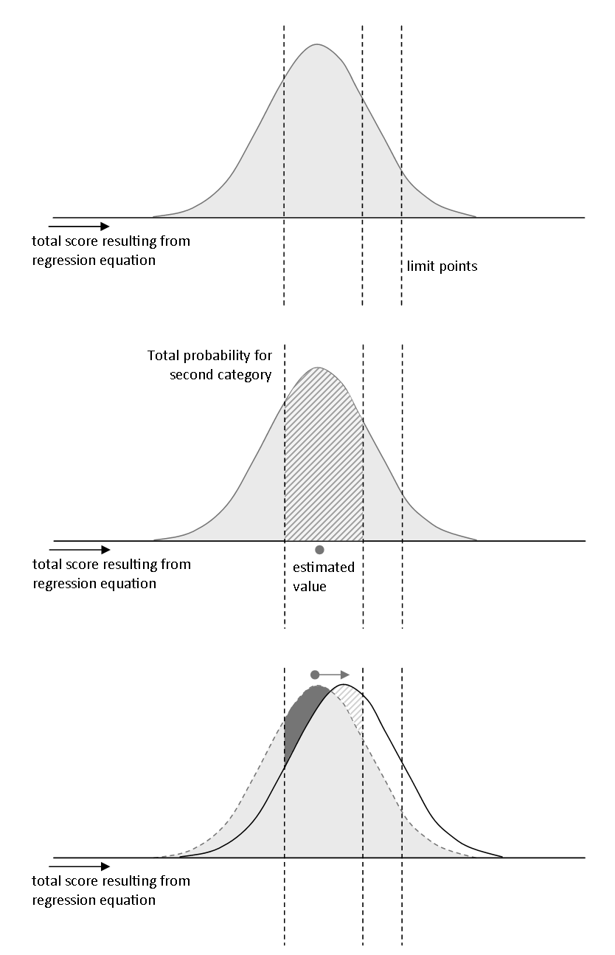

Figure 3.B.1: Interpretation of an ordered probit: the probability distribution shifts. See text for further details.

## Appendix 3.C. Marginal effects

For the dummy variables, the marginal effects describe the increase in the probability of finding an outcome in one of the four categories of the dependent variable between the situation in which the value for a particular dummy is equal to zero and the situation in which it is one. For the continuous variables, the marginal effects are associated with an increase of the dependent variable by one. In case of the standardised variables, these correspond to an increase of the dependent variable by one standard deviation.

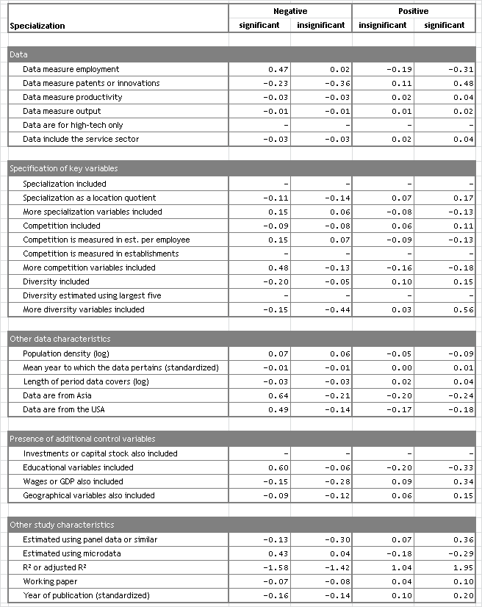

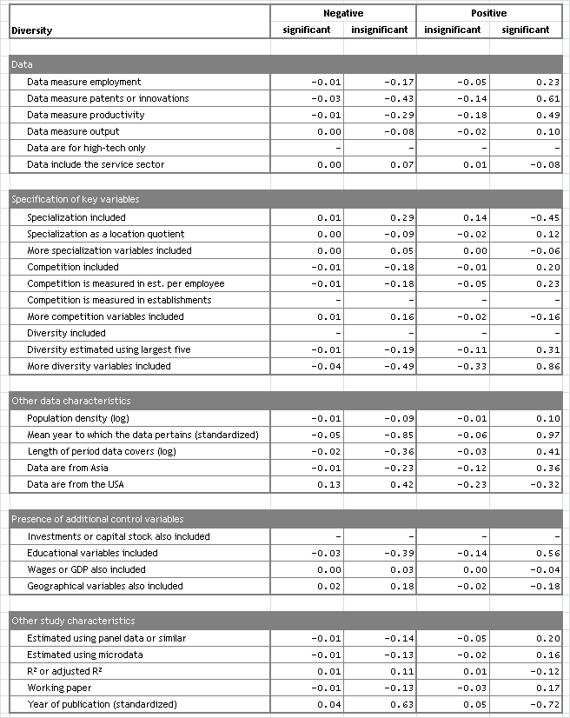

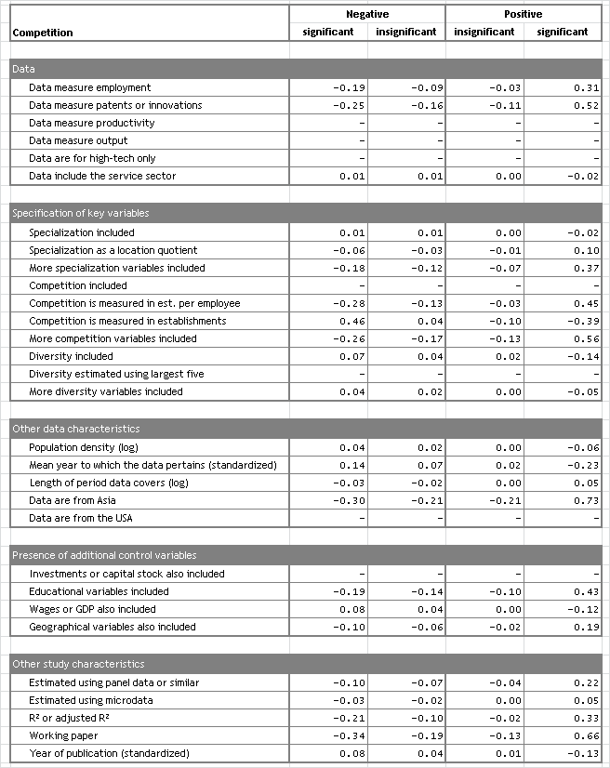

## Appendix 3.D. Robustness test

We test the robustness of our first estimation (the larger set) for specialization by repeating the analysis with all studies *minus one*. As we target studies, not estimates, the analysis is repeated 67 times. (This technique is called jackknifing.) When the estimated coefficient for a variable changes, the omitted study apparently effectuated a drag in the other direction. The figure below reports in a box–and–whisker plot the spread of estimated coefficients (left) and the estimated standard errors (right) in the 67 regressions. The boxes mark the upper and lower quartiles, and the whiskers a distance of 1.5 times the inter–quartile range from the box.

The figure below is primarily intended as an illustration of the technique. Further details, including a codebook for the variable names used, are available upon request.

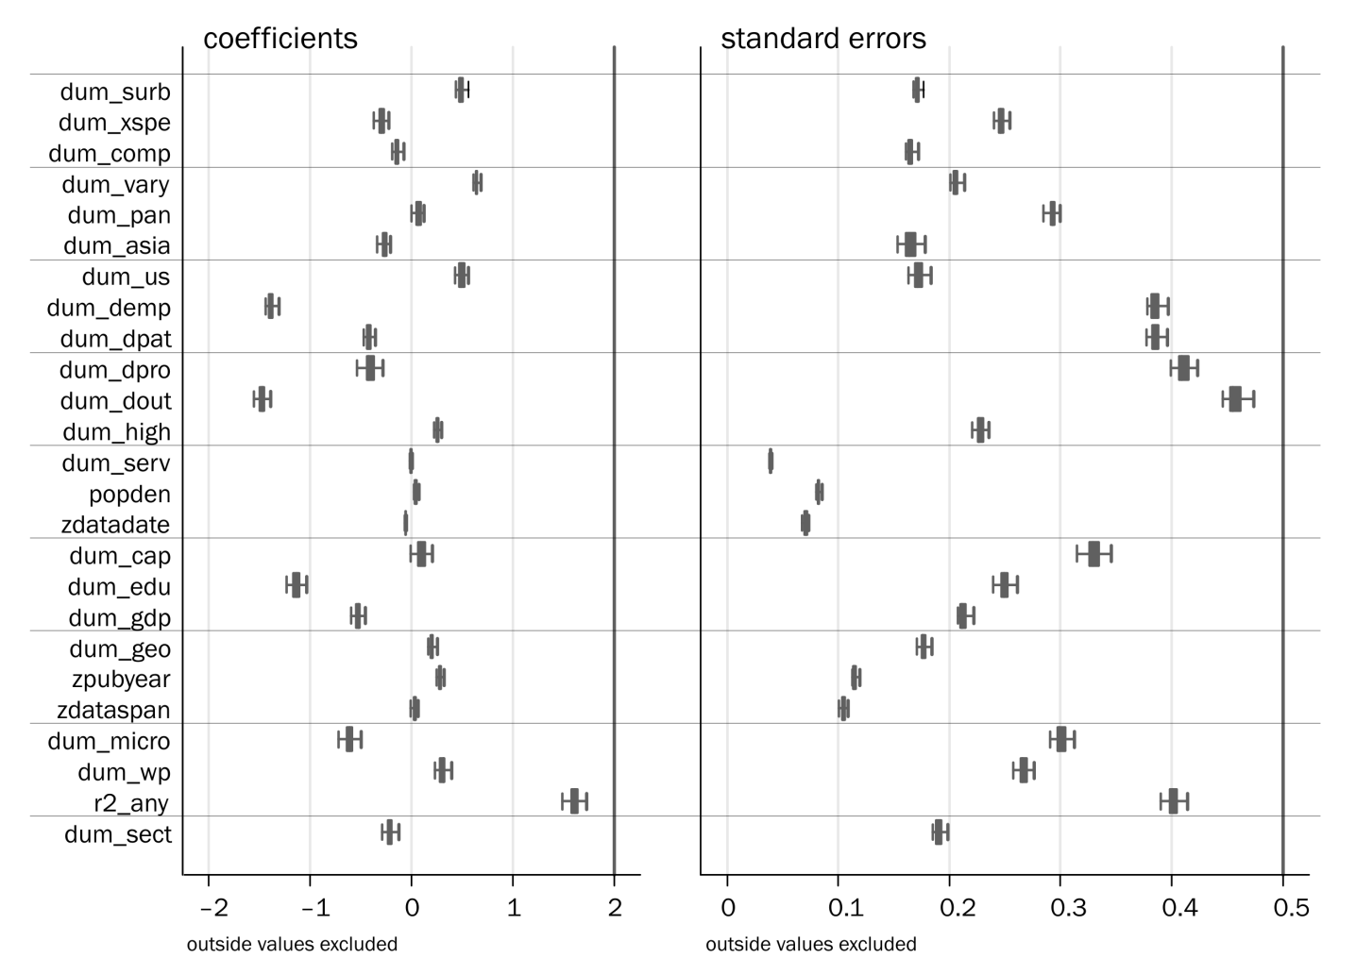

# Regional wage differences in the Netherlands: micro-evidence on agglomeration externalities

## Introduction[[52]](#footnote-52)

Regional wage disparities are known to be large in many countries, and they are often a source of public concern. Most governments have specific policies targeted at regions that structurally lag behind. Yet assuming that firms optimize their location, these wage differences might also reflect actual differences in productivity caused by agglomeration economies, which are positive externalities that correspondingly increase aggregate welfare. Even though regional wage differences in the Netherlands are relatively small, there are still substantial differences between the main agglomerations in the Randstad and peripheral regions.

This chapter firstly describes the nature and magnitude of regional (pre-tax individual worker) wage differences in the Netherlands, and secondly to relate the spatial component of observed wage differences to agglomeration effects. In order to do so, we employ labour market micro­data provided by Statistics Netherlands (CBS). In its setup, we closely follow the analysis on spatial wage disparities in France by Combes, Duranton & Gobillon 2008. To our knowledge, the current study is the first that uses microdata to estimate agglomeration economies in the Netherlands. As the use of microdata provides an opportunity to reduce worker heterogeneity that remains unobserved at a more aggregated level, we will see how the present work compares to the work of Gorter & Kok 2009, who estimated agglomeration effects in the Netherlands using aggregated data on average regional productivity.

The remainder of this chapter will start with some theoretical background. We will then proceed with a description of the data and methodology that was used in Section 4.3, and discuss the choice of agglomeration variables in Section 4.4. Section 4.5 uses the Mincer equation to esti­mate regional differences in the skill premium, the experience premium and the resulting spatial residual; this residual we will attempt to explain further in Section 4.6, relating it to different agglomeration effects. Section 4.7 will then repeat our estimations with aggregated data. Section 4.8 concludes.

## Sources of regional wage differences

There are three main sources of regional wage differences, as pointed out by Combes, Duranton and Gobillon (2008). The first is the composition of the labour market, an urbanization externality. The second set of explanations relies on differences in the presence of local non-human endowments. The third consists of agglomeration economies: spatial proximity of firms to other firms, to producers or to suppliers. We will briefly discuss these three in turn.

Workers with different skill and experience levels, or with different ethnical backgrounds, are not homogeneously distributed across regions.[[53]](#footnote-53) As sectors are not spread evenly across regions either, and different industries require a different mix of worker characteristics, workers tend to spatially sort themselves based on the supply and demand for their specific competences (Combes, Duranton & Gobillon 2008). Yet in an equilibrium situation[[54]](#footnote-54) this sorting will occur only if firms in those regions that experience a shortage of workers in specific industries or occupations offer a premium wage over firms in regions where these workers are relatively abundant. One reason for the absence of an isotropic wage landscape is that institutions in higher education as well as industries that require highly skilled labour are usually concentrated in densely populated centres. Students that move from the periphery to a city to take education there have little incentive to move back to the periphery after completing their education. Composition can therefore be held accountable for part of the spatial differences in wage; in other words, assuming that wages are equal to the marginal product of labour, average wages can be different across regions, even when there are no regional differences in the productivity of workers with equal characteristics.[[55]](#footnote-55)

Local non-human endowments are a second source of wage and productivity differences. Regions that have good access to waterways, a favourable climate, or valuable natural recourses can have a higher productivity than less endowed areas. An especially interesting type of non-human endowments are those with a non-natural nature, like technology, local institutions and private capital, as they are often endogenous. Railway stations in the 19th and 20th century are an example of this. Stations were built on the most populated spots at that time, but as they strongly reduced distance (measured in time), they further accelerated agglomeration forces. The difference with agglomeration externalities lies in the source of the productivity gain. Agglomeration externalities are related to economic agents, whereas local non-human endowments have to do with other circumstances specific to a location.

Various authors have pointed at the importance of agglomeration externalities for economic growth. Agglomeration can work both through physical proximity and through scale, both for demand and supply. These mechanisms reduce transaction costs, both on markets for goods and on markets for production inputs. Thus, agglomeration results in cost reductions by enabling groups of firms to enjoy collective economies of scale (Harvey 1981, p. 105). Yet another source of productivity growth are knowledge spillovers, resulting in more innovation in agglomerations (Jaffe, Trajtenberg & Henderson 1993). According to the Marshall-Arrow-Romer (MAR) model the main ‘route’ of these spillovers is intrasectoral, which Glaeser et al. (1992) tested in their milestone work on cities as the centre of growth (see Chapters 2 and 3). In the MAR model, knowledge is industry-specific and regional concentration of certain industries therefore allows knowledge spillovers between firms in the same industry. Yet some types of spillovers occur across sectors; these diversity effects are known as Jacobs externalities (Jacobs 1969). Where differences meet, innovations are born. A third category of agglomeration economies consists of the so-called Porter effect. Porter (1990) pointed at the importance of (local) intra-sectoral competition as a source for productivity gains.

After the important work of Glaeser et al. (1992), who found that Jacobs externalities were empirically the most important agglomeration effect, many studies repeated their setup. Reviews of this strand of literature are provided among others by Rosenthal and Strange (2004), Beaudry and Schiffauerova (2009), and in Chapter 3.

## Data and methodology

The data used in this Chapter consist of four datasets, each covering the period 1999-2005:

* the ABR;
* the SBB;
* the EBB;
* and the Dutch tax records.

The ABR is the Dutch General Business Register (Algemeen Bedrijvenregister), which is a census covering basic data on all establishments. The SBB (Sociaal Statistisch Bestand) contains census data on the location of residence of employees, both of which are available on the municipality level. By combining employer (ABR) and census data (SSB), the work location is also available on the municipality level. The EBB (Enquête Beroepsbevolking) is the Dutch Employ­ment Survey, with about 70,000 observations annually. It contains, among others, data on education level and job type.

The level of observation in the tax records is that of the job, so one worker can have multiple observations in each year. Since additional information on hourly wages and the number of hours worked is only available for a subset of all jobs of about one third of the total, some parts of the research are based only on this smaller subsample. We use pre-tax hourly wages of individual workers and jobs, which provide a close approximation of the productivity level of workers. Data are available for the period 1999–2005, with over 10 million observations annually.

For most of the analyses in this Chapter we aggregate the location-specific data to NUTS-3 level, since it is expected that the local labour market area is the most likely level at which agglo­me­ration forces operate.[[56]](#footnote-56) A map with the names of these regions can be found in Appen­dix A. However, we will also repeat some of our analyses at the municipality level. We use the spatial classification of 2005, and have data on 40 NUTS-3 regions or 469 municipalities. The work location is defined as the job site or business unit. For each employee, we have age, ethnicity, hourly wage, residence and workplace location (both on the municipality level). For each business unit we have the sectoral classification on the 5-digit NACE level – though we limit its use to the 2-digit level to simplify computations – and the number of employees.

We exclude all employees earning less then 10% or more than 1000% of the average hourly wage, all workers younger than 18 or older than 65, and all workers with a working week of less then 12 hours.[[57]](#footnote-57) The remaining sample consists of almost 20 million observations. For additional analyses, we combined this large dataset with the Dutch Employment Survey. After merging this data with census and firm data, and selections as described above, we have 30,000 observations for each year.

Figure 4.1 shows average hourly wages per worker in each NUTS-3 region. On average, employees working in the agglomeration of The Hague receive the highest hourly wages, while those in Zuidwest-Friesland earn the lowest. In general, wage levels are higher in the western provinces of the Netherlands – mainly in the Randstad – than in the rest of the country. When we would have included the highest incomes (over 10 times the overall average), this difference would be even more pronounced, as many (international) headquarters are located in the largest cities in the Randstad.

|  |  |
| --- | --- |
| relative wages 2000 | reative wages 2005 |
| Figure 4.1. Indexed average hourly wages by NUTS-3 region, 2000 (left) and 2005 (right) | |

We construct our agglomeration variables directly from the microdata. For this pur­pose we use cross sections of tax data, aggregating employment, workers per in­dus­try and number of firms for each Corop region or municipality. Since we have data for all jobs, we will also perform a worker fixed effect estimation. In this way, we correct for all (observed and non-observed) worker specific characte­ris­tics. Agglomeration effects can now be identified on workers that change jobs or work location. As non-observed heterogeneity is known to have a disturbing effect when estimating the magnitude of agglomeration economies (Combes et al., 2008a), using fixed effects methods could provide an improvement.

## Agglomeration variables

As we will follow Glaeser’s tripartite division of agglomeration economies into economies of specialization, competition and diversity, we will briefly discuss the variables they use, as well as those used in the literature that follows up on their work. From these, we will select nine definitions which we will then proceed to test on our data.

### Specialization

As a first remark on measuring specialization, we have to note that many papers confuse speciali­zation and concentration. Glaeser et al. (1992) did so, by referring to the location quotient they measured as a measure of specialization; and many have done so since. Speciali­zation technically should refer to the dominance of one industry in a region; concentration, on the other hand, refers to the importance of one region for an industry. These two are equivalent only if all sectors have the same size; but that is generally not the case. A simple example is the diamond industry in Antwerp and Amsterdam. It is clearly concentrated in those two cities; but to say they are specialized in diamonds would go too far. On the other hand, if a small town is specialized in pig farming, that does certainly not automatically imply pig farming is concen­trated there. The question then is whether smaller sectors will also experience economies of scale with smaller numbers of firms or employees.

Although specialization and concentration are different concepts, we group them together here, and will discuss measures of both, noting their peculiarities in passing. Beforehand, we note that a similar conflict exists between specialization and diversity: from a regional perspective, a specialized region is the opposite of a diverse region (Cutrini 2009).

The most basic measure of specialization measures just economies of scale, disregarding sectors that are small in all regions completely; it is the absolute number of employees in a sector. This is the first operationalization of an agglomeration variable that we will include; all of these are indicated with a short variable name:[[58]](#footnote-58)

This variable can also be specified as a share of the total employment in a region, which has the advantage that a small sector in a small region can still dominate that region, but the disadvantage that it equates a village of 100 where 80% of the population is engaged in fishery with a city of 100,000 where 80% of the population works in fishery (rather improbable) or the textile industry:

$${S_share}_{ir}=\frac{L_{ir}}{L_{*r}}$$

Glaeser et al. 1992 use a simple location quotient (LQ) – a measure of industry concentration. This quotient is both scaled to the region, and to the countrywide size of the industry. An LQ is defined as:

$${S_lq}_{ir}=\frac{{L_{ir}}/{L_{i*}}}{{L_{*r}}/{L_{**}}}$$

The LQ relates the local importance of a sector to the ‘global’ importance of a sector – that is, its importance at the top level; usually, the national level is taken as this reference level, but some studies focus on the EU (e.g. Greunz 2004). Van Soest, Gerking and Van Oort (2002) compared an LQ with alternative absolute measures, and found that these alternatives behaved ‘incon­sistently’ (p. 11). O'Donoghue & Gleave 2004 suggested improving on the location quotient. They strove to discern significant overconcen­tra­tion (that is, a cluster) from a normal presence of an industry in a region and proposed a Standardized Location Quotient (measuring differences from 1 at the 5% confidence level), as well as an Adjusted Location Quotient, which includes only small- and medium-sized enterprises (SMEs), and therefore ignores clusters that consist solely of one large firm.

From a theoretical point of view it is often the presence of larger (‘core’) firms that creates or sustains a cluster. Statistically, there is a larger probability to find large firms in a concentration of firms. Therefore, Ellison and Glaeser (1997) devised an index of concentration (normally labelled γ) that takes this statistical process into account – they call it a dartboard approach. Their rather complex index is calculated at an industry level, showing the degree to which an industry is concentrated; it takes on a value of zero if an industry location is indistinguishable from a completely random pattern:

$${S_ellis}_{i}=\frac{\sum_{r}{{\left(\frac{L_{ir}}{L_{i*}}-\frac{L_{*r}}{L_{**}}\right)}^{2}}-\left(1-\sum_{r}{{\left(\frac{L_{*r}}{L_{**}}\right)}^{2}}\right)×\sum_{f}{{\left(\frac{L_{f}}{L_{i}}\right)}^{2}}}{\left(1-\sum_{r}{{\left(\frac{L_{*r}}{L_{**}}\right)}^{2}}\right)\left(1-\sum_{f}{{\left(\frac{L_{f}}{L_{i}}\right)}^{2}}\right)}$$

A simpler alternative measure, that still takes into account the specialization vs. concentration issue, is the measure for Horizontal Clustering that was developed by Fingleton, Igliori and Moore[[59]](#footnote-59). They relate the actual number of workers in a city-industry to the expected number of workers in a city-industry:

$${S_hc}_{ir}=L_{ir}-\frac{L_{i*}L_{*r}}{L_{**}}=L_{ir}-E\left(L_{ir}\right)$$

For those cases where data allows, Feser & Bergman (2000, p. 12) recommend the use of input-output tables (cited in O'Donoghue & Gleave 2004, p. 422). The use of input-output tables allows assessing relationships between (sub)sectors more clearly than standard industrial classifi­cations can possibly allow; what is more, regional input-output tables will also allow for different relationships in different regions.[[60]](#footnote-60)

### Competition

The most basic form of a competition variable is the number of firms in a region:

$${C_firms}_{ir}=F_{ir}$$

Glaeser et al. (1992) use the relative number of firms per employee as a measure for competition. Their reasoning is that if this ratio is greater than one, the local industry has “more firms relative to its size in this city” (p. 1142) than the national average, and therefore there is more competition. Yet they acknowledge that it might also be the case that firms are smaller in this city, and these effects cannot be distinguished when we use the relative number of firms per employee:

$${C_rfpe}_{ir}=\frac{{F_{ir}}/{L_{i*}}}{{F_{*r}}/{L_{**}}}$$ This measure is used a lot in subsequent literature, as is its inverse, employees per firm. Instead of employees, other size measures are sometimes employed, such as output. Firm size is sometimes divided by the national average, but can also be presented as an absolute number at the regional level. In that case, industries with strong scale effects (where large firms dominate) will seem to have less competition than industries where small firms abound.

$${C_afpe}_{ir}=\frac{{F_{ir}}/{L_{ir}}}{{F_{i*}}/{L_{i*}}} or \frac{F_{ir}}{L_{ir}}$$

Similar to the average firm size is a measure of the complete distribution of firms: a Hirschman-Herfindahl index (Hirschman 1964) of firm shares of employment in a city-industry. This is done, for example, by Combes 2000. The disadvantage of this measure is that it increases with the number of plants in a city-region even if average plant size is the same (Almeida 2005). Therefore, when sectors are of different size, the interpretation of coefficients estimated for this measure across industries is not straightforward. As with any basic Hirschman-Herfindahl index, a larger value means less competition and vice versa. The most basic form of this index reads:

$${C_hhi}_{ir}=\sum_{f}{{\left(\frac{L_{fir}}{L_{*ir}}\right)}^{2}}$$

A completely different approach to competition, which does not depend as much on the size of sectors in regions, is to measure market power with a Lerner index, as is done, for example, by Galeotti (2009). Yet the amount of firm-level data needed for this index makes the approach unfeasible for most research:

$${C_lerner}_{f}=\frac{Sale+∆Inventory-Payroll-Material cost}{Sale+∆Inventory}$$

### Diversity

Diversity (or variety) can be measured as a non-sectoral variable, taking on one value for a region (*Dr*).[[61]](#footnote-61) Alternatively, diversity can be measured by sector (*Dir*). That is what Glaeser et al. (1992) do, albeit in a limited fashion. Their dataset focuses on the six largest industries in a city, and they take the employment share of the *other five* largest industries to indicate the degree of diversity. The notation of their indicator is always slightly complicated; we could write it as follows:

$${D_glae}_{ir}=\sum_{j=1,j≠i}^{6}{L_{jr}}$$

where industries *j* are sorted within each region by size, with 1 as the largest, and 6 therefore as the sixth largest. The reasoning of Glaeser et al. (as repeated in Van Soest, Gerking & Van Oort 2002) is that if the index is large, there is little diversity; the largest six sectors apparently form the major part of the local economy. In this way, their variable has different values for each of the six industries. Its interpretation carries some difficulties, though: for a very large sector, the other five largest sectors are small, and diversity is thus considered to be high, even though aside from the *six* largest sectors there is little room for others. Similarly, the lumping together of the ‘other five’ does not allow distinguishing between one major firm and some smaller ones, or five big firms. The specification of this variable in Glaeser et al. 1992 is therefore also related to their definition of the specialization variable.

Following the work of Shannon (1948), Henry Theil (1965) advocated the use of entropies in economics. The advantage of using an entropy measure for diversity is that it accounts for the size distribution of sectors (Straathof 2003). A basic formula for an entropy is:

$${D_shann}_{r}=\sum_{i}{\left(\frac{L_{ir}}{L_{*r}}×ln\left(\frac{L_{ir}}{L_{*r}}\right)\right)}$$

The most common measure for diversity, however, is a Hirschman-Herfindahl index – especially since Henderson, Kuncoro & Turner 1995. Such an index describes the whole distribution of shares, but in a simpler way than Shannon’s entropy, leaving out the logarithm. For diversity, it is in its most basic form[[62]](#footnote-62) taken as:

$${D_hhi}_{r}=\sum_{i}{{\left(\frac{L_{ir}}{L_{*r}}\right)}^{2}}$$

Notwithstanding their ubiquitousness, Hirschman-Herfindahl indexes have several disad­van­ta­ges. We will discuss three, of which the first two are also valid for Shannon’s entropy.

1. First, a Hirschman-Herfindahl index is extremely sensitive to sectoral defi­ni­tions. This is because the *granularity* of the specification matters. The first implication of this is that different studies using different levels of sectoral aggregation cannot be directly compared. What is worse, however, is that a sectoral classification that does not have an even distribution of subsectors across different types of industries may lead to biased results. This happens, for example, when many manufacturing sectors and subsectors have been defined, while the classification of the service sector is underdeveloped. A case in point is the Dutch SBI classification of industries, where 23 two-digit categories of industries employ almost 850,000 workers, while 13 categories of commercial services include almost 2.4 million employees – 1.3 million of whom are in a single category ‘other business services’.[[63]](#footnote-63)
2. A second disadvantage of the HHI, or of Glaeser’s method, for that matter, is that it does not take into account relationships between sectors. Over recent years, some studies have applied the concept of related variety (Frenken, Van Oort & Verburg 2007) to compensate for this. Such a methodology can be combined with a measure of relatedness between sectors, or variety can be measured within a sector by building a HHI out of its subsectors. Frenken, Van Oort and Verburg choose the latter, as do for example Smit, Abreu and De Groot (2008). An older approach is to group related sectors when measuring concentration, which Hanson (1998) calls ‘related-industry agglomeration’.
3. Thirdly, the values of a HHI can be the same for rather dissimilar distributions. Neffke (Neffke 2009) mentions the examples of {100,20,20,20} and {100,100,9,9}; the first set has a HHI of 0.4375, the second 0.4242.

To also account for the size of the regions, a *relative* HHI has also been developed, which reads:

$${D_rhhi}_{i}=\sum_{r}{{\left(\frac{L_{ir}}{L_{i*}}-\frac{L_{*r}}{L_{**}}\right)}^{2}}$$

In addition to the sector-related agglomeration variables, we also implement a variable to capture general urbanization effects in a region. For this, we use employment density (with *A* for surface area):

$$U_edens=ln\left(\frac{E_{r}}{A_{r}}\right)=lnE_{r}-lnA_{r}$$

or firm density:

$$U_fdens=ln\left(\frac{F_{r}}{A_{r}}\right)=lnF_{r}-lnA_{r}$$

As pointed out in Combes et al. (2008b), when the area of regions has already been included as a separate variable, employment can be included directly in the equation without subtracting the log of the area.

## Estimation of the Mincer equation

Section 4.2 discussed three broad explanations for regional wage disparities. The composition of regional labour markets relates to the characteristics of individual workers that live in a region, whereas regional endowments and agglomeration economies result in higher productivity for a given labour market composition. A method often used in economics to analyse wage differences is the Mincerian wage regression (Mincer 1974).[[64]](#footnote-64) This equation regresses the wage of individual workers on their characteristics. Generally at the very least age, gender, education and job level are included in such an equation; migrant status can also be considered.

As the independent variables can never fully capture all individual characteristics of each worker in the sample, we cannot rule out that the remaining spatial residual is still the result of unobserved heterogeneity. One way to avoid this is the use of worker fixed effects instead of independents pertaining to observed worker characteristics. As a check for robustness, the next section will show how the (spatial) residuals that are obtained using this method compare to those that result from estimating the Mincer equation.

We use dummy variables for the highest qualification that was obtained by workers. This allows for differences in the quality of education. The regression equation is formally denoted by the following equation (where *D* are dummies, and *i* and *r* denote industry and region):

|  |  |  |
| --- | --- | --- |
|  | $$\log\left(w_{i}\right)=α+\sum_{edu=1}^{8}{β_{1,edu}D_{edu}}+β_{2}{age}_{i}+β_{3}age_{i}^{2}+β_{4}D_{gender}++β_{5}D_{immigrant}+β_{6}D_{parttime}+\sum_{i}{β_{7,i}D_{i}}+\sum_{r}{β_{8,r}D_{r}}+ε_{i}$$ | (17) |

The estimated skill premiums do not truly reflect the effect of education, as this is also related to un­observed variables like ability. We use education as a proxy for the ‘knowledge’ of a worker: we are not primarily interested in the value of education as such, but attempt to estimate how the knowledge of workers is rewarded. To give an indication of the relation between key var­iables, Table 4.1 presents some simple correlations. Strong correlations exist between ave­ra­ge wages, average education attendance, the share of highly educated workers (e.g., those with at least tertiary education) and the share of managers and professio­nals in the working population.

4.1. Simple correlations[[65]](#footnote-65)

|  |  |  |  |  |  |  |  |
| --- | --- | --- | --- | --- | --- | --- | --- |
|  | (1) | (2) | (3) | (4) | (5) | (6) | (7) |
| (1) Average paid wages | 1.000 |  |  |  |  |  |  |
| (2) Spatial residual | 0.839 | 1.000 |  |  |  |  |  |
| (3) Average years of education | 0.749 | 0.463 | 1.000 |  |  |  |  |
| (4) Share of higher educated workers | 0.742 | 0.468 | 0.984 | 1.000 |  |  |  |
| (5) Share of managers and professionals | 0.719 | 0.497 | 0.944 | 0.971 | 1.000 |  |  |
| (6) Skill premium | 0.267 | 0.043 | 0.155 | 0.157 | 0.120 | 1.000 |  |
| (7) Experience premium | 0.610 | 0.574 | 0.489 | 0.527 | 0.545 | 0.249 | 1.000 |

Table 4.2 presents the regression results for the years 2000 and 2005, and for a regression on the combined cross sections from 2000 to 2005. We find that the value of the different worker characteristics that were evaluated has remained fairly constant during the reference period. The top of the age curve shifted from age 55 in 2000 to ca. 50 in 2005. Estimated coefficients for the skill and experience premiums are similar to the values that are generally estimated in the literature.

Table 4.2. Mincer regression

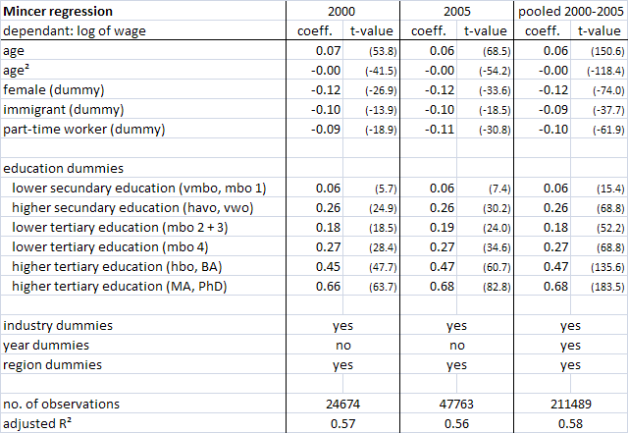

Note 1: t–statistics (in absolute values) are reported between parentheses; all coefficients are significant at the 1% level.

Note 2: education dummies denote the highest qualification obtained; the omitted category is formed by individuals with only primary education

There is a moderate relation with average regional wages, as Table 4.1 indicated, but there are notable exceptions to this and differences between neighbouring regions are often statistically insignificant. The experience premium is estimated to be somewhat higher in cities than in less densely populated areas, and shows a pattern that is comparable to the distribution of average wages across space. A possible explanation is that the observed differences are the result of differences in the type of jobs in the different regions.

|  |  |
| --- | --- |
| F:\4 Onderzoek\4-3i Lonen\graph_age.png | dummies.png |
| Figure 4.2: Non-linear effect of age (age and age² combined) | Figure 4.3: Estimated effect of some dummy variables on wage |

The dummies estimated for each NUTS-3 area represent a spatial residual. Since we left out the dummy for the region with the lowest residual (Zuidwest-Friesland), the estimated spatial residuals can be interpreted as the premium workers with equal characteristics can earn in a region, relative to the omitted region. Zuidwest-Friesland also happens to be the region were the lowest average wages were paid; the highest premium is paid in the Amsterdam region. When we compare the results presented in Figure 4.4 with those on the distribution of average wages presented in Figure 4.1 (average paid wages are – according to Table 4.1 – very strongly correlated to the spatial residual), it can be observed that the spatial residual is generally higher in the Randstad.

|  |
| --- |
| residual from panel (average) |
| Figure 4.4: Average spatial residual by NUTS-3 area (2000-2005) |

## Explanation of the spatial residual

We now turn to an explanation of the spatial residual, following the approach developed in Combes, Duranton & Gobillon 2008. The spatial residual is the part of variety in wages that is not explained by employee characteristics. We do this by applying a two-stage regression. To increase the number of observations, we will use a panel of cross sections instead of single years. In the first stage we re-estimate the Mincer equation (1), but instead of region dummies we include a dummy for each combination of industry *i*, region *r* and year *t*.

|  |  |  |
| --- | --- | --- |
|  | $$\log\left(w_{i}\right)=α+\sum_{edu=1}^{8}{β_{1,edu}D_{edu}}+β_{2}{age}_{i}+β_{3}{age}_{i}^{2}+β_{4}D_{gender}++β_{5}D_{immigrant}+β_{6}D_{parttime}+\sum_{i}{\sum_{r}{\sum_{t}{γ_{irt}D_{i}D_{r}D_{t}}}}+ε_{i}$$ | (18) |

As shown in Table 4.3, estimated coefficients are comparable to those estimated in the previous section.

Table 4.3. Mincer regression including industry × region dummies

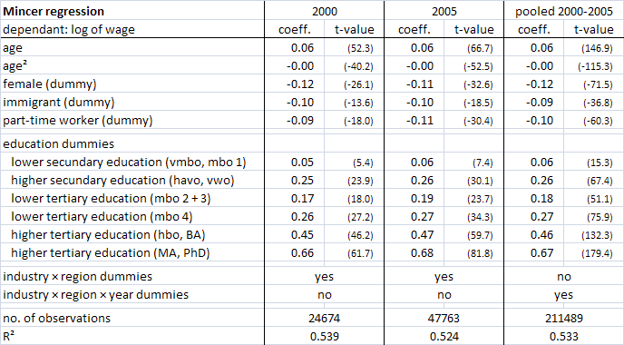

Note 1: all coefficients are significant at the 1% level.

Note 2: education dummies denote the highest qualification obtained; the omitted category is formed by individuals with only primary education.

As discussed in the previous section, we will also compute a spatial residual using worker-specific fixed effects. Using the full 1999-2005 panel of tax statements data, we are able to follow workers over time and jobs. We then estimate the following:

|  |  |  |
| --- | --- | --- |
|  | $$\log\left(w_{worker}\right)=\sum_{worker=1}^{N}{β_{worker}D_{worker}}+\sum_{i}{\sum_{r}{\sum_{t}{γ_{irt}D_{i}D_{r}D_{t}}}}+ε_{worker}$$ | (19) |

When we use fixed effects in this way, a spatial residual can be identified on workers that change jobs to another region or industry. Absolute wage differences are averaged out over workers. For 4.2 million workers two or more observations are available. Over the entire period we have 20.1 million observations, equivalent to 4.8 observations per employee. Within this sample, there are 630,000 job changes. In the second stage of our analysis we explain the resulting residual (a premium paid to employees in a certain industry and region) by a set of geographical variables, to test for the presence of different types of agglomeration externalities. As a first attempt, we include four variables:

* the total number of employees in each region (an urbanization effect: *U\_dens*),
* employment in each industry and region (a specialization effect: *S\_share*),
* Shannon’s entropy (a diversity effect: *D\_shann*),
* and, as a control, *area*.

The instruments we use to measure agglomeration forces have been introduced more extensively in Section 4.1. We estimate the following regression:

|  |  |  |
| --- | --- | --- |
|  | $$γ_{irt}=α+β_{1}\log{E_{rt}}+β_{2}{sshare}_{irt}+β_{3}{dshann}_{rt}+β_{4}\log{{area}_{rt}}+\sum_{i}{β_{5,i}D_{i}}+\sum_{t}{β_{6,t}D_{t}}+ε_{irt}$$ | (20) |

In this regression, we have 8,034 observations when we use NUTS-3 data, and 29,586 when using municipality data.

The interpretation of the results presented in Table 4.4 is that – according to the Mincer equation residuals on the NUTS-3 level – a 1% increase of density of employees working in a region is associated with a 3.4% higher wage on average. We do not find any significant relation between the residual wage component and diversity. The workers fixed effects residuals predict a much lower effect of both employment density and industry share, with an employment density elasticity of 1.0%. This figure is rather lower than what is usually found in the literature (see Melo, Graham & Noland 2009). This fact underlines the importance of sorting as a mechanism driving regional variation in wages, and is consistent with the findings of Combes, Mayer and Thisse (2008).

Table 4.4: Explaining the spatial residual

|  |  |  |  |  |  |  |  |  |
| --- | --- | --- | --- | --- | --- | --- | --- | --- |
| **Regression on the residual** | Corop regions | | | | municipalities | | | |
| dependant: residual from | Mincer | | fixed effects | | Mincer | | fixed effects | |
| fixed effects regression | coeff. | t-value | coeff. | t-value | coeff. | t-value | coeff. | t-value |
| S\_share | \*\*0.021 | (9.2) | \*\*0.004 | (5.3) | \*\*0.014 | (12.1) | \*\*0.005 | (10.1) |
| D\_shann | -0.010 | (-0.8) | -0.008 | (-1.1) | -0.006 | (-1.4) | \*\*0.005 | (5.0) |
| U\_dens | \*\*0.034 | (10.5) | \*\*0.010 | (6.9) | \*\*0.017 | (11.5) | \*\*0.006 | (10.7) |
| area | 0.004 | (-1.1) | \*\*0.008 | (4.1) | \*\*0.008 | (4.1) | 0.000 | (0.3) |
|  |  | |  | |  |  |  |  |
| industry dummies | yes | | yes | | yes | | yes | |
| year dummies | yes | | yes | | yes | | yes | |
|  |  |  |  |  |  |  |  |  |
| no. of observations | 7212 | | 11497 | | 31636 | | 29286 | |
| adjusted R² | 0.308 | | 0.012 | | 0.158 | | 0.025 | |

Note: \* indicates significance at the 10% level, \*\* at the 5% level.

Comparing the residuals from the Mincer equation with those from the fixed-effects estimation, we see that the better an estimation strategy accounts for hetero­geneity in worker charac­te­ristics, the less agglomeration effects are found. However, the low R² even for the Mincer residuals suggests that these geogra­phical variables explain only a limited part of the residual wage component. Especially the explanatory power after correcting for all worker characte­ris­tics is very small. For comparison, we again replicated the analyses on municipality level. Esti­mated coefficients are smaller and less significant than those for the NUTS-3 local labour market areas. This could be due to the fact that differences between municipalities are much larger than those that exist between local labour market areas, and that we capture a different type of effects than those that are the topic of this Chapter.

We now turn to a test of different agglomeration variables, as defined in Section 4.4.3. We ran regressions on the residual with among the independent variables a combination of three agglo­mera­tion variables: one for specialization, one for competition and one for diversity. The correlation matrix for these nine variables is given in Table 4.5.

Table 4.5: Correlations between agglomeration variables

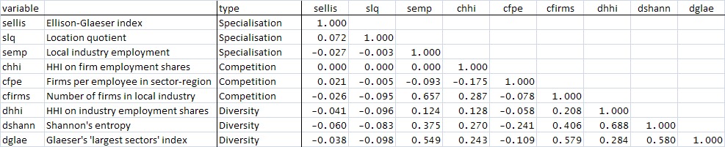

We then estimate the following regression equation at the NUTS-3 level:

|  |  |  |
| --- | --- | --- |
|  | $$\log\left(w_{i}\right)=α+\sum_{edu=1}^{8}{β_{1,edu}D_{edu}}+β_{2}{age}_{i}+β_{3}{age}_{i}^{2}+β_{4}D_{gender}+β_{5}D_{immigrant}+β_{6}D_{parttime}+β_{7}SPEC+β_{8}COMP+β_{9}VARY+\sum_{i}{β_{10,i}D_{i}}+\sum_{t}{β_{11,t}D_{t}}+ε_{i}$$ | (21) |

For each definition of the specialization variable, there are 3×3 estimations, with each of the variables for competition and diversity in turn. Moreover, we repeated the complete set of 3³=27 estimations with the additional inclusion of three urbanization variables: *U\_dens*, *area* and *U\_fdens*, which is the density of firms within a sector. We can therefore visualize the t-values of the estimated coefficients in the box-and-whisker plots of Figures 4.5 and 4.6.[[66]](#footnote-66)

|  |
| --- |
| F:\4 Onderzoek\4-3i Lonen\t-values noag.png  Figure 4.5: Results for agglomeration variables when urbanization controls are not included  Note 1: the t-values -2 and 2, between which results are not significant at the 5% level, have been indicated.  Note 2: variable names are as discussed in Section 4.2 |
| F:\4 Onderzoek\4-3i Lonen\t-values agg.png  Figure 4.6: results for agglomeration variables when urbanization controls are included  Notes: see Figure 4.5 |

We note that some variables are especially robust to the inclusion of other agglomeration variables: for example, the Ellison-Glaeser index *S\_ellis*, hardly varies across the 2×9 estimations, in keeping with its low correlation with all other agglomeration variables (see Table 4.5). The spread of the results found is also smaller when urbanization variables are *not* included, though the significance levels are quite a lot lower for most variables. Most remarkable is Shannon’s entropy, *D\_shann*, which shows significantly posi­tive results (t-values mostly between +10 and +20[[67]](#footnote-67)) when urbanization variables are included, but almost insignificant and certainly negative values when urbanization controls are excluded. These results confirm our findings in Chapter 3, where we saw that in empirical analyses, the specification of variables matters for the effect that will be found.

## Aggregated data

To compare our work with previous research that did not use microdata, we have also aggregated our data to estimate agglomeration effects. Our regional averages were calcu­lated directly from the microdata. The left-hand section of Table 4.6 shows an employ­ment density elasticity of 0.040 for NUTS-3 regions. This implies that doubling the number of workers on a given area results in a 4.0% increase of productivity. This figure is within the range of the 3–8% found in the meta-analysis of Melo, Graham and Noland (2009), but lower than the 18% found by Gorter and Kok (2009). Yet Gorter and Kok use pro­duc­tion density instead of employment density, and the high elasticity they find can well be the result of the fact that they use aggregate data and do not correct for worker characteristics. Our findings can moreover be contrasted with Van Soest, Gerking & Van Oort 2002, who found that an increase in the share of a sector led to a 5.3% decreasein employment growth; yet we saw in Chapter 3 that studies focusing on employment growth are more likely to find negative results for specialization.

To see how our figures change when we would use a different (more detailed) level of regional aggregation, we repeated our regression using municipalities instead of NUTS-3 areas. We now found an elasticity of 1.3%. This much lower figure could be due to unobserved heterogeneity when using the COROP classi­fi­ca­tion. As differences in density and economic activities can be very large at the mu­ni­­cipality level (e.g. a small village can neighbour a large city), the agglo­me­ration parameters might be identified on differences between cities and the countryside instead of more moderate differences that exist between local labour market areas. As variety in density is larger than variety of average wages, this is likely to result in a lower elasticity between employment density and ave­rage wages.

Combes, Duranton and Gobillon (2008) as well as Combes, Mayer and Thisse (2008) have pointed out that aggregate regional data (especially average sectoral composition and worker characteristics) do not sufficiently correct for worker and firm characteristics. The remai­ning unobserved heterogeneity will result in an upward bias when estimating agglo­meration economies. Melo, Graham and Noland (2009) support this observation in their meta-analyses of 34 studies, finding that the use of macrodata generally results in higher elasticities than the use of microdata.

Table 4.6. Explaining regional productivity differences

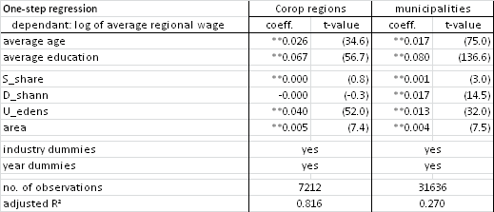

## Conclusions

The first part of this chapter described differences in wages between NUTS-3 regions in the Nether­lands. We confirmed the common knowledge that wages are higher in the Randstad than in the rest of the Netherlands. Also, average wages are relatively comparable among neigh­bouring NUTS-3 regions.

Estimation of the Mincer equation for different regions showed no clear pattern for the skill premium, while the experience premium is higher in more densely populated areas, especially in the largest cities. A geographical representation of the spatial residual showed that, once more, workers in densely populated areas get paid a premium. The spatial residual, which is corrected for observed worker hetero­geneity, is strongly correlated to average regional wage.

We then related the residual wage component, e.g. the part of variety in wages that was not explained by employee characteristics, to agglomeration variables. We esti­mated agglomeration effects using two types of residuals: that of the Mincer equation and that of a worker fixed effects regression. We found that the total size of the regional labour market has a significant and positive effect on wages, even though this explained a relatively small part of the resi­dual wage component. Using the Mincer residuals on the NUTS-3 level, we found an employment density elasticity of 3.4%, and some proof for MAR externalities, where doubling the share of an industry would result in a 2.1% higher productivity. Using residuals from the worker fixed effects regression did not change the general findings, but resulted in an employ­ment density elasticity of 1.0% and a 0.4% productivity increase when the industry share would be doubled. Since including worker fixed effects corrects for all worker heterogeneity, the lower agglome­ration effects that are found when using this data could indicate that a part of the effects that were estimated when using Mincer residuals are still due to unobserved hetero­geneity.

We tested agglomeration economies at both the Corop and the municipality level. The coeffi­cients we found were smaller at the municipality level; but the variation in wages is also larger between municipalities than it is between Corop regions, so this result was not unexpected. We will return to the topic of the regional aggregation level in Chapter 6: there, we will employ dyna­mic boundaries instead of fixed ones.

The agglomeration economies we estimated are lower than those estimated in previous work of Gorter and Kok (2009), but correspond to what is found in existing literature by Combes, Duranton and Gobillon (2008) and Melo, Graham and Noland (2009). The current work supports the finding that the sizes of estimates are to a large extent determined by the ability of the data and methods that are used to correct for regional and individual heterogeneity.

# The influence of firm characteristics vs. regional externalities on innovation

## Introduction[[68]](#footnote-68)

As we discussed in Chapter 1, evidence on the determinants of regional growth at the micro-level is scarce. The lack of micro-based evidence is largely because of limited data-availability. This is unfortunate since the individual firm is the main actor, and not the region (see Beugelsdijk 2007). We attempt to fill this gap by studying the influence of characteristics at the firmlevel in tandem with agglomeration forces at the regional level.

Microdata at the *firm level* have the important advantage of bringing us back to the level at which the action is taking place. Microdata can help to bridge the gap between the level of individual entrepreneurs and the regional level, on which most of the literature is based. In this chapter, we therefore focus on the relationship between the region and the individual firm, combining microdata with regional data in order to estimate the probability that individual firms introduce an innovation. Our microdata focus on what is called the ‘absorptivecapacity’ of individual firms in identifying, adapting and commercializing innovative products and services that originate from both inside and outside their region. In addition to the factors affecting innovative activity, we also control for government policies and obstacles to innovation.

At the *regional level*, three main externalities are generally acknowledged to have a positive influence on the city economy as a whole: localization economies, competition, and diversity. We have amply discussed these in Chapter 2 from a theoretical viewpoint, and have given an overview of the literature on these externalities in Chapter 3. In this chapter, we will stick closely to Glaeser’s trifold operationalization of Marshall-Arrow-Romer (MAR), Porter and Jacobs variables, as we did in Chapter 4. In this respect, our analysis differs from that of Baldwin et al. (2008), who also combine micro- and macrodata, but employ a different set of regional variables, focusing on market potential, the labour market, and the supply chain, in addition to the raw number of firms within a sector (which might serve as a rough measure of specialization or competition). We also choose not to consider the effect of technological frontiers and the ensuing potential for catching up (Abramovitz 1986; Silverberg & Verspagen 1994). Doing so would have required a larger data set, with more technology-related variables, and would, moreover, have called for sector-specific regressions, whereas in our current analyses we can include almost the whole economy.

An important goal of this chapter is to explain innovation as a function of firm-specific characteristics, on the one hand, and agglomeration externalities, on the other, using a unique set of micro- and census data. In the extensive literature on innovation, some have advocated a regional approach, using the concept of a regional innovation system (Asheim & Isaksen 1997; Braczyk, Cooke & Heidenreich 1998; Cooke 1992; Cooke 2001). These studies argue that the spatial scope of knowledge-exchange interaction is limited, and that the regional dimension is therefore important, both for firm-to-firm contacts and for contacts between firms and universities (Ponds, Van Oort & Frenken 2007). A regional innovation system then has a certain capability of “acquiring and using new economic knowledge” (Simmie et al. 2002, p. 50). However, a regional segmentation of space has its problems. Treating regions as homogeneous is a simplification of reality, no matter how organic their formation.[[69]](#footnote-69) Moreover, they tend to overemphasize the role of geographical distance in relation to other types of proximity (Boschma 2005b; Sternberg 2007). However, the use of regions is often a necessary evil because of constraints in data availability and in modelling – Keating (1998, pp. 3­–4) calls this the ‘distorting effects’ of convenience and parsimony. In our analysis, we will highlight several possible shortcomings of the regional approach in those cases where we are limited to the use of regional data.

We do not restrict our analysis to innovations that are new to the market, but instead include both breakthrough innovations and imitative innovations (see Capello 2001). Imitative or ‘defensive’ innovations are innovations which a firm has not itself intro­duced, but adopts from outside the firm, adapting them to the circumstances of the firm. Alternatively, they may even lead to reorganization in the firm itself in the process; these are so-called ‘micro-innovations’ (Mokyr 1990, pp. 12-13). In this process, firms are aided by knowledge, organization, and previous R&D performed in the firm (Cohen & Levinthal 1989). These innovations are necessary to keep up with the competition, whether it be in the cost of the production process and thus the price of the final product, or in labour circumstances for employees, or just to incorporate knowledge needed for future attempts at breakthrough innovations.[[70]](#footnote-70) In addition, these imitations are often more profitable for the individual firm than costly breakthrough innovations, and thus they link innovation at the microeconomic level to economic growth at the macroeconomic level (Geisendorf 2007).

Part of the differences in innovativeness between different firms can be explained by regional effects, but internal factors also play a role. These can be manifold, ranging from the skills of individual entrepreneurs and managers to the time that staff spend on keeping up with scientific progress and the like in their field (Acs, Carlsson & Thurik 1996; Acs & Varga 2005). Research and development (R&D) carried out by firms in the region plays a dual role, since it contributes to the build-up of internal knowledge in the firm (and hence the region), and acts as a direct input into the innovation process (Cohen & Levinthal 1989; Cohen & Levinthal 1990, Zahra & George 2002). The absorptive capacity of firms, defined in a seminal paper by Cohen and Levinthal (1990, p. 569) as *“the ability to identify, assimilate and exploit knowledge from the environment”*, determines how firms react to innovations developed within the firm and elsewhere, and how this knowledge is used in the development of future products and services. Although, in its original form, the concept focused on R&D, it has been extended to incorporate organizational form, networks, management and communication processes, and the human capital of the workforce (Dyer & Singh 1998; Lane & Lubatkin 1998; Zahra & George 2002). In this chapter we take a broad view of absorptive capacity, and operationalize[[71]](#footnote-71) absorptive capacity using measures of human capital, R&D, management and organizational form, and collaborative links, following Abreu et al. (2008). They define absorptive capacity as referring to *“the ability to assimilate and manage knowledge in order to improve innovation performance and comparative advantage.”*

We are not the first to combine externalities and ‘internalities’ in one analysis. Recently, a small number of articles has appeared that pursue their analysis along this dichotomy: for example, Coronado, Acosta and Fernández (2008) discuss a basic ‘attitude to innovation’ of individual firms vis-à-vis general urbanization effects, Beugelsdijk 2007 matches firm data with data on the regional characteristics of R&D, and Mitra 1999 joins a production function at the firm level with urbanization in an analysis of the electrical machinery and cotton industries India. In the CIS literature there are also earlier appearances: for example, Cabagnols and Le Bas (2002) use CIS1 to predict innovation while controlling for market conditions, among which two measures for competition.

The remainder of this Chapter is organized as follows. In the next sections, we will discuss the data we use (Section 5.2), and then proceed to analyse the propensity to innovate among all firms in the Dutch Community Innovation Survey of 2004 (Section 5.3). Our focus will be on a set of firm-specific variables from the CIS and a set of agglomeration variables that we constructed from the Dutch General Business Register. Section 0 concludes.

## Data

To test the concept of absorptive capacity, firm-level data on innovation for the Netherlands are available from the Fourth Community Innovation Survey (CIS4 – see Chapter 1). In the Netherlands, a 10% sample of firms with 10 to 100 employees received a questionnaire.[[72]](#footnote-72) Among firms with more than 100 employees,[[73]](#footnote-73) a census was taken, and they all received a ques­tion­naire. The total response rate was about 70%.[[74]](#footnote-74) Weights have been calculated by Statistics Netherlands so that the weighted results can be treated as representative for the Dutch economy as far as sectoral and size distribution are concerned. However, the regional distribution of firms has not been taken into account when constructing the sample for this survey, so that we cannot easily generalize the results of the CIS4 at a regional level. Some limitations remain: foremost among these is the fact that we cannot quantify the importance or ‘size’ of an innovation. We therefore pursue what Godin 2009 calls a ‘subject approach’: we are interested in the question whether a firm is innovating, not in the number of innovations it produces.

We have a different source to construct our regional agglomeration variables; we take those from the General Business Register (ABR), which is a census, covering all establishments; we also used this dataset in Chapter 4. To account for regional characteristics that are not related to agglomeration as such, we will include a regional dummy for each of the 12 provinces, which constitute the NUTS2 level.

The following available indicators from the Fourth Community Innovation Survey are relevant for our study:

* R&D intensity: the resources a firm spends on R&D. These resources can be measured both in terms of employees and in terms of expenditure; the CIS4 contains both. Much has been said about the reliability of R&D as a predictor of, or as a proxy for, innovation (Archibugi, Cesaratto & Sirilli 1991; Francoz 2000), but here we use R&D intensity as an input and as a control variable, not as a measure of innovation.
* Human capital: the level of education present within a firm. As the concept of learning is closely associated with innovativeness, a higher level of human capital facilitates adoption processes and knowledge spillovers within a firm. The Dutch version of the CIS4 does not contain the level of education as such, but it does contain a question about whether a firm arranged training for its employees.[[75]](#footnote-75)
* Management: whether a firm has adopted new management techniques in the previous three years. Changes in a firm’s management techniques could indicate a flexible and adaptive firm culture, which would favour knowledge transfer and application.
* Collaborations: whether a firm cooperates with other firms, higher education institutions, consultants and government agencies; and whether these collaborations are within the Netherlands or outside the country.[[76]](#footnote-76)
* Market scope: a firm involved in international markets may be under greater pressure to innovate; at the same time, international contacts may encourage and aid innovation. We distinguish between firms that operate only within the Netherlands, firms that operate only outside the Netherlands and firms that operate both inside and outside the country.
* Obstacles: financial and market obstacles, but also constraints related to the availability of knowledge may impede innovation (see Iammarino, Sanna Randaccio & Savona 2006 and Mohnen et al. 2008).
* Subsidies: financial incentives to pursue innovation, for which the source is identified in the CIS4 as either local, national, or European. Subsidies are notoriously complex in that governments can either try to pick the winners or fund the less privileged; both strategies influence the effectiveness of subsidies. In addition, subsidies can replace investments a firm would otherwise have undertaken itself (Garcia-Quevedo 2004).

Descriptive statistics of the variables included in the analysis are provided in .

Table 5.1: Descriptive statistics for the CIS variables

|  |  |  |  |
| --- | --- | --- | --- |
| Variable | Type | Mean | St.dev. |
| Firm has innovated (good) | dummy (dependant) | 0.16 | 0.37 |
| Firm has innovated (service) | dummy (dependant) | 0.12 | 0.33 |
| Firm has innovated (process) | dummy (dependant) | 0.24 | 0.43 |
| Log of R&D expenditure | continuous | 1.02 | 2.16 |
| Log of R&D staff | continuous | 0.18 | 0.82 |
| Log of total firm employment | continuous | 3.93 | 1.31 |
| Training | dummy | 0.17 | 0.38 |
| New management techniques | dummy | 0.16 | 0.37 |
| New organizational structure | dummy | 0.23 | 0.42 |
| New marketing strategies | dummy | 0.07 | 0.26 |
| Collaborations: national | dummy | 0.15 | 0.35 |
| Collaborations: EU | dummy | 0.08 | 0.28 |
| Collaborations: beyond EU | dummy | 0.04 | 0.19 |
| Obstacles: Finance | dummy | 0.50 | 0.50 |
| Obstacles: Knowledge | dummy | 0.16 | 0.36 |
| Obstacles: Market | dummy | 0.44 | 0.50 |
| Obstacles: Other | dummy | 0.54 | 0.50 |
| Local and Regional Public Support | dummy | 0.02 | 0.15 |
| Central Govt. Public Support | dummy | 0.11 | 0.32 |
| EU Public Support | dummy | 0.03 | 0.16 |
| Firm operates nationally and internationally | dummy[[77]](#footnote-77) | 0.37 | 0.48 |

For the agglomeration variables, we have chosen the European NUTS-3 level, which is equivalent to the Corop regions. The Netherlands has 40 Corop regions, which approximate labour market regions (see Figure 5.1).[[78]](#footnote-78) For this reason, and for reasons of comparability with other regions, we use these predefined regions, even though basic microdata on all firms in the Netherlands exist through the General Business Register (ABR), which could be used to construct any type of region – for example, circular regions around each observation, as is done, for example, in Staber 2001. However, we feel that there are two compelling reasons not to use this approach, in addition to the comparability argument discussed above. First, circular regions give a false sense of preciseness, as we have not advanced beyond the disadvantages of the predefined region, which we discussed above. Second, circular regions do not reflect the true spatial playing field of a firm. The spatial environment of a firm can take different shapes for different aspects of its outside relationships. For example, such a playing field is often shaped by infrastructure. To   
  
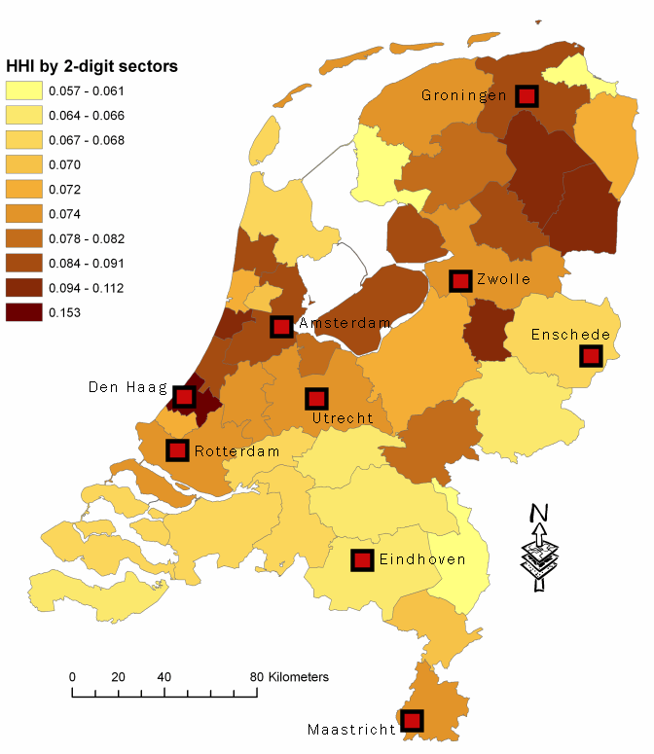

Figure 5.1: Diversity in the 40 NUTS3 (Corop) regions of the Netherlands:  
Hirschman-Herfindahl index (HHI) by 2-digit SBI code

model networks we would need, for example, to model the use of travel time over physical infrastructure, or the reliability of broadband connections for data infrastructure. As a final argument in favour of existing regions, we can point to the important the role of public institutions, which most often are defined by historical regions. For these reasons, we decided against building our own regions. Yet we are aware that the 40 regions we chose to employ are quite large; some of them measure 50 km across, corresponding on average to half an hour driving time from edge to centre. Our results on agglomeration are therefore only valid for this specific scale.

To test for the importance of specialization, competition and diversity in explaining variation in innovation across firms, we chose three commonly-used statistics. These are, respectively:

(i) a location quotient (the share number of employees in a sector in a region divided by the national share of the sector);

(ii) the average firm size in a sector in a region; and

(iii) a Hirschman-Herfindahl index on sectoral shares within a region.[[79]](#footnote-79)

For all three factors we had to choose a level of sectoral aggregation. Since we base our indices on the General Business Register, we know the four-digit class of each firm according to the *Nomenclature statistique des activités économiques dans la Communauté Européenne* (NACE, revision 1), to which the SBI definition (version 1993) of Statistics Netherlands is completely equivalent up to the four-digit level. At the two-digit level, the NACE and thus also the SBI are equivalent to the ISIC definition of the United Nations (revision 3.1).[[80]](#footnote-80) We chose to test the significance of these agglomeration variables at four different sectoral levels: at the 4-digit, 3-digit, and 2-digit levels of the SBI definition, and grouped into eight macrosectors, following the definition of Pavitt (1984), which is also used in Abreu et al. 2008.[[81]](#footnote-81) As different types of innovation exist in technologically similar industries, similarities between industries cut across traditional, product-defined sectors: these are called technological regimes or technological paradigms.[[82]](#footnote-82) In our empirical chapters, we will therefore employ an industry classification that takes these similarities into account. It was devised by Keith Pavitt (1984)[[83]](#footnote-83), and divides the economy into eight sectors, as follows:

* Primary
* Science-based
* Specialized suppliers
* Scale-intensive
* Supplier-dominated
* Information-intensive
* Knowledge-intensive business sectors (KIBS)
* Traditional services

Appendix B gives a translation table from the standard SBI classification to these eight Pavitt sectors; Table 5.2 illustrates the innovativity of Dutch firms by sector.

To control for urbanization effects, we also include an urbanization variable. Urbanization is defined by Statistics Netherlands using five classes, based on address density per km²; this includes both households and firms. Although this data is also available as a continuous variable, we prefer the five classes, as they allow for non-linear effects, similar to the use of spline functions – except in our case the functions only consist of a constant. Our hypothesis is that the core region will have an advantage over the periphery, but where exactly the boundary between cores and peripheries lies in the Netherlands has never been conclusively established. The data we use for this variable are for 2003.

Table 5.2. Innovation across Pavitt sectors (percentage of firms innovating). Source: CIS4.

|  |  |  |  |  |  |  |  |
| --- | --- | --- | --- | --- | --- | --- | --- |
| innovations  sector | Product and process innovation | Product innovation | Process innovation, and new product in firm | Process innovation | No innovation, but new product in firm | No innovation | Total number of firms |
| Primary | 8% | 4% | 3% | 10% | 2% | 73% | 1,832 |
| Science-based | 19% | 7% | 6% | 10% | 4% | 54% | 1,418 |
| Specialized suppliers | 18% | 13% | 5% | 9% | 4% | 51% | 2,731 |
| Scale-intensive | 6% | 2% | 2% | 7% | 2% | 82% | 15,906 |
| Supplier-dominated | 10% | 5% | 5% | 11% | 3% | 66% | 3,136 |
| Information-intensive | 7% | 4% | 4% | 10% | 4% | 71% | 1,181 |
| KIBS | 8% | 6% | 4% | 8% | 3% | 71% | 9,495 |
| Traditional services | 4% | 4% | 3% | 6% | 3% | 81% | 20,604 |
| Total | 7% | 4% | 3% | 7% | 3% | 76% | 56,303 |

## Analysis

### Internal factors

We performed probit analyses for the probability that a firm has introduced a new good, service or process in the years 2002-2004. We did this twice for each type of innovation: first, we used as explanatory variables the internal variables that we consider indicators of absorptive capacity. We also include here dummies for the 8 Pavitt sectors and the 12 provinces (Table 5.3). In a second analysis (see Table 5.4), we added external factors: the three types of agglomeration variables, interacted with the eight sectors, so that we allow sector-specific sensitivity to different types of agglomeration externalities. At this stage, we also added the variable for urbanization effects. We will now discuss the main results of both analyses.

Concerning the internal, firm-level variables, we see that most variables have the expected effect, and the number of significant variables is very high. For example, training employees, and changing the organizational structure (which we can take as a proxy for the organizational flexibility of a firm) have a positive effect for all types of innovation. For some variables the results are clearly different between the three types of innovation. Receiving subsidies, for example, has a positive effect on goods innovations, as do collaborations at any scale. For services, however, subsidies have no or hardly any significant effect, and for process innovation only local subsidies have any influence. Financial obstacles are of no importance; knowledge obstacles (for process innovation) and market obstacles (for goods and service innovation) have a positive effect. These results are partly explained by Mohnen et al. (2008, p. 11): they succinctly state that “innovating firms are more likely than non-innovating firms to perceive the various obstacles that stand in their way.” Particularly in the case of process innovation and knowledge obstacles, we might note that the questionnaire does not set the question on obstacles specifically in the context of one of the subtypes of innovation. Firms that are innovative, and have managed to perform a process innovation, not only might be more aware of the factors that prohibited further innovation, but might also feel that they would have wanted to be even more innovative – for example by successfully completing a product innovation as well.

Collaborations at the international level (i.e. outside the EU; in particular, we should think of the USA and Japan, but possibly also of China) do not matter significantly for process innovations. Surprisingly, collaborations with other firms in the EU go together with a lower propensity to innovate in services. It is possible that this dummy is negative because it often occurs hand in hand with national collaborations (ρ = 0.63): for national collaborations, the dummy has a large positive value, so that their combined effect can still be positive. At the same time, those firms that have adopted a more European outlook might be the more mature firms that are focusing on expansion rather than innovation of service products; but the correlation between employment size, as a rough proxy for age, and collaborations with other firms in the EU is low (ρ = 0.24).[[84]](#footnote-84) Another interesting result is the significantly positive effect of being active on both national and international markets, whereas operating only on the international market does not have a significant effect.

In all six estimations, we see significant results for R&D expenditure, R&D staff, and total staff. The relationship between R&D expenditure and innovation is positive, although it does not imply that R&D is a necessary condition, nor that all sectors benefit from R&D. In fact, R&D staff always has a *negative* coefficient, implying that, ceteris paribus,firms with less R&D staff are more likely to innovate. [[85]](#footnote-85) The propensity to innovate increases with firm size, as Coronado, Acosta and Fernández (2008) hypothesized, but not for goods innovations, where our results partially contradict Davelaar (1989, p. 252) who studied an early innovation survey of Dutch firms in 1983, finding that larger firms are more innovative *both* in product and in process innovations. The combination of a negative sign for goods innovations with a positive sign for process innovations might be explained by a change in focus as firms grow and age; mature firms are already in a well-established position in the market, and compete on prices, therefore focusing on process innovation.

Our regional dummies, which can be found in Table 5.5, show statistically highly significant results for service innovation. Especially the Randstad, but also the intermediate zone of Gelderland and even Zeeland, all have an a priori higher potential for service innovation than our omitted category, which is the Province of Groningen. That Province traditionally has a stronger emphasis on agriculture and associated industries, and to some degree on resource extraction (natural gas), but when we use a size threshold of 10 employees, as the CIS sample does, then Groningen has a sectoral structure not unlike most other provinces – in fact, it has more knowledge intensive business services (KIBS) than any other province outside the Randstad (see Appendix C). We therefore do not see any sectoral portfolio effect. Instead, because Friesland, Noord-Brabant and Limburg are the other provinces that have insignificant coefficients (at the 5% level), although these are not really close to zero, we conclude that there is a classic core-periphery effect at work here. However, as always, the direction of cause and effect is difficult to determine: it might be that more innovative firms move to the Randstad, or it might be that firms moving to the Randstad become more innovative. Basic agglomeration effects or the absorptive capacity variables do not capture all of these effects, and the entrepreneurs’ perceptions and beliefs might play an important role here (see Smit 2008).

When we look at the pure (non-interacted) sector dummies, we see that they act as expected; science-based firms do not innovate much in services, while information intensive and knowledge-based business services (KIBS) do. These last two, in turn, are quite unlikely to perform or implement goods innovation. In process innovation, specialized suppliers, KIBS and traditional services score significantly less than the omitted category, which is labelled ‘primary’, but actually consists of mining and quarrying (see Appendix B).

### Internal and external factors

We now turn to the regression results that incorporate the agglomeration variables. We note first of all that the main (non-interacted) agglomeration variables have no statistically significant impact except for the positive influence of competition on process innovation. This effect runs contrary to what Cabagnols and Le Bas (2002) found in the French CIS1; but according to them, the effect of competition on product vs. process innovation varies throughout the literature. For the interacted effects, only five have a coefficient that is statistically significant at the 5% level:

* specialization has a negative effect on goods innovation in information intensive services;
* specialization has a negative effect on service innovation in traditional services;
* diversity has a negative effect[[86]](#footnote-86) on service innovation in science-based firms;
* diversity has a positive effect on goods innovation in knowledge-intensive business services; and
* competition has a negative effect on process innovation in scale-intensive industries.

The general absence of significant relations is in itself an interesting result, which is significantly different from most of the studies we included in our meta-analysis in Chapter 3. Although many of the studies included there reported some insignificant results, only three estimates that included all three effects found only insignificant results across the board.

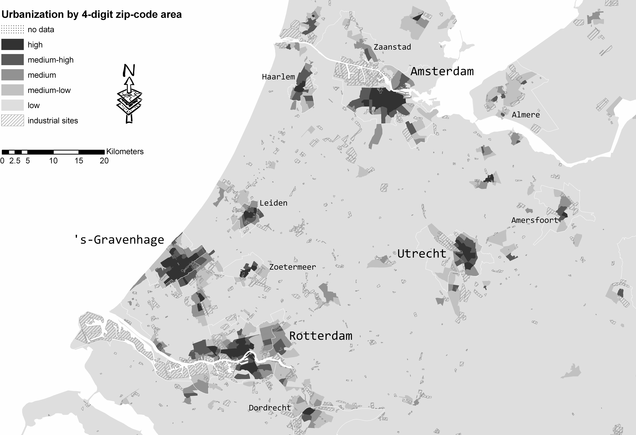

Figure 5.2: Urbanization in the Randstad area

Note 1: Municipalities with more than 100.000 inhabitants have been indicated with their borders; areas marked as industrial sites have also been indicated (data from IBIS are for 2007).

We tested the robustness of our results by leaving out the regional dummies or the collaboration variable: but leaving these out produced more or less the same significance levels for all agglomeration variables. We might think the absence of significant results may relate to our definition of innovation as any new product which is new *to the firm* itself, and not necessarily to the market as a whole; in this way, imitative innovations are also included, and for those the effects of specialization, competition and variety can differ from their effects on breakthrough innovations. Yet we believe imitative innovations are important for, and positively related to, productivity and employment growth.[[87]](#footnote-87)

The urbanization variables, which we have included as dummies for the five classes defined by Statistics Netherlands in order to capture possible nonlinear effects, show significant hetero­geneity for product innovation: in all four included urbanization categories (see Figure 5.2) the probability of product innovation is higher than in the ‘highly urbanized’ reference category. The effect is largest for the middle category, which typically includes the fringes of large cities, or the cores of small cities. That this effect cannot be due to the location of industrial sites is apparent from Figure 5.2: almost all industrial sites are located in the least urbanized areas. A lack of urbanization results has been found elsewhere as well; and if we test our specification in the meta-analysis of Melo, Graham and Noland (2009), we see that given the setting of our analysis, no large effect was to be predicted.[[88]](#footnote-88) Yet for service innovations we find no effect of urbanization at all, which is contrary to our expectations; following Carlino, Chatterjee and Hunt (2007, p. 398), we hypothesized that density encourages ‘the flow of ideas that generate innovation and growth’, especially in services.

Table 5.3: Probit results: firm variables only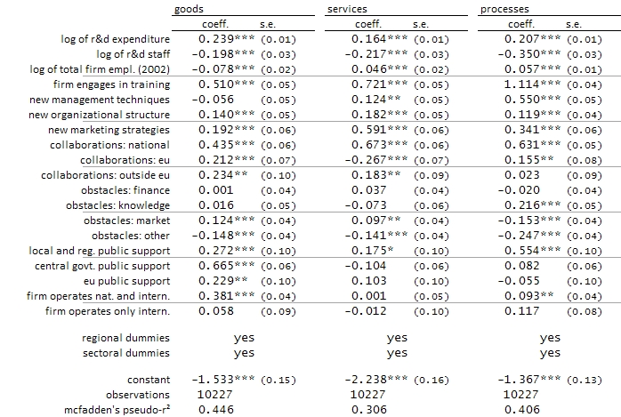

Note: in all regressions in this chapter, the dependent variable is whether a firm has introduced an innovation (0=no, 1=yes).

Table 5.4: Probit results: both firm and agglomeration variables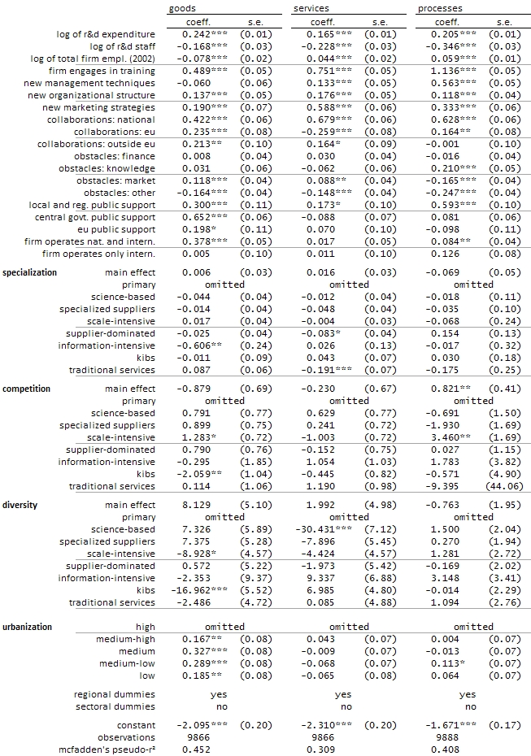

Table 5.5: Dummy variable results for Table 5.3 (top) and Table 5.4 (bottom)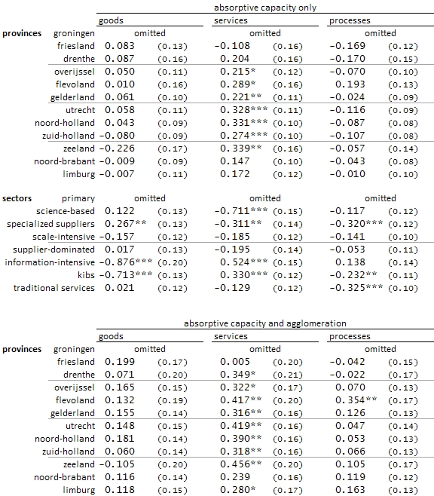

## Conclusions

We have combined firm-specific data with regional data on agglomeration externalities, since we believe that where agglomeration externalities exist, internal characteristics, including what is called the ‘absorptive capacity’ of a firm, influence the degree to which a firm can make use of them. Therefore, we combined regional data with firm data on R&D and on other factors related to knowledge production and adoption. Our results show that innovation is the outcome of complex processes where firm and neighbourhood variables both matter.

At the same time, our results confirm hypotheses and results from other studies that did not employ both types of data. In that sense, our analysis shows that it is not necessary to always include both types of data: there appears to be no omitted variable bias when we leave out one set or the other. In practice, we see that the estimated coefficients for the intra-firm variables do not change much when we add regional variables, and vice versa.

Therefore, even though we could criticize previous studies for putting too much emphasis on regional effects and neglecting firm effects, we feel that a purely regional approach may also be justified. Similarly, in the absence of firm-specific data, testing for agglomeration externalities is certainly still possible.

A very important result is that in our specific set-up (Dutch firms that defined themselves to be innovative, with agglomeration effects measured at the NUTS-3 level), the relationship between agglomeration externalities and innovation is not a clear one. Almost all estimated coefficients are insignificant at the 5% level. [[89]](#footnote-89) The fact that for agglomeration externalities we find only few statistically significant coefficients does not necessarily make our results less valid; significance is not sacred, and the coefficients we find still have a meaning (McCloskey 1985). Yet the contrast with the estimated coefficients for firm characteristics is large. Our results show that these variables are significantly related to innovation, and thereby confirm that absorptive capacity is a meaningful concept when investigating innovation at the firm level.

In defence of the inclusion of agglomeration variables, we might argue that there is still some confusion and disagreement as to their most useful definition, a discussion which really took off after the publication of Glaeser et al. (1992). Although we have chosen three operationalizations which are very much in line with mainstream research on this topic, as summarized in Chapter 3, we cannot prove that these are the best measures, either in the sense of being unbiased or in the sense of being efficient. Standard errors are large for the agglomeration variables, whereas the firm-specific effects seem to be robust and strong. We will return to the choice of variables measuring different aspects of agglomeration externalities in Chapter 6.

# Stocking up: the influence of past innovativity in a region

## Introduction[[90]](#footnote-90)

The production of a firm depends on its inputs, and knowledge is an important production factor. Firms have access to a certain amount of knowledge, and there are many ways this knowledge has become available: for example, it can be that this knowledge has been researched by the firm itself (own R&D), that is has been bought from external sources, or that it has been done by others but is now freely available (e.g., expired patents). Yet another possibility is that it is so-called *tacit knowledge*, embedded in its staff, which is sometimes labelled implicit, idiosyncratic or uncodified knowledge (Kleinknecht & Ter Wengel 1998, p. 198). The key to estimate the effects of available knowledge on production (and growth) is therefore to determine how to measure and how to demarcate this knowledge stock.

In this chapter, we will measure knowledge as R&D performed in the past, expressed in fte’s. However, our main interest is not the amount of R&D performed by a firm itself, but possible spillovers from other nearby firms. We will therefore introduce three dimensions of distance: physical, temporal, and sectoral. A major item in the literature on stocks is the problem of depreciation: old knowledge loses its value over time as it is superseded by new knowledge. We choose instead to implement a distance decay function for each of our three dimensions; but rather than exogenously determining distance decay functions for each of these three, we will implement each dimension as two classes – one nearer, one further away (see Section 6.2.3 for details). In this way, we ‘let the data speak’: our estimation does not impose a structure, and allows for non-linearity.[[91]](#footnote-91)

In the current chapter, we will investigate whether the stock of R&D workers can account for the *innovativity* of firms at the regional scale.[[92]](#footnote-92) It is well known that several forces operating at the regional scale determine regional innovativity. Especially since Glaeser et al. 1992, many studies have strived to discern the effects of specialization (Marshall effects, also called Marshall-Arrow-Romer effects), competition (after Porter 1990) and diversity (after Jacobs 1969), as we discussed in Chapter 2. The debate on the relative importance of these factors is still very much alive – useful overviews are given in Rosenthal & Strange 2004 and Beaudry & Schiffauerova 2009, while our Chapter 3 provided a meta-analytic review of the literature.

Once again we will make use of microdata – the Dutch Community Innovation Survey (see Chapter 1), covering the period 1996-2004. We will now turn to a brief discussion of the theoretical background of endogenous growth modelling, before we discuss the data and present our results.

## Theoretical background

### Endogenous growth modelling

Kenneth Arrow (1962) and Eytan Sheshinski (1967) strove to develop a model of economic growth that placed the amount of available knowledge at the core of production, on a par with labour and capital inputs. It is their work that was later developed by Paul Romer into his endogenous growth models (1990).[[93]](#footnote-93) In Arrow’s 1962 paper on learning by doing, he strives to develop “an endogenous theory of the changes in knowledge” (p. 155). To that end, he uses the stock of capital goods as a proxy for experience, which functions as a determinant of productivity. Van de Klundert and Smulders (1992) give a good overview of the theory of Arrow (and Sheshinski) in a framework closely related to that of neoclassical economics. They write

|  |  |
| --- | --- |
| $$y_{i}=Ak_{i}^{α}l_{i}^{1-α}$$ |  |

at the firm level (*i*), with *A* as a technological modifier. *A* can then be written as the sum of all capital stocks,with an extra multiplier γ (Van de Klundert & Smulders 1992, footnote 3):

|  |  |
| --- | --- |
| $$A={\left(\sum_{i∈I}{k_{i}}\right)}^{γ}=K^{γ}$$ |  |

where *K* is the sums of all *k*’s. The most interesting feature of this specification is the summation over all firms *i* out of a population *I*, and the main question is how to demarcate this population. (This topic we will cover in the next section.) Substituting (2) into (1) and rewriting (1) for the whole economy *Y* instead of for individual firms then renders

|  |  |
| --- | --- |
| $$Y=AK^{α}L^{1-α}=K^{α+γ}L^{1-α}$$ |  |

Hence, individual firms benefit from a given technology parameter *A*; but the economy as a whole benefits from the accumulated technology, embedded in capital. In other words, there are increasing returns to scale at the macro level. Those increasing returns can form a problem of their own in modelling, as they may seem to predict explosive growth (see Chapter 2, note 14 for a discussion of this ‘problem’).[[94]](#footnote-94)

There are many ways in which we can interpret these stocks of accumulated technology. Romer himself wrote of technological change that he interpreted it as ‘improvement in the instructions for mixing together raw materials’ (Romer 1990, p. S72, but cf. also Romer 1998). Yet that definition is derived from the model itself, which contains three elements: the raw inputs of capital and labour, and a human capital variable. Human capital in these models is considered an embodied factor, which cannot accumulate indefinitely. Productivity then partly depends on tacit knowledge embedded in these individuals; their quality has an important influence on the results of mixing capital and labour.

There are, however, other ways to interpret the knowledge component. It might be embedded in capital goods, for example, which are far less localized than individuals. Yet for capital goods, an important part is played by knowledge about the existence of these goods, and the ability to operate, repair and improve them. In contrast to the private nature of capital goods, the new factor Romer added (in Romer 1990, but cf. again Romer 1998) was meant as a nonrival technological component; knowledge that can be simultaneously used by an unlimited number of producers. In many cases empirical work has taken this to mean a stock of R&D or accumulated patents; we see this for example in the important paper by Cohen and Levinthal on absorptive capacity (1989, pp. 570-571), in the mass of literature surveyed by Wieser 2005, or in a recent article by Damijan, Kostevc and Rojec (2008), who attempt to decipher the causality issue between R&D, productivity and innovation.

### Defining boundaries

If we go back to the micro level, to the individual firm in equation (2), the real question now lies in $\sum_{i∈I}{k_{i}}$; what is the collection of relevant firms *I* for any individual firm *i*? We have assumed above that there is a ‘whole economy’ *Y*, which is traditionally a national economy, as it is in most models of endogenous growth; but the relevant scale for firms can be both larger (international) and smaller (regional). Moreover, it is not only spatial relationships that matter, but also networks of all kinds (Boschma 2005b; Capello & Faggian 2005; Castells 1996; Torre & Gilly 2000). Romer’s model has mainly been used to study countries; but Izushi 2008 thoroughly proves that Romer’s strict model, as well as alternative versions based on Lucas 1988, can be used in a regional setting just as well. We will take that approach, and look for the importance of regional knowledge stocks, focusing on a very local scale level, in line with Edward Glaeser’s famous maxim “*[I]ntellectual breakthroughs must cross hallways and streets more easily than oceans and continents*.” (Glaeser et al. 1992, p. 1127). Only microdata allows analyses at this scale, and its use is demonstrated for example by Wallsten 2001, who argues in favour of microdata and then proceeds to investigate whether local spillover effects exist in American banking, finding that co-location matters strongly at a radius of less than one mile.

The regional level we choose for our main variable of interest will therefore be a very local scale. We will use travel times to determine ‘moving windows’ or rings (Rosenthal & Strange 2003) of 15 minutes and 30 minutes around individual firms. The advantage of travel times is that it makes comparison between studies on different countries easier, at least between those countries where the available modes of transport (with associated speed) and value of time (Becker 1965) are comparable. The main advantage of moving windows, on the other hand, is that a firm of interest is never located near the border of its region; see Section 6.3 below. There has been a lot of research into the importance of finding the correct regional scale and shape. An important recent contribution is Briant, Combes & Lafourcade 2008, who find the size and especially the shape of regions matter little compared to other specification problems. On the other hand, Burger, Van Oort & Van der Knaap 2008 argue that theoretical considerations should underlie all choices a researcher makes with regard to a regional specification. We emphatically choose a scale level that might be dubbed intra-metropolitan: we want to investigate effects that operate at such small distances that they can easily fall within the boundaries of one city or metropolitan region. At the same time, we do not exclude the countryside, where perceptions of distance and time (‘pace of life’; Bettencourt et al. 2007) can be different, but interaction can take place all the same.

We choose our local approach on the one hand because in the polycentric, dense city structure of the Netherlands, most aggregation levels are problematic. For example, an analysis at a level comparable to that of the American SMSAs would render the whole urban Randstad of the country one unit of analysis. Our level of analysis also implies that we will (deliberately) leave out all kinds of spillovers through networks, or even through commuting employees.

Another reason for choosing this level is that we want to focus on the specific ultralocal mechanisms of knowledge transfer: face-to-face knowledge transfer, for example when employees meet one another at the corner bar, or when startups share offices in a university-supported incubator. These mechanisms are often assumed in the literature, yet they are difficult to prove, except with anecdotic evidence (e.g. Von Hippel 1986). [[95]](#footnote-95) We do not question the anecdotic evidence as such; yet we want to investigate whether such an ultralocal effect really matters across the economy as a whole, or within broadly defined segments of the economy. This also bears upon the possible benefits from cluster policy, which in the Netherlands reached its summit in the *Peaks in the Delta* report (Ministry of Economic Affairs 2004; see Chapter 1). Although we do not investigate effects at longer distances, or spillovers within non-spatial networks, or diffusion of knowledge within multiplant companies or even multinationals, this is not because we believe or claim that such effects do not exist. However, we are purely interested in *local* spillovers in this chapter.

Besides our knowledge stock variables, we will also include agglomeration effects. One conclusion from Chapter 3 is that is important to have a theoretical reason to opt for a certain regional level of analysis. In our case, we believe competition effects are less important at a regional scale in a small country such as the Netherlands – Michael Porter himself (Porter 1996) speaks of the diminishing importance of agglomeration *“in modern national and international* [i.e. not regional] *competition”* (p. 86). Moreover, it is difficult to construct adequate measures for this effect (see Chapter 4). We therefore leave out competition effects. For specialization and diversity effects, we consider the *perceived* region to be of prime importance here (see Section 2.3). As a local example, think of a firm located just outside Amsterdam, in the Netherlands, at 15 minutes travel time from that city. It can very well be that the firm is also at 15 minutes distance from the city of Leiden; yet a firm might feel closely connected to Amsterdam and disregard the vicinity of Leiden completely (cf. Torre & Rallet 2005). Many peripheral locations around Amsterdam experience strong suburbanization forces from that city in terms of people. In a firm, the entrepreneur and his employees might originate in Amsterdam; the firm itself might have started out in that city (Duranton & Puga 2001); some of the employees probably commute from the city. The entrepreneur might even claim his company is located ‘near Amsterdam’, or ‘in the urban area of Amsterdam’.[[96]](#footnote-96) Therefore we choose the so-called Corop regions as the regional level of analysis. These regions, which are similar to Chamber of Commerce areas, are supposed­ly aligned with dominant cities, and shaped as their spheres of influence. Unfortunately, their borders also coincide with provincial borders, so that some idiosyncrasies exist; but for the sake of comparability we will stick to Corop regions, which are also the Dutch NUTS-3 regions (see Appendix B) for specialization and diversity effects.

### R&D stocks

Our variable of interest is the stock of R&D in the area surrounding a firm. We will briefly discuss four issues here: the R&D variable we choose; its regional distribution; its temporal aspects; and the sectoral aspect.

The regional knowledge stock we consider is R&D efforts, proxied by the number of full-time employees working in R&D. Our data also provides us with R&D expenditures, both on in-house R&D and on externally commissioned and acquired R&D and associated capital goods (see Appendix C). We prefer the data on R&D employees. This is because externally produced knowledge that is bought by a firm is likely to be available to other firms on the market as well. It will therefore have a shallower impact on the knowledge level within the firm than internally produced knowledge. Furthermore, we prefer employees over expenditure, because the know­ledge is partly imbedded in the employees, and the use of expenditure might create a bias towards industries with a high ratio of capital to labour.

In our dataset, we attribute all produced knowledge to the headquarters of a firm. One problem that is often encountered in firm surveys is that of distinguishing between firms and their separate plants or establishments. For example, Philips relocated its headquarters from Eind­hoven to Amsterdam in the late 1990s; but most R&D is still performed at the Eindhoven plants, and none at the Amsterdam headquarters. Relocations of R&D facilities are not common, at least not in the Netherlands (Cornet & Rensman 2001). However, as we have no means to adequately distribute the R&D performed by a firm to its plants, we have to make do with attributing it to the HQ location.[[97]](#footnote-97) In general, most of the R&D is performed there, as was confirmed, for example, by Ceh 1999 for Canadian firms in the period 1975-1990. In the Dutch CIS the number of multiplant firms is not very high, and a follow-up survey on CIS2[[98]](#footnote-98) by Statistics Netherlands revealed that out of 3298 responses, only 399 (12%) had spread their R&D over more than one province.

As for the time dimension, we have data for three years at four-year intervals (see below). We choose to do away with intricate discounting for two reasons:

* depreciation of R&D knowledge is relatively fast. It is therefore reasonable to disregard most knowledge older than 8 years. Quick ageing is surely valid in the IT sector, where creative destruction (Schumpeter 1942) is the rule, but probably also in other sectors, where even a depreciation rate of 0.12 is considered a low value (Nadiri & Prucha 1993). Pakes and Schankerman (1984) report a ‘virtual obsolescence’ after nine years for R&D focused on product development;
* and in those areas where depreciation is not fast, and older knowledge is still current, we believe that knowledge is so spatially diffused to such a degree after 8 years, that we no longer need to measure a local effect. This assumption is partly based on the finding that the road from R&D to a money-earning product, which is more than likely to be available at supraregional markets – especially since our ‘regional market’ would be defined by 30 minutes travel time – is shorter than three years (Pakes & Schankerman 1984, table 4.3)

An important advantage of keeping the *t–*8and *t–*4periods separated is that we can still gauge how fast discounting actually goes, letting the data speak for the rate of decay. If both periods show up (highly) significant, we can then conclude there might also be a leftover influence from the *t–*12period. In any case, we expect the effect from the *t–*8period to be lower than those of the *t–*4period. Another possibility is that the *t–*8period has a negative influence on current innovativity; that would point to the law of the ‘handicap of the head start’ (Romein 1937).

R&D stocks in the Netherlands have been studied at a national level by Jacobs, Nahuis & Tang 2002, who employ sectoral input-output relations to symbolize the intersectoral links across which knowledge travels. We choose not to take this approach, but to align the sectoral dimension with the regional and temporal dimensions, and use a bifold distinction. We therefore focus on intrasectoral R&D versus R&D from all other sectors. Yet to account for sectoral heterogeneity, we will repeat our main analysis at various levels, defining intrasectoral R&D at four different sectoral levels:

* across 8 so-called Pavitt sectors (based on Pavitt 1984 – see Section 5.2);
* across 19 macrosectors, which are listed in Appendix A;
* at the 2-digit level of the Dutch SBI, which is equivalent to the international NACE coding up to the 4th digit;
* at the 3-digit level of the Dutch SBI.

Ex ante, our preference is for the Pavitt classification, as this is especially geared towards classifying subsectors by their attitude towards and use of knowledge.

## Data

We use four Dutch datasets for this analysis. Our main dataset is the fourth wave of the Community Innovation Survey (CIS). The CIS is a harmonized survey, which is conducted on a country by country basis every four years over most of Europe, and even in some countries outside Europe (notably the USA, Canada, Australia and South Africa). The fourth round covered the years 2002–2004; that is, companies were asked in 2004 to report on their behaviour over the period 2002–2004. We will take the final reporting year (2004) as the point of reference for CIS4 in the following, and will do so likewise with earlier rounds.

We complement this data with information from census data of all Dutch firms in 2004, the so-called Algemeen Bedrijvenregister (ABR). We use this to calculate degrees of specialization and diversity for the 40 Corop regions in the Netherlands (see above). Our third and fourth datasets are the second and third waves of the CIS, dating from 1996 and 2000, respectively. We use these to measure the stock of R&D.

Usage of the CIS dataset has some drawbacks. Although the sample size is large – between 10.000 and 15.000 observations in each round – it still remains a sample, and although care has been taken by Statistics Netherlands to attain a reasonably balanced distribution across sectors and across firm size classes, they did not focus on the spatial distribution of firms. This spatial distribution becomes more of an issue when we use a finer sectoral distribution; we believe our analyses at the Pavitt- and the macrosector level are least affected. Also, CIS surveys ignore public sector R&D and do not mention innovations that are new to the specific market of a firm (Salazar & Holbrook 2004).[[99]](#footnote-99) More critique of the CIS is given in Godin 2009.

To capture the regional knowledge stock, we will make use of a spatial ‘moving window’. That is, using four-digit zipcode-data (2003), we construct a region around each postcode area that consists of all postcodes within 15 minutes travel time (by car), and a second ring that contains all postcodes within 30 minutes travel time. The advantage of such a methodology is that predefined regions have clear centres and edges, and that a firm at the edge of a region can be as likely to communicate with a firm just across the border as with a firm in the centre of its own region. Direct physical distances overcome this problem, and can be successfully applied nowadays as more and more microdata becomes available (see for example Cainelli & Lupi 2008). Figures 6.2 and 6.3 show how these distance bands work out for an urban and a rural region, respectively; Figure 6.1 shows the location of those regions within the Netherlands on a population density map.[[100]](#footnote-100)

|  |
| --- |
| Figure 6.3: Population density in the Netherlands, in inhabitants per km² (2005). Source: www.ruimtemonitor.nl, a website of the former RPB. The larger squares indicate the regions depicted in Figures 6.2 and 6.3; the two smaller squares indicate the regions depicted in Figures 6.C.1 and 6.C.2. |

|  |  |
| --- | --- |
| F:\4 Onderzoek\4-3j Stocks\Presentations\Example around 1011_TravTime2.jpg | F:\4 Onderzoek\4-3j Stocks\Presentations\Example around 9611_TravTime2.jpg |
| Figure 6.4: Travel time bands around postcode 1011 (central Amsterdam). | Figure 6.5: Travel time bands around postcode 9611 (Sappemeer).  Note: Distance classes are defined as in Figure 6.2; the scale of both figures is approximately the same. |

## Analysis

In this section, we will test the main hypothesis whether a firm profits from previous innovativity in its region. For our analysis, we will employ a probit model. A simple probit model estimates a latent variable *Y*\* ($∈R)$; if *Y*\*>0, the model predicts a success (*Y*=1), otherwise it predicts *Y*=0. Our full model looks like this:

|  |  |
| --- | --- |
| $$Y^{*}=α+{βPREV}_{r,s,t}^{}+γ_{1…3}FIRM+γ_{4…10}REGION+sectoral dummies+ ϵ$$ |  |

where *PREV* represents the total regional R&D effort around a firm. We can measure *PREV* at different sectoral levels, as discussed above. Our basic specification is at the 2-digit SBI level. Our *PREV* variable has the following three dimensions, leading to 2³=8 distinct variables:

* *r*, two geographical areas: an inner ring, formed by the nearest 50 postcodes, and an outer ring, consisting of the next nearest 50 postcodes, as shown in Figures 2 and 3 above;
* *s*, intrasectoral and intersectoral effects: we include both the number of innovations within the sector of the observed firm, and those in all other sectors;
* *t*, two time periods: the previous (*t–*4from CIS3) and the one before that (*t–*8 from CIS2).

The other sets of variables, which all refer to the year 2004, are:

* *FIRM*: three variables at the firm level:
  + its number of employees;
  + its total turnover;
  + the own R&D efforts of the firm in the CIS4 period.
* *REGION*: four variables concerning the region a firm is in, of which the fourth consists of four dummies:
  + a measure of diversity (Jacobs effects): a Hirschman-Herfindahl index at the 2-digit sectoral level, measured by COROP region.
  + a measure of specialization (MAR effects): a location quotient at the 2-digit sectoral level, also measured by COROP region.
  + a Randstad dummy, taking on the value 1 for firms located in the three Randstad provinces.
  + a measure of urbanization at the postcode level, which we also used in Chapter 5: the ‘omgevings­adressen­dichtheid’ calculated by Statistics Netherlands as the density of unique addresses in a postcode area, and measured in five classes, ranging from very urban (1) to rural (5).[[101]](#footnote-101)

We include a dummy for the Randstad because it has more locational advantages than the urban effects that were captured by the urbanization variable: proximity to the main airport (Schiphol), to the national government (The Hague), and excellent transport links to all of the country. However, we expect this dummy to be negative for the manufacturing sector, where innovation is somewhat concentrated in Noord-Brabant, particularly around Eindhoven.

Note that we do not take into account the indirect effect of the innovation stock of period 2; of course the innovativity in that period also had an influence on the firms of period 3.

## Results

The results of our analysis are displayed in Tables 6.1 and 6.2. In Table 1, we present the basic results, starting from a basic model without stocks or agglomeration effects (regression 1), to which we then add agglomeration effects (2), and finally stocks at two different levels (3-4). For regression 4, the marginal effects are reported. Table 6.2 shows different levels of sectoral aggregation for the stock variable, which we now include across all three dimensions, giving 2³=8 variables. Table 6.3 gives more detailed results for four major Pavitt sectors, while Table 6.4 reports the results for just the stock variables when we consider only one of the three dimensions (space, time, sector), or only two out of three. Finally, results for firms of different size classes are available in an Appendix 6.B.

Table 6.6: Main results.

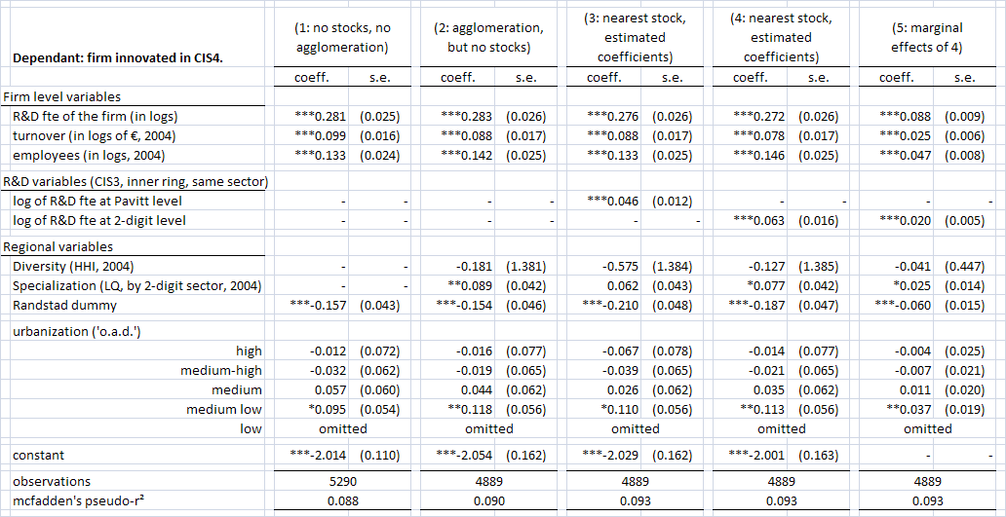

Note 1: As customary, \* indicates significance at 10%, \*\* at 5%, \*\*\* at the 1% level.

Our main result appears immediately in regressions 3-5: there is a statistically significant effect of the local knowledge stock. Moreover, the local knowledge stock effect (measuring within-sector effects at the 2-digit or the Pavitt sector level, from the *t–*4period, in the ‘inner ring’ of 0-15 minutes travel time) is positive. Its marginal effect (at the 2-digit level) is 0.020; in other words, a doubling of our stock variable would lead to a 2% increase in the chance that a firm inno­vates. This effect is understandably smaller than the marginal effect of own R&D: there, a doubling of the R&D effort increase the probability to innovate with almost 9%. In regressions 6‑9, we see that the estimated coefficients are higher when we measure the knowledge stock at a more detailed level. This is as would be expected – as the sectoral scope becomes smaller, so become the observed stocks. The marginal effect, which we do not report for all regressions[[102]](#footnote-102), increases from 0.012 for the Pavitt level to 0.032 for the 3-digit level.

Table 6.7: Results with R&D stocks calculated at different levels of sectoral aggregation.

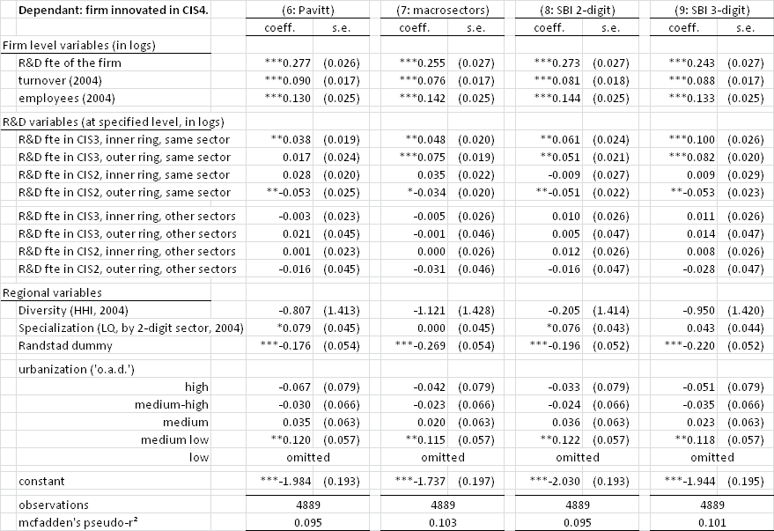

Note: kfte = 1000s of full time employees.

The spatial, temporal and sectoral decay does not entirely appear as expected in regressions 6-9. At the macrolevel, for example, the outer ring (i.e., 15-30 minutes travel time from the postcode area of the firm) has a higher coefficient than the inner ring; for the Pavitt level, it has no effect; for the least aggregated two levels, the effect in the outer ring is only slightly smaller than the inner ring effect. Possibly, when we consider stocks within a narrow sector, firms’ networks reach further out; specialized knowledge can come from further away, just as Christaller (1933) predicted.

As for the time decay, we see that in the *t–*8period, the outer ring yields significant but negative results, so apparently there might be a ‘handicap of the head start’, as we suggested above (Section 6.2). However, the fact that the *t*–8 period almost nowhere yields significantly positive results, can be interpreted as confirming our hypothesis that the depreciation of R&D knowledge in the context of innovation is fast, or that knowledge from eight years ago is no longer tied to the region.[[103]](#footnote-103)

The influence from other sectors is not significantly different from zero, with high standard errors, no matter what sectoral classification we use. (The ‘other sectors’ of course become a smaller group as we expand the ‘own sector’ from all firms in an observation’s 3-digit classification to a whole Pavitt sector.) When we look at different combinations of spatial, temporal and sectoral decay (Table 6.4), we see that this absence of an effect persists. Actually, the regression where we ignored the ‘other sectors’ completely provided the largest number of significant stock variables (fourth group, for which we report marginal effects). Possibly, our chosen two-level approach – either ‘own’ or ‘other’ – proves too narrow for sectoral differences; a weighing method, for example using input-output tables (Griliches 1992), might lead to better results.

Looking at both Table 6.1 and Table 6.2, we note that all three measures at the firm level (R&D, turnover, and the log of the number of employees) are highly significant, and have the expected positive sign: larger firms innovate more (Acs & Audretsch 1988), as do firms that are more engaged in R&D.[[104]](#footnote-104) Their estimated coefficients are not influenced much by the inclusion of the knowledge stock variable between regressions 2 and 3 or 4.

Our regional variables show the most puzzling results. Diversity is nowhere significant in Tables 6.1, 6.2 and 6.3 (nor in the estimations for different firm sizes in Appendix 6.B), although it has the expected negative sign in regressions 1-9, 12 and 13. (The Hirschman-Herfindahl index varies between 0 and 1, where 1 indicates *absence* of diversity.) This runs contrary to what Glaeser et al. 1992 and many others found (see Chapter 3). There does appear to be a significantly positive influence of specialization in some of the pooled regressions (2, 4, 5, 6, 8), but it disappears in the sectoral regressions 10-13. The Randstad dummy is significant in most regressions, and always negative. Apparently, being located in the Randstad hampers innovativity when we control for other agglomeration variables and for R&D. This result is valid both for manufacturing sectors (e.g. regressions 10 and 11) and, remarkably, for service sectors (regressions 12 and 13). For knowledge-intensive business services, however, the effect is not significantly different from zero. Why it is that traditional services are more innovative outside the Randstad, we cannot say; possibly it is because they feel at a disadvantage and are (or want to be[[105]](#footnote-105)) innovative to compensate for locational disadvantages.

Table 6.8: Results for selected Pavitt sectors, with R&D calculated at the 2-digit SBI level.

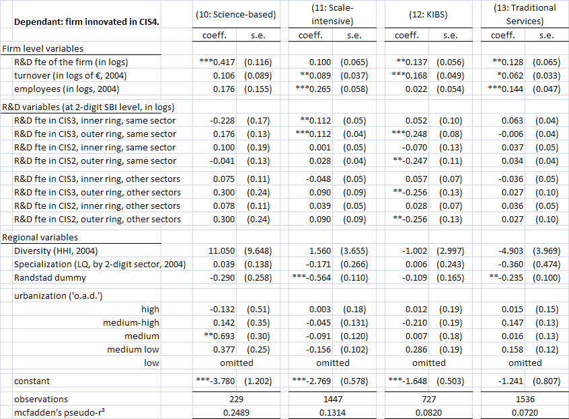

The urbanization variable, which consisted of address densities in five classes to allow for non-linearity, shows significantly positive results for the ‘medium low’ category in regressions 1-9. In the sectoral regressions, the only urbanization dummy that comes up significantly positive is the ‘medium’ category for science-based industries. Figure 5.2 shows this result can not be linked to industrial sites, which are mostly located in the last, category ‘low density’. The result is, however, in line with Howells, who found that R&D in the UK in 1971-1976 was dispro­portio­nally located in the ‘less urbanized’ areas (the third out of four categories he used, following Keeble 1980).

When we look, finally, at the sectoral regressions (10-13), we see that there is some heterogeneity there. [[106]](#footnote-106) For science-based firms, the amount of R&D is important (with a larger coefficient than in regression 8, which is also at the 2-digit level), but the size of the firm, in turnover or employees, is insignificant. For scale-intensive firms, the reverse is the case. These findings underline the validity of Pavitt’s classification. However, we also note that the science-based firms are not significantly influenced by the knowledge stock we constructed, whereas the scale-intensive firms are – at least, they are influenced by the intrasectoral stock from *t–*4, with equal coefficients for the inner ring and the outer ring. Apparently, the spatial decay for scale-intensive firms starts only beyond the 30-minute travel time range. For the KIBS, the results for the stock variable are rather strange, with the outer ring effects significant both intra- and intersectoral, and both for *t–*4and for *t–*8; but only the intrasectoral stock for *t–*4has a positive effect, and the other three effects are negative. We have no explanation for these puzzling results.

As for the regional variables in Table 6.3, we observe that our variable for specialization is insignificant for all four sectors. The Randstad dummy is negative for all four, and significantly so for the scale-intensive sector and for traditional services. The urbanization dummies show no effect for either of the two service sectors, whereas science-based firms seem positively influenced by a location in the ‘medium’ urbanization category. This last result, however, may be due to a small number of innovative firms being actually located there – there are only 229 firms in regression 10.

Table 6.9: Results for single dimensions, and combinations of only two out of three,   
with R&D calculated at the 2-digit SBI level.

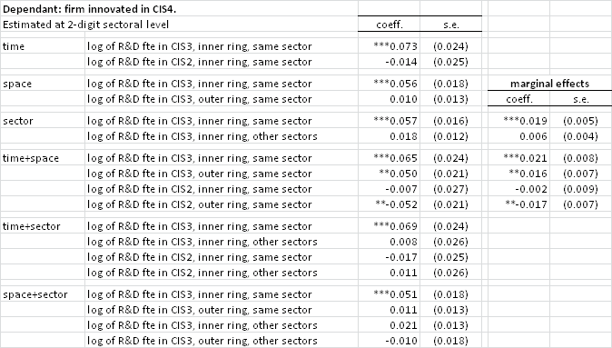

## **Conclusions**

There appears to be a general knowledge stock effect in the Netherlands at a very localized level. The effect is strongest within a range of 15 minutes travel time, with a marginal effect of 2-3%: a doubling of the R&D efforts within a 15 minute range from a firm, within its own sector, leads to a 2-3% higher probability that the firm will innovate four years later. Spatially, it depends on our level of sectoral aggregation whether the effect grows, persists or fades away in the 15-30 minute range. If we define the ‘home sector’ of a firm narrowly, the spatial decay is much slower than when we use broadly-defined Pavitt sectors, and it certainly extends beyond the 30-minute range we used. Networks probably play an important role here – but, as we already stated above, those are not the focus of this analysis. Our hypothesis that an eight-year period would be long enough to measure the depreciation of the local knowledge stock was confirmed: in fact, the size of R&D efforts in the *t*–8 period had a negative or an insignificant influence in all our estimations.

We found little or no evidence for diversity and specialization in this analysis, in line with our results in the previous chapter; in the current chapter, we once again controlled for important firm characteristics (turnover, size in employees, R&D expenditure) from the same dataset as in Chapter 5. Results for those firm characteristics were as expected, all yielding positively significant coefficients. For the firms own R&D expenditure, the marginal effect was found to be 9%: a doubling of the own R&D expenditure leads to a 9% higher chance of innovating in the current time period.

Finally, we found that the knowledge stock effect does not apply to firms in the science-based sector, whereas for firms in scale-intensive industries the effect is present, but has no spatial decay within our 30-minute maximum range.

## Appendix 6.A. Questionnaire excerpt

As a short introduction to the CIS questionnaires, we here give some of the relevant questions from the CIS4. Our basis is the harmonized English-language survey questionnaire. A complete version of the questionnaire is currently (February 2010) available from the OECD website at http://www.oecd.org/dataoecd/52/35/40140021.pdf.

A product innovation is the market introduction of a *new* good or service or a *significantly* improved good or service with respect to its capabilities, such as improved software, user friendliness, components or sub-systems. The innovation (new or improved) must be new to your enterprise, but it does not need to be new to your sector or market. It does not matter if the innovation was originally developed by your enterprise or by other enterprises.

**2.1** During the three years 2002 to 2004, did your enterprise introduce (yes/no):

* New or significantly improved goods. (Exclude the simple resale of new goods purchased from other enterprises and changes of a solely aesthetic nature.)
* New or significantly improved services.

**2.3** Were any of your goods and service innovations during the three years 2002 to 2004 (yes/no):

* New to your market? (Your enterprise introduced a new or significantly improved good or service onto your market before your competitors. It may have already been available in other markets.)
* Only new to your firm? (Your enterprise introduced a new or significantly improved good or service that was already available from your competitors in your market.)

**x.x**[[107]](#footnote-107) Using the definitions above, please give the percentage of your total turnover in 2004 (in %) from:

* Goods and service innovations introduced during 2002 to 2004 that were *new to your market*;
* Goods and service innovations introduced during 2002 to 2004 that were *only new to your firm*;
* Goods and services that were *unchanged or only marginally modified* during 2002 to 2004 (include the resale of new goods or services purchased from other enterprises).

A process innovation is the implementation of a *new* or *significantly* improved production process, distribution method, or support activity for your goods or services. The innovation (new or improved) must be new to your enterprise, but it does not need to be new to your sector or market. It does not matter if the innovation was originally developed by your enterprise or by other enterprises. Exclude purely organisational innovations.

**3.1** During the three years 2002 to 2004, did your enterprise introduce (yes/no):

* New or significantly improved methods of manufacturing or producing goods or services.
* New or significantly improved logistics, delivery or distribution methods for your inputs, goods or services.
* New or significantly improved supporting activities for your processes, such as maintenance systems or operations for purchasing, accounting, or computing.

**4.1** Did your enterprise have any innovation activities to develop product or process innovations that were abandoned during 2002 to 2004 or still ongoing by the end of 2004 (yes/no)?

If your enterprise had no product or process innovations or innovation activity during 2002 to 2004 (no to all options in questions 2.1, 3.1, and 4.1), go to question 8.2 Otherwise, go to question 5.1.

**5.1** During the three years 2002 to 2004, did your enterprise engage in the following innovation activities (yes/no):

* Intramural (in-house) R&D: creative work undertaken within your enterprise to increase the stock of knowledge and its use to devise new and improved products and processes (including software development)
  + if yes, did your firm perform R&D during 2002 to 2004 continuously or occasionally?
* Extramural R&D: same activities as above, but performed by other companies (including other enterprises within your group) or by public or private research organisations and purchased by your enterprise.
* Acquisition of machinery, equipment and software: acquisition of advanced machinery, equipment and computer hardware or software to produce new or significantly improved products and processes.
* Acquisition of other external knowledge: purchase or licensing of patents and non-patented inventions, know-how, and other types of knowledge from other enterprises or organisations.
* Training: internal or external training for your personnel specifically for the development and/or introduction of new or significantly improved products and processes
* Market introductions of innovations: activities for the market introduction of your new or significantly improved goods and services, including market research and launch advertising
* Other preparations: procedures and technical preparations to implement new or significantly improved products and processes that are not covered elsewhere.

**5.2** Please estimate the expenditure for each of the following four innovation activities in 2004 only. (Include personnel and related costs.)

* Intramural (in-house) R&D: include capital expenditures on buildings and equipment specifically for R&D.
* Acquisition of R&D (extramural R&D).
* Acquisition of machinery, equipment and software: exclude expenditures on equipment for R&D.
* Acquisitions of other external knowledge.
* Total of these four innovation expenditure categories.

## Appendix 6.B. Additional regressions

|  |
| --- |
| Table 6.B.1: Results by size class of the firm, in employees |
|  |

## Appendix 6.C. Alternative approach

As an alternative to the travel time bands we used in the analysis in this Chapter, we also tested a *k* nearest neighbour approach, using *k*=50 for the first ring, and *k*=100 for the second. Being able to use absolute distances between postcode areas would make our analysis slightly simpler, as a separate travel time dataset would not be needed. The nearest neighbour approach has two attractive characteristics:

Although postcode areas are irregularly shaped – we used centre-to-centre distances rather than border-to-border – the end result of these groupings resembles a circle. The size of such a circle varies with the size of the postcode areas, which in turn reflects local population density (see Figures 6.C.1 and 6.C.2).

In urbanized regions, postcode areas are small, and therefore the area covered by the first 100 postcodes (or 101, as we include the ‘home’ postcode) is small. In a more peripheral region, the area covered is much larger. That characteristic serves our purpose well: travel times and perceived distances will also be lower in peripheral areas, so that this aligned us more closely with a travel time model.

Most of the regions had a maximum extent of between 12 and 25 km from the core. Unfortu­nate­ly, as regions at edges are truncated by seas or borders, their extent away from the truncated side can become rather large. 3 shows the largest distances from the core to the outermost postcode area assigned to the region: there are extreme regions where the furthest postcode area is 47 km away from the core area. Therefore we decided not to go ahead with a nearest neighbours specification.

|  |  |
| --- | --- |
| Example around 1011_100.jpg  Figure 6.C.1: 100 postcode areas nearest to 1011  (central Amsterdam).  Note: Darker colours indicate a lower rank, i.e. closer proximity to the core of the region. Outside the 100 postcode areas, municipality borders and names are indicated. | Example around 9611_100.jpg  Figure 6.C.2: 100 postcode areas nearest to 9611 (Sappemeer).  Note: this map has the same scale as 1. |
| Histogram_100.jpg | |
| Figure 6.C.3: Histogram of distances from the 100th nearest postcode to the core. | |

# Conclusions

“Technical change is like God. It is much discussed, worshipped by some, rejected by others, but little understood.”

­ — Ross Thomson, *“The Eco-technic Process and the   
Development of the Sewing Machine”*, 1984[[108]](#footnote-108)

## Results

In this chapter, we will draw attention to the most important conclusions from this thesis, and discuss the policy implications these have, as well as the new questions they raise.

Our meta-analysis (Chapter 3) provided an important background for our subsequent empirical work. We studied the literature that followed up on Glaeser 1992 by analysing the effects of specialization (or MAR effects), competition (Porter effects) and diversity (Jacobs effects). Among the 73 studies we gathered we found particularly strong evidence for competition: it had the largest share of positive effects found (70%). Diversity came second, at 60%, while specialization scored 49% positive findings. Diversity, however, had the smallest share of signifi­cant­ly nega­tive findings.

We found that meta-analysis as a tool worked well in laying bare some of the sources of the heterogeneity among these results. We found, for example, that positive diversity effects are more likely to be found as time progresses, and that the level of spatial aggregation influences the results for specialization – where less densely populated regions (e.g. whole states instead of just PMSAs) tend to yield less significantly positive results. On the other hand, there is more comparability across studies than some might think; studies that investigate diversity in the US or in Europe, for example, are not *ceteris paribus* likely to find different results. Another result was that the use of microdata matters: when using microdata, the probability of finding positive significant specialization effects is found to be lower than when aggregated data are used. This is in line with Combes, Duranton & Gobillon 2008 and Combes, Mayer & Thisse 2008.

In Chapter 4, we tested whether there are spatial differences in productivity in the Netherlands, based on wage data. Even though the Netherlands is a small country, where a one-hour commute can take you halfway across the country, such differences turn out to be substantial. They can be partially explained by agglomeration economies: we found evidence for both urbanization and specialization effects. Employment density at the NUTS-3 level had a marginal effect on productivity (that is, on wages, controlling for employee and job characteristics) of 3.4%: in other words, a doubling of the total employment density in a region would lead to a 3.4% increase in productivity. The share of an industry in the local economy, which is a measure for the existence of MAR externalities, had a marginal effect of 2.1%. However, a one-step esti­mation, which used just worker fixed effects with wage as the dependant variable, yielded lower margi­nal effects. In the same chapter, we also tested whether results from aggregated data and results based on microdata differ, and were able to confirm that aggregated data yields higher estimates of agglomeration effects.

In Chapter 4, we also showed how different measures for the three agglomeration forces yield different results. The dependent variable in our analyses was the spatial residual from the Min­cer equation. In our regressions, some proxies for the same effect found opposing results – measuring Competition as a Hirschman-Herfindahl index or as the total number of firms, for example. Some variables prove markedly robust to the specification of the other agglomeration variables – the Ellison-Glaeser index, for example – while others are more easily influenced (e.g. raw counts of firms or employees, sometimes used in the literature to measure competition and specialization, respectively).

Chapter 5 focused on innovation, combining characteristics of the firm itself with those of the region: we matched firm characteristics from the Fourth Community Innovation Survey with regional agglo­meration variables from the General Registry of Firms from Statistics Netherlands. Variables at the firm level had by far the strongest influence on the probability that a firm would innovate, and agglomeration economies played a minor role at best. Among the important variables at firm level were public support (but mainly for goods innovations) and organi­zational characteristics. As for the agglomeration effects, we found that competition has a positi­ve influence on process innovations. Moreover, instead of assuming the effect of agglomeration variables constant across sectors, we allowed for variation in coefficients between the eight Pavitt sectors. In doing so, we found that both competition and diversity have a significantly negative influence on product innovation in knowledge-intensive business sectors (KIBS), and that the effect of competition on process innovation in scale-intensive industries is exceptionally strong.

Subsequently, in Chapter 6, we looked for a specific type of agglomeration economies: knowledge spillovers. We constructed a local knowledge stock, and tested its decay in three dimensions: in space, in time, and across sectors. The most local stock, which we defined as R&D years 'spent' in the same sector four years ago within 15 minutes travel time, we found to be positive, with a marginal effect between 2 and 3%. The spatial decay appears to be faster when we define the 'home' sector more narrowly. With only minor exceptions, all effects of the *t–*4period are joined by an insignificant or a negative effect of the *t*–8 period; this implies that either all R&D of eight years old is no longer useful for innovation, or that it has lost its local effect because it has spread beyond the region by then. Notably, the stock effect is absent for science-based industries, but present for scale-intensive industries.

## Implications and further research

In Chapter 3, we found that the literature on agglomeration effects does not agree on the impor­tance or even the sign of the three main dynamic effects. One of the reason for this lack of consensus is that the methods used to study similar phenomena diverged wildly, and part of the variation in outcomes can be attributed to that variety. We might even go so far as to claim that fear of scientific replication (repeating research in a different context; Hamermesh 2007) can hamper progress: it becomes difficult to draw firm conclusions on a hypothesis (‘competition is good for innovation’) if every new paper on the topic chooses not only fresh data from the latest available date, but also fresh methods.

The changing effects of agglomeration over time are an important avenue of future research. The time dimension can be investigated at different levels. A sizeable amount of work has already been done at the firm level, for example in our Chapter 6, if we take firm size as a rough approximation of firm age. It has also been undertaken at the sectoral level, where Neffke et al. (2008) compared nascent and mature sectors. However, important questions await at the aggregated level: for example, are the effects of agglomeration that Glaeser (1992) estimates for the period 1956-1982 really constant over time? Is local specialization really becoming less important in the face of globalization and communications revolutions?

With the rising use of microdata, the discussion which results are ‘more accurate’, or rather: more relevant, is bound to continue for some time. Our own results using microdata yielded some results that downplay the role of agglomeration forces. The fact that analyses at microlevel find smaller effects than analyses at an aggregated level, which Combes, Duranton and Gobillon (2008) predict, and which we found in Chapter 3 and showed in Chapter 4, implies that either part of the existing effects is not captured at microlevel, or that aggregated data tend to capture other effects as well. Combes, Duranton and Gobillon (2008) argue that sorting is the main explanation here. Of course, the existence of sorting does not contradict the fact that agglo­me­ration and innovativity coincide. It can even be the case that the role of sorting is such that aggre­gated data is still the best suited for policy research. Further developments in this field, individuating sorting mechanisms and the characteristics by which firms and workers sort themselves, are surely necessary. We believe perceptions, both at the firm and at the employee level, should play a role here: for example, ‘follow the leader’ mechanisms are surely present in the location decisions of firms in the Netherlands. Both public and private parties make use of this phenomenon, for example in convincing ABN Amro to set up shop on the Amsterdam Zuidas.

The existence of a regional knowledge stock, which we were able to confirm in Chapter 6, implies that firms actually benefit from being in an environment where R&D is performed. The benefit consists of an increased chance of innovation; that does not necessarily imply produc­tivity or employment growth, and the link between those three is something that should be more explicitly included in future research, particularly in policy-related work. A regional knowledge stock would for a large part be embodied in human capital. An interesting direction for future research would therefore be to see whether there is an effect of employees that switch between jobs, moving from an innovative or at least R&D-intensive firm to a firm that is less active on that terrain. Moving away from innovation research, microdata even allows us to ask ourselves where the new ‘inhabitants’ of a new industrial or office site come from, and, even broader, where their employees come from. Did they follow the firm? Did they live in the neighbourhood before? From where are new employees hired, and do they move when they move jobs? Microdata offers enormous possibilities in this field.

Among the employees that move from firm to firm are creative and entrepreneurial ones (‘intrapreneurs’, Wennekers & Thurik 1999) that are active in stimulating innovation (‘innova­tion champions’, Howell & Higgins 1990). The role of entrepreneurs is more related to Schum­peter’s concept of marketing an innovation than to the invention itself, which is often performed by specialized staff. Engineers are often specialized in one topic, and they can not easily switch from one sector or one product to another. Entrepreneurial innovators can, however, and combined with a generally higher mobility of employees in the service sectors, the mobility of creative employees might prove to be an important factor in measuring ‘success’ in services. However, the use of innovation as an indicator remains more problematic in services, notwithstanding the successful efforts of the Innovation Survey to cover the service sector.

A final, important issue we addressed in this thesis is the regional scope of agglomeration. In the Dutch context, there are no clear boundaries between regions, nor can definite spheres of influence be defined, as we stated in Chapter 1. In recent years, a debate has arisen whether the Randstad area should function as a whole, or whether it can be divided into subregions, each with its own specialization; and if the latter is the case, whether complementarity within a polycentric Randstad is important, or if different subregions (‘wings’) should go their own way in providing services and targeting new firms and inhabitants. We showed that knowledge spillovers are very local (Chapter 6); yet in Chapter 5 we showed that locational advantages for service innovations are present in a wide arc around the Randstad: significantly positive[[109]](#footnote-109) province dummies included not only Utrecht, North Holland and South Holland, but also Flevoland, Gelderland and even Zeeland. This underlines once more that the Randstad is not separate; it cannot be split from its environment. Similarly, within the Randstad, complemen­tarity is only a weak force compared to inter-city competition (Van Oort, Burger & Raspe f.c.). Whereas on the one hand the whole of the Randstad benefits from Schiphol airport[[110]](#footnote-110), on the other hand, the cities compete on attracting the creative class (Trip & Romein 2009).

A final word on agglomeration and innovation. We already mentioned the fact that innovation has become a buzz-word in recent times. Where most regions wanted to become a Silicon Valley in the 90s, biotech seems to be the most likely candidate for regional policy in the first decade of the 21st century. It is one of the duties of regional science to make policy makers aware of the existing strengths and possibilities of regions. Attracting three small biotech firms to a region may be a political success, it does not create a strong cluster, and the firms might not enjoy any advantage of specialization at all – at least not due to physical proximity. Therefore, more work is called for to study non-linearities, thresholds and critical mass. And of course, honesty in refusing to blindly follow the bandwagon wherever it goes.

Appendix A. NUTS-3 (COROP) classification

The Netherlands is divided into 40 Corop regions. Their borders follow the borders of municipalities, and no Corop region crosses a province (NUTS-2) border. The classification is quite stable over time, but small changes are sometimes necessary when municipality borders change.



Source: Wikipedia Commons, Coropgebieden plain.png

Appendix B. Pavitt and other sectoral classifications

We use throughout this thesis the sectoral classification as based on the work of Pavitt (1984). The table below gives an translation table between SBI sectors (the Dutch standard), macrosectors (19 sectors), and the eight-sector Pavitt classification. Note that the Primary sector in this table does not contain agriculture, as agriculture is absent from most of the datasets used.

|  |  |  |
| --- | --- | --- |
| Pavitt sector | macrosector | SBI 2-digit sector |
| Primary | Mining and Quarrying | Mining of Coal |
| Extraction |
| Other Mining |
| Science-based | Chemicals | Coke and Petroleum |
| Chemicals |
| Rubber and Plastic |
| Other Non-Metal Minerals |
| Specialised suppliers | Machinery and Equipment | Machinery and Equipment |
| Office Machinery and Computers |
| Electrical Machinery |
| Communication Equipment |
| Optical Instruments |
| Motor Vehicles |
| Other Transport Equipment |
| Scale-intensive | Food, Beverage and Tobacco | Food and Beverage |
| Tobacco |
| Metals | Basic Metals |
| Fabricated Metals |
| Electricity, Gas and Water | Electricity, Gas and Water |
| Water Purification and Distribution |
| Construction | Construction |
| Transport and Communication | Land Transport |
| Water Transport |
| Air Transport |
| Transport and Travel Auxiliary |
| Post and Telecommunication |
| Supplier-dominated | Textile, Clothes and Leather | Textiles |
| Clothes |
| Leather |
| Wood, Paper and Pulp | Wood |
| Pulp and Paper |
| Publishing and Printing |
| Manufacturing n.e.c. | Furniture n.e.c. |
| Recycling |
| Information-intensive | Financial Intermediation | Financial Intermediation |
| Insurance |
| Other Financial Services |
| KIBS | Computer and Related | Computer and Related Activities |
| Research and Development | Research and Development |
| Business Services | Other Business Services |
| Traditional services | Wholesale Trade and Repair | Trade and Repair of Motorvehicles |
| Wholesale Trade |
| Retail Trade | Retail Trade |
| Hotels and Restaurants | Hotels and Restaurants |
| Real Estate and Renting of Machinery | Real Estate |
| Renting of Machinery and Equipment |

Appendix C. Regional distribution of Pavitt sectors and R&D in the Netherlands

The first table below shows the composition of the economy of the Dutch provinces by Pavitt sectors, with the total number of employees in the right-hand column. In this case, due to weighting, the Primary sector does contain agriculture. The second table shows the distribution of R&D across the Dutch provinces. Noord-Brabant has a very high share of R&D workers, compared to the other provinces; Groningen counts a very small number of R&D staff. Both tables include only companies with more than 10 employees.

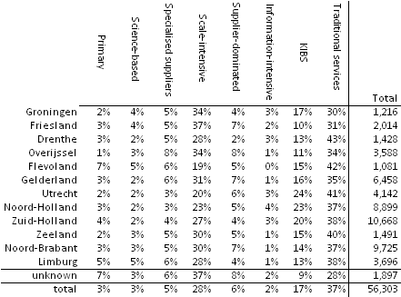

Note: Figures are based on the CIS4-dataset (2002-2004), with weights calculated by Statistics Netherlands.

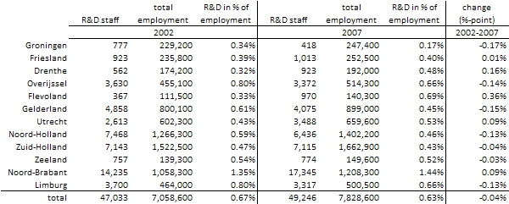

Note: Figures come from CBS Statline.

Reference list

Abramovitz, M. (1956), “Resource and Output Trends in the United States since 1870”, *American Economic Review*, vol. 46, no. 2, pp. 5-23

Abramovitz, M. (1986), “Catching Up, Forging Ahead, and Falling Behind”, *Journal of Economic History*, vol. 46, no. 2, pp. 385-406

Abreu, M., V. Grinevich, M. Kitson & M. Savona (2008), *Absorptive Capacity and Regional Patterns of Innovation*, Research Report no. 08/11, Department of Innovation, Universities and Skills, London

Acs, Z.J. (2002), *Innovation and the Growth of Cities*, Cheltenham: Edward Elgar

Acs, Z.J. (2006), *The Growth of Cities*, Cheltenham: Edward Elgar

Acs, Z.J. & C. Armington (2004), “Employment Growth and Entrepreneurial Activity in Cities”, *Regional Studies*, vol. 38, no. 8, pp. 911-927

Acs, Z.J., B. Carlsson & A.R. Thurik (1996), *Small Business in the Modern Economy*, Oxford: Blackwell Publishers

Acs, Z.J. & A. Varga (2002), “Geography, Endogenous Growth, and Innovation”, *International Regional Science Review*, vol. 25, no. 1, pp. 132-148

Acs, Z.J. & D.B. Audretsch (1988), “Innovation in Large and Small Firms: An Empirical Analysis”, *American Economic Review*, vol. 78, no. 4, pp. 678-690

Acs, Z.J. & A. Varga (2005), “Entrepreneurship, Agglomeration and Technological Change”, *Small Business Economics*, vol. 24, pp. 323-334

Aghion, P., N. Bloom, R. Blundell, R. Griffith & P. Howitt (2005), “Competition and Innovation: An Inverted-U Relationship”, *Quarterly Journal of Economics*, vol. 120, no. 2, pp. 701-728

Ali-Yrkkö, J. & O. Martikainen (2008), *The Impact of Technological and Non-Technological Innovations on Firm Growth* (working paper: ETLA Keskusteluaiheita #1165)

Almeida, R. (2005), *Local Economic Structure and Growth* (working paper: World Bank Policy Research Working Paper #3728)

Altonji, J.G. & R.M. Blank (1999), “Race and Gender in the Labor Market”, in O. Ashenfelter & D. Card (edd.), *Handbook of Labor Economics*, vol. 3C, Amsterdam: Elsevier, pp. 3143-3259

Andersson, R., J.M. Quigley & M. Wilhelmsson (2005), “Agglomeration and the Spatial Distribution of Creativity”, *Papers in Regional Science*, vol. 84, no. 3, pp. 445-464

Archibugi, D. (2001), “Pavitt's Taxonomy Sixteen Years On: A Review Article”, *Economics of Innovation and New Technology*, vol. 10, no. 5, pp. 415-425

Archibugi, D., S. Cesaratto & G. Sirilli (1991), “Sources of Innovative Activities and Industrial Organization in Italy”, *Research Policy*, vol. 20, no. 4, pp. 299-313

Armstrong, H. & J. Taylor (2000), *Regional Economics and Policy*, Oxford: Blackwell

Arrow, K.J. (1962), “The Economic Implications of Learning by Doing”, *Review of Economic Studies*, vol. 29, no. 3, pp. 155-173

Arundel, A. & H. Hollanders (2006), *Searching the Forest for the Trees: “Missing” Indicators of Innovation*, 2006 Trend Chart Methodology Report, MERIT, Maastricht

Asheim, B.T. & A. Isaksen (1997), “Location, Agglomeration and Innovation: Towards Regional Innovation Systems in Norway?”, *European Planning Studies*, vol. 5, no. 3, pp. 299-330

Ashenfelter, O., C. Harmon & H. Oosterbeek (1999), “A Review of Estimates of the Schooling/Earnings Relationship, with Tests for Publication Bias”, *Labour Economics*, vol. 6, no. 4, pp. 453-470

Athey, G., C. Glossop, B. Harrison, M. Nathan & C. Webber (2007), *Innovation and the City: How Innovation has Developed in Five City-regions* no. IC/05, National Endowment for Science, Technology and the Arts, London

Baldwin, J.R., D. Beckstead, W.M. Brown & D.L. Rigby (2008), “Agglomeration and the Geography of Localization Economies in Canada”, *Regional Studies*, vol. 42, no. 1, pp. 117-132

Baldwin, R.E. & P. Martin (2004), “Agglomeration and Regional Growth”, in J.V. Henderson & J.-F. Thisse (edd.), *Handbook of Regional and Urban Economics*, vol. 4, Amsterdam: Elsevier, pp. 2671-2711

Baltzopoulos, A. (2009), *Agglomeration Externalities and Entrepreneurship - micro-level evidence from Sweden* (working paper: CESIS #190)

Baptista, R. & G.M.P. Swann (1999), “A Comparison of Clustering Dynamics in the US and UK Computer Industries”, *Journal of Evolutionary Economics*, vol. 9, no. 3, pp. 373-399

Baptista, R. & P. Swann (1998), “Do firms in clusters innovate more?”, *Research Policy*, vol. 27, no. 5, pp. 525-540

Barro, R.J. & X. Sala-i-Martin (2003), *Economic Growth*, Cambridge (MA): MIT Press

Bartelsman, E.J. & Z. Wolf (2009), *Forecasting Aggregate Productivity Using Information from Firm-Level Data* (working paper: Tinbergen Institute Working Paper #09/043-3)

Baten, J., A. Spadavecchia, S. Yin & J. Streb (2005), *Clusters, Externalities and Innovation: New Evidence from German Firms, 1878 to 1913* (working paper: Universität Tübingen)

Batisse, C. (2002), “Dynamic Externalities and Local Growth - A Panel Data Analysis applied to Chinese Provinces”, *China Economic Review*, vol. 13, pp. 231-251

Beaudry, C. (2009), “Entry, Growth and Patenting in Industrial Clusters: A Study of the Aerospace Industry in the UK”, *International Journal of the Economics of Business*, vol. 8, no. 3, pp. 405-436

Beaudry, C. & S. Breschi (2003), “Are Firms in Clusters Really more Innovative?”, *Economics of Innovation and New Technology*, vol. 12, no. 4, pp. 325-342

Beaudry, C. & A. Schiffauerova (2009), “Who's Right, Marshall or Jacobs? The Localization versus Urbanization Debate”, *Research Policy*, vol. 38, no. 2, pp. 318-337

Becker, G.S. (1965), “A Theory of the Allocation of Time”, *The Economic Journal*, vol. 75, no. 299, pp. 493-517

Beckstead, D., W.M. Brown & G. Gellatly (2008), *Cities and Growth: The Left Brain of North American Cities: Scientists and Engineers and Urban Growth* (working paper: Statistics Canada Research Paper #017)

Bergman, E.M., G. Maier & F. Toedtling (1991), *Regions Reconsidered: Economic Networks, Innovation and Local Development in Industrialized Countries*, London: Mansell

Bettencourt, L.M., J. Lobo, D. Helbing, C. Kuhnert & G.B. West (2007), “Growth, Innovation, Scaling, and the Pace of Life in Cities”, *Proceedings of the National Academy of Sciences of the USA*, vol. 104, no. 17, pp. 7301-7306

Bettencourt, L.M.A., J. Lobo & D. Strumsky (2007), “Invention in the City: Increasing Returns to Patenting as a Scaling Function of Metropolitan Size”, *Research Policy*, vol. 36, no. 1, pp. 107-120

Beugelsdijk, S. (2007), “The Regional Environment and a Firm's Innovative Performance: A Plea for a Multilevel Interactionist Approach”, *Economic Geography*, vol. 83, no. 2, pp. 181-199

Bodvarsson, Ö.B., H.F. van den Berg & J.J. Lewer (2008), “Measuring Immigration's Effects on Labor Demand: A Reexamination of the Mariel Boatlift”, *Labour Economics*, vol. 15, no. 4, pp. 560-574

Boekholt, P. & E. van der Weele (1998), “Southeast Brabant: a Regional Innovation System in Transition”, in H.-J. Braczyk, P. Cooke & M. Heidenreich (edd.), *Regional Innovation Systems: The Role of Governances in a Globalized World*, London: UCL Press, pp. 48-71

Boix, R. & J. Trullén (2007), “Knowledge, Networks of Cities and Growth in Regional Urban Systems”, *Papers in Regional Science*, vol. 86, no. 4, pp. 551-574

Boschma, R. (2005a), “Proximity and Innovation: A Critical Assessment”, *Regional Studies*, vol. 39, no. 1, pp. 61-74

Boschma, R.A. (2005b), “Role of Proximity in Interaction and Performance: Conceptual and Empirical Challenges (editorial)”, *Regional Studies*, vol. 39, no. 1, pp. 41-45

Boschma, R.A. & A.B.R. Weterings (2005), “The Effect of Regional Differences on the Performance of Software Firms in the Netherlands”, *Journal of Economic Geography*, vol. 5, no. 5, pp. 567-588

Boschma, R.A. & K. Frenken (2006), “Why is economic geography not an evolutionary science? Towards an evolutionary economic geography”, *Journal of Economic Geography*, vol. 6, no. 3, pp. 273-302

Braczyk, H.-J., P. Cooke & M. Heidenreich (edd.) (1998), *Regional Innovation Systems:* *The role of governances in a globalized world*, London: UCL Press

Bradley, R. & J.S. Gans (1998), “Growth in Australian Cities”, *Economic Record*, vol. 74, no. 226, pp. 266-278

Brakman, S., H. Garretsen & C. van Marrewijk (2001), *An Introduction to Geographical Economics*, Cambridge: Cambridge University Press

Brakman, S. & B.J. Heijdra (2004), *The Monopolistic Competition Revolution in Retrospect*, Cambridge: Cambridge University Press

Braudel, F. (1979), *Civilisation Matérielle et Capitalisme: XVe-XVIIIe Siècle*, Paris: Armand Colin

Briant, A., P.-P. Combes & M. Lafourcade (2008), *Dots to Boxes: Do the Size and Shape of Spatial Units Jeopardize Economic Geography Estimations?* (working paper: CEPR Discussion Paper #6928)

Brülhart, M. & N.A. Mathys (2008), “Sectoral Agglomeration Economies in a Panel of European Regions”, *Regional Science and Urban Economics*, vol. 38, no. 4, pp. 348-362

Burger, M.J., F.G. van Oort & B. van der Knaap (2008), *A Treatise on the Scale-Dependency of Agglomeration Externalities and the Modifiable Areal Unit Problem* (working paper: ERIM Report Series #2008-076-ORG)

Cabagnols, A. & C. Le Bas (2002), “Differences in the Determinants of Product and Process Innovations: The French Case”, in A. Kleinknecht & P. Mohnen (edd.), *Innovation and Firm Performance: Econometric Explorations of Survey Data*, Houndmills: Palgrave, pp. 112-149

Cainelli, G. & C. Lupi (2008), *Does Spatial Proximity Matter? Micro-evidence from Italy* (working paper: Economics & Statistics Discussion Paper #42/08)

Cainelli, G. & R. Leoncini (1999), “Esternalità e sviluppo industriale di lungo periodo in Italia. Una analisi a livello provinciale”, *L'industria (NS)*, vol. 20, no. 1, pp. 147-166

Cairncross, F., *The Economist*, 30-9-1995: “The Death of Distance”

Camagni, R. (1991), *Innovation Networks: Spatial Perspectives*, London: Belhaven Press

Cameron, G. (1996), *Innovation and Economic Growth*, Ph.D. dissertation, University of Oxford, Oxford

Capello, R. (2001), “Urban Innovation and Collective Learning: Theory and Evidence from Five Metropolitan Cities in Europe”, in M.M. Fischer & J. Fröhlich (edd.), *Knowledge, complexity and innovation systems*, Berlin: Springer, pp. 181-208

Capello, R. & A. Faggian (2005), “Collective Learning and Relational Capital in Local Innovation Processes”, *Regional Studies*, vol. 39, no. 1, pp. 75-87

Caragliu, A. & P. Nijkamp (2008), *The Impact of Regional Absorptive Capacity on Spatial Knowledge Spillovers* (working paper: Tinbergen Institute Discussion Paper #08-119/3)

Carlino, G. & R. Hunt (2007), *Innovation Across US Industries: The Effects of Local Economic Characteristics* (working paper: Federal Reserve Bank of Philadelphia #07-28)

Carlino, G., S. Chatterjee & R. Hunt (2007), “Urban Density and the Rate of Invention”, *Journal of Urban Economics*, vol. 61, no. 2007, pp. 389-419

Castells, M. (1996), *The Rise of the Network Society*, Oxford: Blackwell

Ceh, B. (1999), “Technological Change in Canadian Foreign-Owned Companies: The Role of Invention, Location, Firm Structure, and Technology Transfer”, *Great Lakes Geographer*, vol. 6, pp. 41-64

Cerina, F. & F. Mureddu (2009), *Is agglomeration really good for growth? Global efficiency and interregional equity* (working paper: CRENoS #2009/13)

Chen, H.P. (2002), “Urban Externalities and City Growth in Taiwan”, *Annals of Regional Science*, vol. 36, no. 4, pp. 531-550

Cheshire, P.C. & E.J. Malecki (2003), “Growth, Development, and Innovation: A Look Backward and Forward”, *Papers in Regional Science*, vol. 83, no. 1, pp. 249-267

Christaller, W. (1933), *Die zentralen Orte in Süddeutschland: eine ökonomisch-geographische Untersuchung über die Gesetzmässigkeit der Verbreitung und Entwicklung der Siedlungen mit städtischen Funktionen*, Jena: Fischer

Cingano, F. & F. Schivardi (2004), “Identifying the Sources of Local Productivity Growth”, *Journal of the European Economic Association*, vol. 2, no. 4, pp. 720-742

Cohen, W.M. & D.A. Levinthal (1989), “Innovation and Learning: The Two Faces of R&D”, *Economic Journal*, vol. 99, no. 397, pp. 569-596

Cohen, W.M. & D.A. Levinthal (1990), “Absorptive Capacity: A New Perspective on Learning and Innovation”, *Administrative Science Quarterly*, vol. 35, no. 1, pp. 128-185

Combes, P.P. (2000), “Economic Structure and Local Growth: France, 1984-1993”, *Journal of Urban Economics*, vol. 47, no. 3, pp. 329-355

Combes, P.P., G. Duranton & L. Gobillon (2008), “Spatial wage disparities: Sorting matters!”, *Journal of Urban Economics*, vol. 63, no. 2, pp. 723-742

Combes, P.P., T. Magnac & J.M. Robin (2004), “The Dynamics of Local Employment in France”, *Journal of Urban Economics*, vol. 56, no. 2, pp. 217-243

Combes, P.P., T. Mayer & J.F. Thisse (2008), *Economic Geography*, Princeton: Princeton University press

Condliffe, S., W. Latham, C. Le Bas & F. Miribel (2008), *Agglomeration Economies within IT-producing and IT-consuming Industries in U.S. Regions* (working paper: Alfred Lerner College Working Papers #2008-24)

Cooke, P. (1992), “Regional Innovation Systems: Competitive Regulation in the New Europe”, *Geoforum*, vol. 23, p. 365

Cooke, P., M. Gomez Uranga & G. Etxebarria (1997), “Regional Innovation Systems: Institutional and Organisational Dimensions”, *Research Policy*, vol. 26, no. 4-5, pp. 475-491

Cooke, P. (2001), “Regional Innovation Systems, Clusters, and the Knowledge Economy”, *Industrial and Corporate Change*, vol. 10, no. 4, pp. 945-974

Cornet, M. & M. Rensman (2001), *The Location of R&D in the Netherlands: Trends, Determinants and Policy*, CPB Document no. 14

Coronado, D., M. Acosta & A. Fernández (2008), “Attitudes to Innovation in Peripheral Economic Regions”, *Research Policy*, vol. 37, no. 6-7, pp. 1009-1021

Crépon, B., E. Duguet & J. Mairesse (1998), “Research, Innovation and Productivity: An Economic Analysis at the Firm Level”, *Economics of Innovation and New Technology*, vol. 7, pp. 115-158

Crevoisier, O. (1999), “Innovation and the City”, in E.J. Malecki & P. Oinas (edd.), *Making Connections: Technological Learning and Regional Economic Change*, Aldershot: Ashgate, pp. 61-78

Cutrini, E. (2009), “Using Entropy Measures to Disentangle Regional from National Localization Patterns”, *Regional Science and Urban Economics*, vol. 39, no. 2, pp. 243-250

Damijan, J.P., Č. Kostevc & M. Rojec (2008), *Innovation and Firms' Productivity Growth in Slovenia: Sensitivity of Results to Sectoral Heterogeneity and to Estimation Method* (working paper: LICOS Discussion Paper Series #203/2008)

Das, S. & H. Finne (2008), “Innovation and Co-location”, *Spatial Economic Analysis*, vol. 3, no. 2, pp. 159-194

Davelaar, E.J. (1989), *Incubation and Innovation: a Spatial Perspective*, Ph.D. dissertation, Vrije Universiteit, Amsterdam

De Bruijn, P.J.M. (2004), “Mapping Innovation: Regional dimensions of Innovation and Networking in the Netherlands”, *Tijdschrift voor Economische en Sociale Geografie*, vol. 95, no. 4, pp. 433-440

De Dominicis, L. (2006), *Spatial Concentration, Inequality and Growth in European Regions: Three Essays*, Ph.D. dissertation, Università di Roma II: Tor Vergata

De Dominicis, L., G. Arbia & H.L.F. de Groot (2007), *The Spatial Distribution of Economic Activities in Italy* (working paper: Tinbergen Institute Discussion Paper #07-094/3)

De Groot, H. & A. van Schaik (1997), “Unemployment and Catching Up: Europe Vis-à-vis the USA”, *De Economist*, vol. 145, no. 2, pp. 179-201

De Groot, H.L.F., J. Poot & M.J. Smit (2009), “Agglomeration, Innovation and Regional Development: Theoretical Perspectives and Meta-Analysis”, in R. Capello & P. Nijkamp (edd.), *Handbook of regional growth and development theories*, Cheltenham: Edward Elgar, pp. 256-281

De Lucio, J.J., J.A. Herce & A. Goicolea (2002), “The effects of externalities on productivity growth in Spanish industry”, *Regional Science and Urban Economics*, vol. 32, no. 2, pp. 241-258

De Vor, F. & H.L.F. de Groot (f.c.), “Agglomeration Externalities and Local Growth: the Performance of Industrial Sites in the Amsterdam Region”, *Annals of Regional Science*

Dei Ottati, G. (1994), “Trust, Interlinking Transactions and Credit in the Industrial District”, in G. Becattini et al. (edd.), *From Industrial Districts to Local Development: An Itinerary of Research*, Cheltenham: Edward Elgar, pp. 108-131

Deidda, S., R. Paci & S. Usai (2006), *Spatial Externalities and Local Economic Growth* (working paper: CRENoS #02/06)

Dekkers, J. (2010), *Externalities, Land Use Planning and Urban Expansion*, PhD dissertation, Vrije Universiteit, Amsterdam

Dekle, R. (2002), “Industrial Concentration and Regional Growth: Evidence from the Prefectures”, *Review of Economics and Statistics*, vol. 84, no. 2, pp. 310-315

Dijkstra, L. & H. Poelman (2008), *Remote Rural Regions: How proximity to a city influences the performance of rural regions*, Regional Focus no. 01/2008, European Union/Regional Policy

Dodge, M. & R. Kitchin (2004), “Charting Movement: Mapping Internet Infrastructure”, in R. Hanley (ed.), *Moving People, Goods, and Information in the 21st Century*, New York: Routledge, pp. 159-185

Döring, T. & J. Schnellenbach (2006), “What Do We Know about Geographical Knowledge Spillovers and Regional Growth?: A Survey of the Literature”, *Regional Studies*, vol. 40, no. 3, pp. 375-395

Dosi, G. (1988), “Sources, Procedures and Microeconomic Effects of Innovation”, *Journal of Economic Literature*, vol. XXVI, pp. 1120-1171

Drucker, J.M. & E. Feser (2007), *Regional Industrial Dominance, Agglomeration Economies, and Manufacturing Plant Productivity* (working paper: CES 07-31)

Duranton, G. & H.G. Overman (2005), “Testing for Localization Using Micro-geographic Data”, *Review of Economic Studies*, vol. 72, no. 4, pp. 1077-1106

Duranton, G. & D. Puga (2001), “Nursery Cities: Urban Diversity, Process Innovation, and the Life Cycle of Products”, *American Economic Review*, vol. 91, no. 5, pp. 1454-1477

Durlauf, S.N. (2004), “Neighborhood Effects”, in J.V. Henderson & J.-F. Thisse (edd.), *Handbook of Urban and Regional Economics: Cities and Geography*, vol. 4, Amsterdam: Elsevier, pp. 2173-2242

Dyer, J.H. & H. Singh (1998), “The Relational View: Cooperative Strategy and Sources of Interorganizational Competitive Advantage”, *Academy of management review*, vol. 23, no. 4, pp. 660-679

Eldridge, J.D. & J.P. Jones (1991), “Warped Space: a Geography of Distance Decay”, *The Professional Geographer*, vol. 43, no. 4, pp. 500-511

Ellison, G. & E.L. Glaeser (1997), “Geographic Concentration in US Manufacturing Industries: A Dartboard Approach”, *Journal of Political Economy*, vol. 105, no. 5, p. 889

Fainstein, S.S. (2005), “Cities and Diversity: Should We Want It? Can We Plan For It?”, *Urban Affairs Review*, vol. 41, no. 1, pp. 3-19

Feldman, M.P. & D.B. Audretsch (1999), “Innovation in cities: science-based diversity, specialization and localized competition”, *European Economic Review*, vol. 43, no. 2, pp. 409-429

Feser, E.J. & E.M. Bergman (2000), “National Industry Cluster Templates: A Framework for Applied Regional Cluster Analysis”, *Regional Studies*, vol. 34, no. 1, pp. 1-19

Fingleton, B., D.C. Igliori & B.C. Moore (2005), “Cluster Dynamics: New Evidence and Projections for Computing Services in Great Britain”, *Journal of Regional Science*, vol. 45, no. 2, pp. 283-311

Flannery, J.J. (1971), “The Relative Effectiveness of Some Common Graduated Point Symbols in the Presentation of Quantitative Data”, *Cartographica*, vol. 8, no. 2, pp. 96-109

Flegg, A.T., C.D. Webber & M.V. Elliott (2005), “On the Appropriate Use of Location Quotients in Generating Regional Input-Output Tables”, *Regional Studies*, vol. 29, no. 6, pp. 547-561

Florax, R.J.G.M., H.L.F. de Groot & R.A. de Mooij (2002), *Meta-analysis: A Tool for Upgrading Inputs of Macroeconomic Policy Models* (working paper: Tinbergen Institute Discussion Paper #02-041/3)

Florax, R.J.G.M. (1992), *The University: a Regional Booster?: Economic Impacts of Academic Knowledge Infrastructure*, Aldershot: Avebury

Florida, R. (2002), *The Rise of the Creative Class: And How It's Transforming Work, Leisure, Community and Everyday Life*, New York: Basic Books

Francoz, D. (2000), *Measuring R&D in R&D and Innovation Surveys: Analysis of Causes of Divergence in Nine OECD Countries*, Working Party of National Experts on Science and Technology Indicators, OECD, Paris

Frenken, K., F.G. van Oort & T. Verburg (2007), “Related Variety, Unrelated Variety and Regional Economic Growth”, *Regional Studies*, vol. 41, no. 5, pp. 685-697

Friedman, T.L. (2005), *The World is Flat: A Brief History of the Globalized World in the Twenty-first Century*, London: Lane

Fritsch, M. & V. Slavtchev (2007), *Industry Specialization, Diversity and the Efficiency of Regional Innovation Systems* (working paper: Jena Economic Research Papers #2007-018)

Fu, S. & J. Hong (2008), *Testing Urbanization Economies in Manufacturing Industries: Urban Diversity or Urban Size?* (working paper: MPRA Paper #10078)

Fuentelsaz, L., J. Gómez & S. Palomas (2009), “The Effects of New Technologies on Productivity: An Intrafirm Diffusion-based Assessment”, *Research Policy*, vol. 38, no. 7, pp. 1172-1180

Fujita, M. & J.F. Thisse (2002), *Economics of Agglomeration: Cities, Industrial Location, and Regional Growth*, Cambridge: Cambridge University Press

Galeotti, E. (2009), “Do Domestic Firms Benefit from Geographic Proximity with FDI? Evidence from the Privatization of the Czech Glass Industry”, *AUCO Czech Economic Review*, vol. 3, no. 1, pp. 26-47

Gao, T. (2004), “Regional Industrial Growth: Evidence from Chinese Industries”, *Regional Science and Urban Economics*, vol. 34, no. 1, pp. 101-124

Garcia-Quevedo, J. (2004), “Do Public Subsidies Complement Business R&D? A Meta-Analysis of the Econometric Evidence”, *Kyklos*, vol. 57, no. 1, pp. 87-102

Geisendorf, S. (2007), *The Influence of Innovation and Imitation on Economic Performance* (working paper: Papers on agent-based economics #2)

Gersbach, H. & A. Schmutzler (2000), “Declining Costs of Communication and Transportation: What are the Effects on Agglomerations?”, *European Economic Review*, vol. 44, no. 9, pp. 1745-1761

Glaeser, E.L. (1998), “Are Cities Dying?”, *Journal of Economic Perspectives*, vol. 12, no. 2, pp. 139-160

Glaeser, E.L., H.D. Kallal, J.A. Scheinkman & A. Shleifer (1992), “Growth in Cities”, *Journal of Political Economy*, vol. 100, no. 6, pp. 1126-1152

Glaeser, E.L. (2000), “The New Economics of Urban and Regional Growth”, in G.L. Clark, M.P. Feldman & M.S. Gertler (edd.), *The Oxford Handbook of Economic Geography*, Oxford: Oxford University Press, pp. 83-98

Glaeser, E.L. & J.D. Gottlieb (2009), *The Wealth of Cities: Agglomeration Economies and Spatial Equilibrium in the United States* (working paper: NBER Working Paper 14806)

Glaeser, E.L. & W.R. Kerr (2008), *Local Industrial Conditions and Entrepreneurship: How Much of the Spatial Distribution Can We Explain?* (working paper: Harvard Business School #09-055)

Godin, B. (2008), *Innovation: The History of a Category* (working paper: Project on the Intellectual History of Innovation #1)

Godin, B. (2009), *The Rise of Innovation Surveys: Measuring a Fuzzy Concept* (working paper: Project on the History and Sociology of S&T Statistics #16)

Goffette-Nagot, F. & B. Schmitt (1999), “Agglomeration Economies and Spatial Configurations in Rural Areas”, *Environment and Planning A*, vol. 31, no. 7, pp. 1239-1257

Gorter, J. & S. Kok (2009), *Agglomeration Economies in the Netherlands* (working paper: CPB Discussion Paper #144)

Greene, W.H. (2000), *Econometric Analysis*, Upper Saddle River (NJ): Prentice-Hall

Greunz, L. (2004), “Industrial Structure and Innovation - Evidence from European Regions”, *Journal of Evolutionary Economics*, vol. 14, no. 5, pp. 563-592

Griliches, Z. (1979), “Issues in Assessing the Contribution of Research and Development to Productivity Growth”, *The Bell Journal of Economics*, vol. 10, no. 1, pp. 92-116

Griliches, Z. (1977), “Estimating the Returns to Schooling: Some Econometric Problems”, *Econometrica*, vol. 45, no. 1, pp. 1-22

Griliches, Z. (1992), “The Search for R&D Spillovers”, *Scandinavian Journal of Economics*, vol. 94, p. S29-S47

Gustavsson, R. (2003), “Industrial Growth and Dynamic Externalities; the Case of Sweden”, *Journal of Economic Integration*, vol. 18, no. 3, pp. 607-625

Hall, B.H., F. Lotti & J. Mairesse (2008), “Employment, Innovation, and Productivity: Evidence from Italian Microdata”, *Industrial and Corporate Change*, vol. 17, no. 4, pp. 813-839

Hall, P.G. (1996), *Cities of Tomorrow: an Intellectual History of Urban Planning and Design in the Twentieth Century*, Oxford: Blackwell

Hall, P.G. (1998), *Cities in Civilization*, New York: Pantheon Books

Hamermesh, D. (2007), *Replication in Economics* (working paper: IZA Discussion Paper #2760)

Hanson, G.H. (1998), “Regional Adjustment to Trade Liberalization”, *Regional Science and Urban Economics*, vol. 28, no. 4, pp. 419-444

Harrison, B., M.R. Kelley & J. Gant (1996), “Specialization versus Diversity in Local Economies: The Implications for Innovative Private-Sector Behavior”, *Cityscape*, vol. 2, no. 2, pp. 61-93

Harvey, D. (1981), “The Urban Process under Capitalism: A Framework for Analysis”, in M.J. Dear & A.J. Scott (edd.), *Urbanization and urban planning in capitalist society*, London: Taylor & Francis, pp. 91-122

Head, K., J. Ries & D. Swenson (1995), “Agglomeration Benefits and Location Choice: Evidence from Japanese Manufacturing Investments in the United States”, *Journal of International Economics*, vol. 38, no. 3-4, pp. 223-247

Heckman, J.J., L. Lochner & P. Todd (2003), *Fifty years of Mincer earnings regressions* (working paper: IZA discussion paper #775)

Henderson, J.V. (2003), “Marshall's Scale Economies”, *Journal of Urban Economics*, vol. 53, no. 1, pp. 1-28

Henderson, V., A. Kuncoro & M. Turner (1995), “Industrial Development in Cities”, *Journal of Political Economy*, vol. 103, no. 5, pp. 1067-1090

Henderson, V., T. Lee & Y.J. Lee (2001), “Scale Externalities in Korea,”, *Journal of Urban Economics*, vol. 49, no. 3, pp. 479-504

Hirschman, A.O. (1964), “The Paternity of an Index”, *American Economic Review*, vol. 54, no. 5, pp. 761-762

Howell, J.M. & C.A. Higgins (1990), “Champions of technological innovation”, *Administrative Science Quarterly*, vol. 35, no. 2, pp. 317-331

Iammarino, S., F. Sanna Randaccio & M. Savona (2006), “Obstacles to Innovation and Multinational Firms in the Italian Regions. Firm-level Evidence from the Third Community Innovation Survey”, in A.T. Tavares & A. Teixeira (edd.), *Multinationals, clusters and innovation: does public policy matter?*, Basingstoke: Palgrave Macmillan

Izushi, H. (2008), “What Does Endogenous Growth Theory Tell About Regional Economies? Empirics of R&D Worker-Based Productivity Growth”, *Regional Studies*, vol. 42, no. 7, pp. 947-960

Jacobs, B., R. Nahuis & P.J.G. Tang (2002), “Sectoral Productivity Growth and R&D Spillovers in the Netherlands”, *De Economist*, vol. 150, no. 2, pp. 181-210

Jacobs, J. (1969), *The Economy of Cities*, New York: Random House

Jaffe, A.B., M. Trajtenberg & R. Henderson (1993), “Geographic Localization of Knowledge Spillovers as Evidenced by Patent Citations”, *Quarterly Journal of Economics*, vol. 108, no. 3, pp. 577-598

Jofre-Monseny, J. (2009), “The Scope of Agglomeration Economies: Evidence from Catalonia”, *Papers in Regional Science*, vol. 88, no. 3, pp. 575-590

Jones, C.I. (1995), “R&D-Based Models of Economic Growth”, *Journal of Political Economy*, vol. 103, no. 4, pp. 759-784

Jones, C.I. (1998), *Introduction to Economic Growth*, New York: Norton

Kameyama, Y., “Dynamic Externalities and the Growth of Manufacturing Employment in Japanese Cities: The Roles of Specialization and Diversity”, conference presentation at Australian Conference of Economists, Sydney, 28 September 2004

Kaufmann, A. (2007), “Patterns of Innovation Relations in Metropolitan Regions: The Case of the Vienna Urban Region”, *Annals of Regional Science*, vol. 41, no. 3, pp. 735-748

Keating, M. (1998), *The New Regionalism in Western Europe: Territorial Restructuring and Political Change*, Cheltenham: Edward Elgar

Keeble, D.E. (1980), “Industrial decline, regional policy and the urban - rural manufacturing shift in the United Kingdom”, *Environment and Planning A*, vol. 12, no. 8, pp. 945-962

Ketelhöhn, N.W. (2006), “The Role of Clusters as Sources of Dynamic Externalities in the US Semiconductor Industry”, *Journal of Economic Geography*, vol. 6, no. 5, pp. 679-699

Kimble, G.H.T. (1951), “The Inadequacy of the Regional Concept”, in L.D. Stamp & S.W. Wooldridge (edd.), *London Essays in Geography*, London: Longmans, pp. 151-174

King, C., A.J. Silk & N.W. Ketelhöhn (2003), “Knowledge Spillovers and Growth in the Disagglomeration of the US Advertising-agency Industry”, *Journal of Economics & Management Strategy*, vol. 12, no. 3, pp. 327-362

Kleinknecht, A. & J. ter Wengel (1998), “The Myth of Economic Globalisation”, *Cambridge Journal of Economics*, vol. 22, pp. 637-647

Kleinknecht, A.H., J.O.N. Reijnen & W. Smits (1992), *Een Innovatie-output Meting voor Nederland: De Methode en Eerste Resultaten*, Den Haag: Ministerie van Economische Zaken

Koetse, M.J., H.L.F. de Groot & R.J.G.M. Florax (2009), “A Meta-Analysis of the Investment-Uncertainty Relationship”, *Southern Economic Journal*, vol. 76, no. 1, pp. 283-306

Kok, J., G. Menkhorst, B. de Roo, N. de Vries & E. Vening (1999), *Migratieprocessen anno 1999*, Faculteit der Ruimtelijke Wetenschappen Rijksuniversiteit Groningen, Groningen

Krugman, P. (1995), *Development, Geography, and Economic Theory*, Cambridge (MA): MIT Press

Krugman, P. (1996), *Pop Internationalism*, Cambridge (MA): MIT Press

Lagendijk, A. (2001), “Scaling Knowledge Production: How Significant is the Region?”, in M.M. Fischer & J. Fröhlich (edd.), *Knowledge, Complexity and Innovation Systems*, Berlin: Springer, pp. 79-100

Lane, P.J., B.R. Koka & S. Pathak (2006), “The Reification of Absorptive Capacity: A Critical Review and Rejuvenation of the Construct”, *The Academy of Management review*, vol. 31, no. 4, pp. 833-863

Lane, P.J. & M. Lubatkin (1998), “Relative Absorptive Capacity and Interorganizational Learning”, *Strategic Management Journal*, vol. 19, no. 5, pp. 461-477

Larue, S. & L. Latruffe (2009), *Agglomeration Externalities and Technical Efficiency in French Pig Production* (working paper: Smart–Lereco #09-10)

Lee, B.S., K. Sosin & S.H. Hong (2005), “Sectoral Manufacturing Productivity Growth in Korean Regions”, *Urban Studies*, vol. 42, no. 7, pp. 1201-1219

Leiponen, A. & I. Drejer (2007), “What Exactly are Technological Regimes?: Intra-industry Heterogeneity in the Organization of Innovation Activities”, *Research Policy*, vol. 36, no. 8, pp. 1221-1238

Lenders, S., L. Lauwers, D. Vervloet & E. Kerselaers (2006), *Afbakening van het Vlaamse Platteland: Een Statistische Analyse*, Mededeling ILVO no. 2, Instituut voor Landbouw- en Visserijonderzoek, Merelbeke

Leunis, W. & K. Verhage (1999), *Labor Accounts in Theory and Practice: The Dutch Experience*, Statistics Netherlands, Voorburg

Lipsey, R.G., K. Carlaw & C. Bekar (2005), *Economic Transformations: General Purpose Technologies and Long-term Economic Growth*, Oxford: Oxford University Press

Lu, Y., J. Ni & Z. Tao (2009), *City-industry Growth in China* (working paper s.l.)

Lucas, R.E. (1988), “On the Mechanics of Economic Development”, *Journal of Monetary Economics*, vol. 22, pp. 3-42

MacDonald, S. (1996), “Industrial Espionage and Innovation”, *Interdisciplinary Science Reviews*, vol. 21, no. 3, pp. 209-214

Malecki, E.J. (1994), “Entrepreneurship in Local and Regional Development”, *International Regional Science Review*, vol. 16, no. 1/2, pp. 119-153

Malpezzi, S., K.Y. Seah & J.D. Shilling (2004), “Is It What We Do or How We Do It? New Evidence on Agglomeration Economies and Metropolitan Growth”, *Real Estate Economics*, vol. 32, no. 2, pp. 265-295

Mano, Y. & K. Otsuka (2000), “Agglomeration Economies and Geographical Concentration of Industries: A Case Study of Manufacturing Sectors in Postwar Japan”, *Journal of the Japanese and International Economies*, vol. 14, no. 3, pp. 189-203

Markusen, A. (1996), “Sticky Places in Slippery Space: A Typology of Industrial Districts”, *Economic Geography*, vol. 72, no. 3, pp. 293-313

Martin, P., T. Mayer & F. Mayneris (2008), *Spatial Concentration and Firm-level Productivity in France* (working paper: CEPR Discussion paper series #6858)

Martin, P. & I.P. Ottaviano (1999), “Growing locations: Industry Location in a Model of Endogenous Growth”, *European Economic Review*, vol. 43, no. 2, pp. 281-302

Massard, N. & S. Riou (2002), “L'Impact des Structures Locales sur l'Innovation en France: Spécialisation ou Diversité?”, *Revue Région et Développement*, vol. 16, pp. 111-136

Masurel, E. (2007), “Why SMEs Invest in Environmental Measures: Sustainability Evidence from Small and Medium-Sized Printing Firms”, *Business Strategy and the Environment*, vol. 16, no. 3, pp. 190-201

McCloskey, D.N. (1985), “The Loss Function Has Been Mislaid: The Rhetoric of Significance Tests”, *American Economic Review*, vol. 75, no. 2, pp. 201-205

Melo, P.S.C., D.J. Graham & R.B. Noland (2009), “A Meta-analysis of Estimates of Urban Agglomeration Externalities”, *Regional Science and Urban Economics*, vol. 39, no. 3, pp. 332-342

Mendoza Cota, J.E. (2002), *Agglomeration Economies and Urban Manufacturing Growth in the Northern Border Cities of Mexico* (working paper s.l.)

Mincer, J. (1974), *Schooling, Earnings, and Experience*, New York: Columbia University Press

Ministerie van Volkshuisvesting & Ruimtelijke Ordening (1976), *Derde Nota over de Ruimtelijke Ordening, deel 2: Verstedelijkingsnota*, Staatsuitgeverij, Den Haag

Ministry of Economic Affairs (2004), *Peaks in the Delta: Regional Economic Perspective*, Ministry of Economic Affairs, The Hague

Mitra, A. (1999), “Agglomeration Economies as Manifested in Technical Efficiency at the Firm Level”, *Journal of Urban Economics*, vol. 45, no. 3, pp. 490-500

Mody, A. & F.Y. Wang (1997), “Explaining Industrial Growth in Coastal China: Economic Reforms ... And What Else?”, *World Bank Economic Review*, vol. 11, no. 2, pp. 293-325

Mohnen, P., F.C. Palm, S. Schim van der Loeff & A. Tiwari (2008), *Financial Constraints and Other Obstacles: Are they a Threat to Innovation Activity?* (working paper: UNU-MERIT Working Paper Series #2008-006)

Mokyr, J. (1990), *The Lever of Riches: Technological Creativity and Economic Progress*, Oxford: Oxford University Press

Mukkala, K. (2004), “Agglomeration Economies in the Finnish Manufacturing Sector”, *Applied Economics*, vol. 36, no. 21, pp. 2419-2427

Mulder, P., H.L.F. de Groot & M.W. Hofkes (2001), “Economic Growth and Technological Change: A Comparison of Insights From a Neo-classical and an Evolutionary Perspective”, *Technological Forecasting and Social Change*, vol. 68, no. 2, pp. 151-171

Nadiri, M.I. & I.R. Prucha (1993), *Estimation of the Depreciation Rate of Physical and R&D Capital in the U.S. Total Manufacturing Sector* (working paper: NBER Working Paper #4591)

Neffke, F. (2009), *Productive Places: The Influence of Technological Change and Relatedness on Agglomeration Externalities*, Ph.D. dissertation, Utrecht University

Neffke, F., M. Svensson Henning, R. Boschma, K.-J. Lundquist & L.-O. Olander (2008), *Who Needs Agglomeration? Varying Agglomeration Externalities and the Industry Life Cycle* (working paper: Papers in Evolutionary Economic Geography #08.08)

Niebuhr, A. (2006), *Migration and Innovation: Does Cultural Diversity Matter for Regional R&D Activity?* (working paper: IAB Discussion Paper #14/2006)

Nijkamp, P. & J. Poot (1998), “Spatial Perspectives on New Theories of Economic Growth”, *Annals of Regional Science*, vol. 32, no. 1, pp. 7-37

Ó hUallacháin, B. & N. Reid (1997), “Acquisition versus Greenfield Investment: The Location and Growth of Japanese Manufacturers in the United States”, *Regional Studies*, vol. 31, no. 4, pp. 403-416

O'Donoghue, D. & B. Gleave (2004), “A Note on Methods for Measuring Industrial Agglomeration”, *Regional Studies*, vol. 38, no. 4, pp. 419-427

OECD & Eurostat (2005), *Oslo Manual: Guidelines for Collecting and Interpreting Innovation Data*, OECD, Paris

Ohkawa, K. & H. Rosovsky (1973), *Japanese Economic Growth: Trend Acceleration in the Twentieth Century*, Stanford: Stanford University Press

Ouwersloot, H. & P. Rietveld (2000), “The Geography of R&D: Tobit Analysis and a Bayesian Approach to Mapping R&D Activities in the Netherlands”, *Environment and Planning A*, vol. 32, no. 9, pp. 1673-1688

Paci, R. & S. Usai (1999), “Externalities, Knowledge Spillovers and the Spatial Distribution of Innovation”, *GeoJournal*, vol. 49, pp. 381-390

Paci, R. & S. Usai (2000), “The Role of Specialisation and Diversity Externalities in the Agglomeration of Innovative Activities”, *Rivista Italiana degli Economisti*, vol. 5, no. 2, pp. 237-268

Paci, R. & S. Usai (2001), *Externalities and Local Economic Growth in Manufacturing Industries* (working paper: CRENoS #01-13)

Paci, R. & S. Usai (2006), *Agglomeration Economies and Growth: The Case of Italian Local Labour Systems, 1991-2001* (working paper: CRENoS #200612)

Pakes, A. & M. Schankerman (1984), “The Rate of Obsolescence of Patents, Research Gestation Lags, and the Private Rate of Return to Research Resources”, in Z. Griliches (ed.), *R&D, Patents, and Productivity*, Chicago: University of Chicago Press, pp. 73-88

Partridge, M.D. & D.S. Rickman (1999), “Static and Dynamic Externalities, Industry Composition, and State Labor Productivity: A Panel Study of States”, *Southern Economic Journal*, vol. 66, no. 2, pp. 319-335

Pavitt, K. (1982), “R&D, Patenting and Innovative Activities: A Statistical Exploration”, *Research Policy*, vol. 11, no. 1, pp. 33-51

Pavitt, K. (1984), “Sectoral Patterns of Technical Change: Towards a Taxonomy and a Theory”, *Research Policy*, vol. 13, no. 6, pp. 343-373

Pellenbarg, P. (2005), “Bedrijfsverplaatsingen”, in P. Pellenbarg, P. van Steen & L. van Wissen (edd.), *Ruimtelijke Aspecten van de Bbedrijvendynamiek in Nederland*, Assen: Van Gorcum, pp. 101-125

Pellenbarg, P., P. van Steen & L. van Wissen (edd.) (2005), *Ruimtelijke Aspecten van de Bedrijvendynamiek in Nederland*, Assen: Van Gorcum

Philips, A. (1971), *Technology and Market Structure*, Lexington: Heath

Phlippen, S. & B. van der Knaap (2007), *When Clusters Become Networks* (working paper: Tinbergen Institute Discussion Paper #2007-100/3)

Polanyi, M. (1967), *The Tacit Dimension*, Garden City (NY): Doubleday Anchor

Ponds, R. (2008), *Regional Innovation and the Geography of Research Collaboration in Science-based Industries*, PhD dissertation, Utrecht University, Utrecht

Ponds, R., F.G. van Oort & K. Frenken (2007), “The Geographical and Institutional Proximity of Research Collaboration”, *Papers in Regional Science*, vol. 86, no. 3, pp. 423-443

Porter, M.E. (1990), *The Competitive Advantage of Nations*, Houndmills: Macmillan

Porter, M.E. (1996), “Competitive Advantage, Agglomeration Economies, and Regional Policy”, *International Regional Science Review*, vol. 19, no. 1&2, pp. 85-94

Rasmussen, T.B. (1979), *Bucchero Pottery from Southern Etruria*, Cambridge: Cambridge University Press

Reiff, A. (1959), *Interpretatio, Imitatio, Aemulatio: Begriff und Vorstellung literarischer Abhängigkeit bei den Römern*, PhD dissertation, Universität Köln

Reinau, K.H., “Knowledge Between Communities of Practice and Firms in Clusters: Global and Local Sources of Knowledge and Practice”, conference presentation at Regional Studies Association Conference “Regions in Focus?”, Lisbon, 2 May 2007

Robinson, W.S. (1950), “Ecological Correlations and the Behavior of Individuals”, *American Sociological Review*, vol. 15, no. 3, pp. 351-357

Romein, J. (1937), “De Dialectiek van de Vooruitgang”, in J. Romein (ed.), *Het Onvoltooid Verleden*, Amsterdam: Querido, pp. 9-65

Romer, P.M. (1990), “Endogenous Technological Change”, *Journal of Political Economy*, vol. 98, no. 5, pp. 71-102

Romer, P.M. (1998), “Two Strategies for Economic Development: Using Ideas and Producing Ideas”, in D.A. Klein (ed.), *The Strategic Management of Intellectual Capital*, New York: Butterworth-Heinemann, pp. 211-238

Rosenthal, S.S. & W.C. Strange (2003), “Geography, Industrial Organization, and Agglomeration”, *Review of Economics and Statistics*, vol. 85, no. 2, pp. 377-393

Rosenthal, S.S. & W.C. Strange (2004), “Evidence on the Nature and Sources of Agglomeration Economies”, in V. Henderson & J.-F. Thisse (edd.), *Handbook of Regional and Urban Economics*, Amsterdam: Elsevier

Salazar, M. & A. Holbrook (2004), “A Debate on Innovation Surveys”, *Science and Public Policy*, vol. 31, no. 4, pp. 254-266

Scheuerman, W. (2002), “Globalization”, in E.N. Zalta (ed.), *Stanford Encyclopedia of Philosophy*, http://plato.stanford.edu/

Schoenmakers, W., G. Duysters & W. Vanhaverbeke (2008), *Radical versus Non-Radical Inventions* (working paper: UNU-MERIT Working Paper Series #2008-036)

Schumpeter, J.A. (1934), *The Theory of Economic Development*, London: Oxford University Press

Schumpeter, J.A. (1942), *Capitalism, Socialism and Democracy*, New York: Harper

Serrano, G. & B. Cabrer (2004), “The Effect of Knowledge Spillovers on Productivity Growth Inequalities in Spanish Regions”, *Environment and Planning A*, vol. 36, no. 4, pp. 731-753

Shannon, C.E. (1948), “A Mathematical Theory of Communication”, *The Bell System Technical Journal*, vol. 27, pp. 379-423 and 623-656

Sheshinski, E. (1967), “Optimal Accumulation with Learning by Doing”, in K. Shell (ed.), *Essays on the Theory of Optimal Economic Growth*, Cambridge (MA): MIT Press, pp. 31-52

Siemons, J.C.M.M. (2009), “Uitbreiden of Verhuizen, Maar Waarom Hier?”, *Nieuwsbrief Kenniskring Amsterdam*, vol. 15, no. 1, pp. 5-6

Silverberg, G. & B. Verspagen (1994), “Learning, Innovation and Economic Growth: A Long-run Model of Industrial Dynamics”, *Industrial and Corporate Change*, vol. 3, no. 1, pp. 199-223

Silverberg, G., G. Dosi & L. Orsenigo (1988), “Innovation, Diversity and Diffusion: A Self-Organisation Model”, *Economic Journal*, vol. 98, no. 393, pp. 1032-1054

Simmie, J. (2001), “Innovation and Agglomeration Theory”, in J. Simmie (ed.), *Innovative Cities*, London: Spon Press, pp. 11-52

Simmie, J. & R. Martin (2007), “Path Dependence, Local Innovation Systems and Absorptive Capacity”, in J. Simmie (ed.), *Path Dependence and the Evolution of City Regional Economies*, Cambridge, pp. 1-25

Simmie, J., J. Sennett, P. Wood & D. Hart (2002), “Innovation in Europe: A Tale of Networks, Knowledge and Trade in Five Cities”, *Regional Studies*, vol. 36, no. 1, pp. 47-64

Sjöholm, F. (1999), “Productivity Growth in Indonesia: The Role of Regional Characteristics and Direct Foreign Investment”, *Economic Development and Cultural Change*, vol. 47, no. 3, pp. 559-584

Smit, M.J., “The City and Innovation: What Perspective Do We Take?”, conference presentation at RSA Annual International Conference, Prague, 27 May 2008

Smit, M.J. (2009), “Stocking Up: The Influence of Past Innovativity in a Region”, in I. Bernhard (ed.), *The Geography of Innovation and Entrepreneurship*, Trollhättan: University West, pp. 951-967

Smit, M.J., M. Abreu & H.L.F. de Groot (2008), *Micro-evidence on the Determinants of Innovativeness in the Netherlands: The Relative Importance of Absorptive Capacity and Agglomeration Externalities* (working paper)

Soete, L., B. Verspagen & B. ter Weel (2010), *Systems of Innovation* (working paper: CPB Discussion Paper #138)

Solow, R.M. (1956), “A Contribution to the Theory of Economic Growth”, *Quarterly Journal of Economics*, vol. 70, pp. 65-94

Sonobe, T. & K. Otsuka (2006), “The Division of Labor and the Formation of Industrial Clusters in Taiwan”, *Review of Development Economics*, vol. 10, no. 1, pp. 71-86

Staber, U. (2001), “Spatial Proximity and Firm Survival in a Declining Industrial District: The Case of Knitwear Firms in Baden-Württemberg”, *Regional Studies*, vol. 35, no. 4, pp. 329-341

Stanley, T.D. (2001), “Wheat from Chaff: Meta-analysis as Quantitative Literature Review”, *Journal of Economic Perspectives*, vol. 15, no. 3, pp. 131-150

Stanley, T.D. (2005), “Beyond Publication Bias”, *Journal of Economic Surveys*, vol. 19, no. 3, pp. 309-345

Sternberg, R. (2007), “Entrepreneurship, Proximity and Regional Innovation Systems”, *Tijdschrift voor Economische en Sociale Geografie*, vol. 98, no. 5, pp. 652-666

Straathof, B. (2003), *A Note on Shannon's Entropy as an Index of Product Variety* (working paper: MERIT Infonomics Research Memorandum Series #031)

Suedekum, J. & U. Blien (2005), “Local Economic Structure and Industry Development in Germany, 1993-2001”, *Economics Bulletin*, vol. 15, no. 17, pp. 1-8

Sveikauskas, L. (1975), “The Productivity of Cities”, *Quarterly Journal of Economics*, vol. 89, no. 3, pp. 393-413

Svensson, R. (2006), *Innovation Performance and Government Intervention* (working paper: IFN Working Paper #664)

Swan, T.W. (1956), “Economic Growth and Capital Accumulation”, *Economic Record*, vol. 32, pp. 334-361

Taylor, M. (1985), “Industrial Geography”, *Progress in Physical Geography*, vol. 9, pp. 432-442

Taylor, M. & B. Asheim (2001), “The Concept of the Firm in Economic Geography”, *Economic Geography*, vol. 77, no. 4, pp. 315-328

Theil, H. (1965), “The Information Approach to Demand Analysis”, *Econometrica*, vol. 33, no. 1, pp. 67-87

Torre, A. & J.P. Gilly (2000), “On the Analytical Dimension of Proximity Dynamics”, *Regional Studies*, vol. 34, pp. 169-180

Torre, A. & A. Rallet (2005), “Proximity and Localization”, *Regional Studies*, vol. 39, no. 1, pp. 47-59

Trip, J.J. & A. Romein (2009), “Beyond the Hype: Creative City Development in Rotterdam”, *Journal of Urban Regeneration and Renewal*, vol. 2, no. 3, pp. 216-231

UCLA Academic Technology Services, “FAQ: What are pseudo R-squareds?”, retrieved from *http://www.ats.ucla.edu/stat/mult\_pkg/faq/general/Psuedo\_RSquareds.htm* on 25-1-2010

UNFPA (2007), *State of World Population 2007: Unleashing the Potential of Urban Growth*, UNFPA, New York

Van de Klundert, T. & S. Smulders (1992), “Reconstructing Growth Theory: A Survey”, *De Economist*, vol. 140, no. 2, pp. 177-203

Van der Cammen, H. & L.A. de Klerk (1996), *Ruimtelijke Ordening: Van Plannen Komen Plannen*, Baarn: Het Spectrum

Van der Panne, G. (2004), “Agglomeration Externalities: Marshall versus Jacobs”, *Journal of Evolutionary Economics*, vol. 14, no. 5, pp. 593-604

Van Dijk, T. & A. van der Valk, “Shades of urbanity: diverging statistical definitions”, conference presentation at ENHR International Conference ' Sustainable Urban Areas', Rotterdam, 25 June 2007

Van Oort, F.G. (2002), “Innovation and Agglomeration Economies in the Netherlands”, *Tijdschrift voor Economische en Sociale Geografie*, vol. 93, no. 3, pp. 344-360

Van Oort, F.G. (2004), *Urban Growth and Innovation: Spatially Bounded Externalities in the Netherlands*, Aldershot: Ashgate

Van Oort, F.G. & O.A.L.C. Atzema (2004), “On the Conceptualization of Agglomeration Economies: The Case of New Firm Formation in the Dutch ICT Sector”, *Annals of Regional Science*, vol. 38, no. 2, pp. 263-290

Van Oort, F.G., M. Burger & O. Raspe “On the economic foundations of the urban network paradigm. Spatial integration, functional integration and urban complementarities within the Dutch Randstad”, *Urban Studies*

Van Oort, F.G. & E. Stam (2005), *Agglomeration Economies and Entrepreneurship: Testing for Spatial Externalities in the Dutch ICT Industry* (working paper: Papers on Entrepreneurship, Growth and Public Policy #0905)

Van Soest, D.P., S.D. Gerking & F.G. van Oort (2002), *Knowledge Externalities, Agglomeration Economies, and Employment Growth in Dutch Cities* (working paper: CentER Discussion Paper #2002-41)

Van Stel, A.J. & H.R. Nieuwenhuijsen (2004), “Knowledge Spillovers and Economic Growth: An Analysis Using Data of Dutch Regions in the Period 1987-1995”, *Regional Studies*, vol. 38, no. 4, pp. 393-407

Viladecans-Marsal, E. (2004), “Agglomeration Economies and Industrial Location: City-level Evidence”, *Journal of Economic Geography*, vol. 4, no. 5, pp. 565-582

Von Hippel, E. (1986), “Cooperation Between Rivals: Informal Know-How Trading”, *Research Policy*, vol. 16, pp. 291-302

Wallsten, S.J. (2001), “An Empirical Test of Geographic Knowledge Spillovers using Geographic Information Systems and Firm-level Data”, *Regional Science and Urban Economics*, vol. 31, no. 5, pp. 571-599

Webbink, D. (2004), *Returns to University Education: Evidence from an Institutional Reform* (working paper: CPB Discussion Paper #34)

Wedemeier, J. (2009), *Creative Cities and the Concept of Diversity* (working paper: HWWI #1-20)

Wennekers, S. & R. Thurik (1999), “Linking Entrepreneurship and Economic Growth”, *Small Business Economics*, vol. 13, no. 1, pp. 27-56

Weterings, A., E. Dammers, M. Breedijk, S. Boschman & P. Wijngaarden (2009), *De Waarde van de Kantooromgeving: Effecten van Omgevingskenmerken op de Huurprijzen van Kantoorpanden*, Planbureau voor de Leefomgeving

Weterings, A., O. Raspe & F.G. van Oort (2005), *De Atlas van Kennis en Innovatie*, Ruimtelijk Planbureau, Den Haag

Wieser, R. (2005), “Research and Development Productivity and Spillovers: Empirical Evidence at the Firm Level”, *Journal of Economic Surveys*, vol. 19, no. 4, pp. 587-621

Zahra, S.A. & G. George (2002), “Absorptive Capacity: A Review, Reconceptualization, and Extension”, *The Academy of Management review*, vol. 27, no. 2, pp. 185-203

Zhang, J. (2003), “Growing Silicon Valley on a Landscape: An Agent-based Approach to High-tech Industrial Clusters”, *Journal of Evolutionary Economics*, vol. 13, no. 5, pp. 529-548

1. Most famously, the Ministry of Planning had appointed which villages were to become New Towns; see the ‘Verstedelijkingsnota’ (Ministerie van Volkshuisvesting & Ruimtelijke Ordening 1976), Van der Cammen & De Klerk 1996 and Dekkers 2010. [↑](#footnote-ref-1)
2. There is a small amount of research on agglomeration effects in rural areas, partly focusing on agriculture and other rural sectors (e.g. Larue & Latruffe 2009), partly on more general topics (e.g. Goffette-Nagot & Schmitt 1999). [↑](#footnote-ref-2)
3. We will, however, not delve into this difficult topic of defining the boundaries between cities and countryside. For such discussions, see Van Dijk & Van der Valk 2007, Dijkstra & Poelman 2008, and Lenders et al. 2006; the latter show, importantly, that the perceived extent of the countryside differs from the statistically or politically defined countryside. [↑](#footnote-ref-3)
4. Van Oort used a different database of Dutch firms, the so-called Lisa database, compiled by the regional Chambers of Commerce. This dataset is particularly well-developed for the province of South Holland, which formed one of his case studies. His short analysis of innovation centred around R&D wage expenditures, which we will consider an input in Chapters 5 and 6. [↑](#footnote-ref-4)
5. The Randstad area has no formal definition, but the consensus is that it lies within the provinces of Utrecht, North Holland and South Holland. It is often divided in a North Wing and a South Wing; the North Wing then includes the area from Haarlem or even Alkmaar via Amsterdam to Utrecht, the South Wing covers the area from The Hague to Dordrecht. The new city of Almere, in the Province of Flevoland, is often included in the North Wing as well. The borders of the Randstad do not follow provincial borders; the northern half of North Holland, for example, is nearly always designated as peripheral (e.g. Van Oort 2004). [↑](#footnote-ref-5)
6. Many key contributions in the economics literature of the last two decades to understanding the growth of cities can be found in Acs 2006. [↑](#footnote-ref-6)
7. Note that this concerns the productivity of inventors; general productivity is higher in city-centres (Sveikauskas 1975, cited in Melo, Graham & Noland 2009), but there are of course also strong selection processes involved. Moreover, Carlino, Chatterjee and Hunt (2007) did find that larger cities produce superproportionally more patents than small cities; but they measure patents per capita instead of patents per inventor. Neither they, nor Bettencourt, Lobo and Strumsky (2007), take the countryside into account as a reference category. [↑](#footnote-ref-7)
8. The term stems from *The Economist* (Cairncross, 30 September 1995), but the concept is older: Martin Heidegger discussed it in the 1970s (Scheuerman 2002). Compare also the similar claim that ‘the world is flat’ (Friedman 2005). [↑](#footnote-ref-8)
9. Around 125,000 Cubans left their island from the port of Mariel for the United States between April and October 1980, with permission from the Castro government. Around half of the immigrants settled down in Miami, leading to a 7% increase in the labour force of that city (Bodvarsson, Van den Berg & Lewer 2008). [↑](#footnote-ref-9)
10. This strategy was underlined for example at a presentation of the Amsterdam Chamber of Commerce in November 2007 by Mr. Eric Huygen, then a manager at the Rabo Mobiel department of Rabobank NV in Utrecht, the Netherlands. His department, which started with only 15 employees, was moved out of the headquarters of Rabobank in Utrecht on purpose, so that it would grow and develop in relative freedom from management interference, and at a safe distance from incumbent technological paradigms. [↑](#footnote-ref-10)
11. The division of Schumpeter’s thinking in Mark I and Mark II (the first focusing on ‘wild spirits’, the second on large enterprises’) stems from Philips 1971 (as described in Simmie 2001, pp. 15-18). [↑](#footnote-ref-11)
12. Beugelsdijk 2007 gives an overview of these: innovative milieux stem from Camagni 1991, industrial districts from Dei Ottati 1994 and Markusen 1996, and regional innovation systems from Cooke, Gomez Uranga & Etxebarria 1997. [↑](#footnote-ref-12)
13. We disregard ‘corner solutions’ here, as it is central to our reasoning that such extreme cases are unlikely to occur or persist eternally in the real world. [↑](#footnote-ref-13)
14. In growth literature (e.g. Baldwin & Martin 2004), one of the basic conclusions of equilibrium models is that a shock (an unexpected source of new knowledge, or sudden government subsidies, or anything else) does not fundamentally alter the growth rate; it only results in a shift of long-run productivity levels (De Groot & Van Schaik 1997). I believe we should not build too much upon this 'insight' of equilibrium. It is simply a feature of a basic assumption underlying the models: no parameter is allowed to let the result of the function grow out of bounds as we approach infinity. This might seem a sane constraint at first sight – a model has to stay manageable. Compare it to a nuclear reactor, immersed in cooling liquid. We can allow it to produce more energy per second; but we want to keep the power under control. So we let power production move from one level to another, without allowing exponential growth to actually take off. But then equilibrium theory is still quite a practical way of organizing the model, one might object; because of the constraint that there can actually be no long-run exponential growth, the model becomes useable for all desired time periods. That is true; but useable and useful are two things. Since the model is used to predict the effect of shocks, and since we have no idea how many shocks will occur in the future, when they will exactly occur, and of which magnitude they might be, the model is actually rather worthless for long-run predictions. On the other hand, that might not be a problem – policy making is hardly ever based on forecasts for the far future, but is concerned foremost with short- and mid-range advice. [↑](#footnote-ref-14)
15. See also Mulder, De Groot & Hofkes 2001 for a comparison of neoclassical, endogenous and evolutionary models of economic growth. [↑](#footnote-ref-15)
16. Note that this is certainly not the case: most famously, an overkill of competition will have negative effects (Aghion et al. 2005). In addition, the interregional distribution of growth can also be important from a welfare perspective (Cerina & Mureddu 2009). [↑](#footnote-ref-16)
17. The biggest problem here is that not only the size of these externalities but also their regional extent is unknown, and that therefore different levels of government will be cautious in committing their (financial) efforts. The role and effectiveness of public instruments has been studied widely, as for example in Svensson 2006. [↑](#footnote-ref-17)
18. Note that the founding of a firm technically also includes a location decision, but that this type of decision is dominated so heavily by the (social) background of the founder/entrepreneur, that this type of location choice forms a class of its own (Pellenbarg 2005, p. 104; Siemons 2009). [↑](#footnote-ref-18)
19. We could think for example of a location decision model similar to neighbourhood models (Durlauf 2004), which would look like this:

    |  |  |  |
    | --- | --- | --- |
    |  | $$ω_{i}={\text{argmax}}_{ω∈Ω_{i}}\text{V}\left(ω_{i}\text{,}X_{i}\text{,}ε_{i}\text{,}Y_{n}\text{,}μ_{i}^{e}\left(ω_{n,-i}\right)\right)$$ |  |

    with

    ω, the immediate payoff of the firm’s decision;

    X, a vector of deterministic individual characteristics of the firm (many of which could be grouped together as the absorptive capacity of the firm, including the attitude and positioning of a firm in networks and on different markets);

    ε, random individual characteristics of the individual firm;

    Y, a vector of deterministic neighbourhood characteristics;

    µ, the subjective beliefs of the firm about the behaviour of other firms. [↑](#footnote-ref-19)
20. So we assume, formally stated, that *wfirt* = *wirt* for each *f*. For simplicity, it is assumed that there is a one-to-one mapping between industries and occupations. Moreover, each industry produces only one commodi­ty. [↑](#footnote-ref-20)
21. But note that this last effect depends on the fact that we have not included a growth of economy-wide total factor productivity growth. [↑](#footnote-ref-21)
22. A case in point is Etruscan *bucchero* pottery, famed throughout antiquity. Its production techniques are now unknown; modern potters are especially unable to reproduce its thinness (Rasmussen 1979). In this case, it is still possible that their innovation will be recovered, if their alphabet will be deciphered; but even then it remains to be seen whether any Etruscan documents (already found or yet to be discovered) will discuss these techniques accurately enough to be of assistance. [↑](#footnote-ref-22)
23. This is where industrial espionage comes in (MacDonald 1996). [↑](#footnote-ref-23)
24. See footnote 10. [↑](#footnote-ref-24)
25. This chapter builds on a previous study, published as De Groot, Poot & Smit 2009. This chapter substantially expands the meta-analysis database from 31 to 73 articles, and also reports on additional testing. See Section for more details. [↑](#footnote-ref-25)
26. A special issue of the *Journal of Economic Surveys* (volume 19, number 3, 2005) provides a range of applications of meta-analysis in economics. See also Stanley 2001. [↑](#footnote-ref-26)
27. We will test these and several other measures that are used in the literature in Chapter 6, using Dutch microdata. [↑](#footnote-ref-27)
28. We use *L* for total employment and *F* for the number of firms. A star (\*) denotes a summation over the index it replaces. [↑](#footnote-ref-28)
29. See Duranton & Overman 2005 and De Dominicis, Arbia & De Groot 2007 for studies that incorporate the spatial dimension more explicitly in an analysis of concentration. [↑](#footnote-ref-29)
30. We write *y*, *k* and *l* for output, capital and labour at the firm level, and *Y*, *K* and *L* for the total. [↑](#footnote-ref-30)
31. Glaeser et al. (1992) actually allow the *g* function to also vary with initial conditions. [↑](#footnote-ref-31)
32. Only the six largest industries in each MSA are incorporated in the analysis. [↑](#footnote-ref-32)
33. Foremost among these were Catherine Beaudry and Andrea Schiffauerova, who kindly sent us an unpublished appendix to a more qualitative overview article they published in 2009. [↑](#footnote-ref-33)
34. These estimates were derived from 392 estimated equations, where most equations provided information on more than one externality. The number of estimated equations per study included in the database varies between 1 and 22, with an average 5.4 estimates per study (see Table 3.2). In our regressions (see Section 3.3.2) a few of these estimates disappear because of missing values, resulting in a maximum of 748 observations. [↑](#footnote-ref-34)
35. Arundel & Hollanders 2006 stress that the relationship between R&D, invention and innovation is a lot less clear than is often supposed among policy makers. We could include R&D expenditure as an extra stage before innovations, using some kind of knowledge production function, but R&D was not to be found in the studies under consideration here. See Griliches 1979 and Cameron 1996 for analyses of the effectiveness of R&D. [↑](#footnote-ref-35)
36. The first method, including all estimates found, was the method we pursued in De Groot, Poot & Smit 2009. That paper, however, applied to a limited dataset; as we have since expanded both the dataset and our methodology, we will now be able to restrict our dataset to a more homogeneous subsample, excluding those estimates that were derived for a specific (sub)sector. [↑](#footnote-ref-36)
37. This variable describing the mean population density of the regions included in the study was constructed based on data on the regions included in the primary analyses (mainly from national statistical offices). We have also considered the average surface area and population size separately, but that did not lead to different results. Details are available upon request. [↑](#footnote-ref-37)
38. The R² is a rough measure in this respect, and it has an inherent variation between studies based on macrodata and studies based on microdata, and between studies analysing levels and studies estimating differences. [↑](#footnote-ref-38)
39. We might hypothesize that estimates on a larger number of observations are more likely to render significant results - that is, a result in one of the outer categories of our ordered probit. Including the number of observations as an independent variable is therefore problematic. We tested the equality of the distribution of outcomes over the four categories between smaller studies (<1097 observations, or actually <e7) and larger studies, using a Wilcoxon rank-sum test. For specialization and competition, the difference between the distribution is insignificant. For diversity, the difference is significant at the 7% level, and the differences are found mainly on the positive side:

    |  |  |  |  |  |  |
    | --- | --- | --- | --- | --- | --- |
    | sample size | –– | – | + | ++ | obs. |
    | $${<e}^{7}$$ | 13.1% | 30.3% | 31.2% | 25.4% | 122 |
    | $${≥e}^{7}$$ | 14.5% | 22.4% | 22.9% | 40.2% | 179 |
    | total | 14.0% | 25.6% | 26.2% | 34.2% | 301 |

    [↑](#footnote-ref-39)
40. We standardize the year of publication and the mean year of the data (so that the data for these variables has mean 0 and standard deviation 1); for population density and the length of the period covered we take logs. [↑](#footnote-ref-40)
41. Alternatively, we could have evaluated at the median. This turns out to have only limited impact on the outcomes. Details are available upon request. [↑](#footnote-ref-41)
42. Our results for the total set, which we report in Table 3.4 are in many places similar to the results we published earlier in De Groot, Poot & Smit 2009; apart from the expansion of the dataset, we added some variables, but many of our earlier the results stand. There are a few exceptions, however, which we will discuss where appropriate in the discussion of the results that follows. [↑](#footnote-ref-42)
43. A risk in meta-analysis is that dummies for a specific specification apply only to one or two studies, so that the dummy starts to function as a dummy for those studies as a whole. To counter this effect, we have strived to include only dummies that applied positively to at least five different studies. [↑](#footnote-ref-43)
44. This contrasts the results we published as De Groot, Poot & Smit 2009, where we found that density significantly and positively affected the chances of finding positive effects of specialization on urban growth. This we took as an indication that the level of spatial aggregation tends to matter for observed outcomes. However, we will see in our preferred specification below that this finding still holds, at least once again for specialization. [↑](#footnote-ref-44)
45. Australia is grouped with Europe where the regional dummies are concerned. [↑](#footnote-ref-45)
46. We have also repeated the analysis of our complete set with sector dummies, but the results of that analysis (available upon request) were almost equal to the results without dummies, and none of the dummies was significant at a 5% significance level. [↑](#footnote-ref-46)
47. In this smaller set, we sometimes have to leave out a few dummy variables, because they apply to too few observations; we set a threshold of five studies (not estimates) to include a dummy. [↑](#footnote-ref-47)
48. In the estimation for competition, we had to leave out the US dummy, so that the reference category here is Europe and the US together. [↑](#footnote-ref-48)
49. We repeated the regression with an interaction effect between the working paper dummy and the standar­dized year of publication as well, and the interaction effect was also negative and significant at α = 10%, while the main effect of the year of publication crept only slightly towards 0, resulting in a coefficient of –1.76 with an associated t-value of –3.06. [↑](#footnote-ref-49)
50. Labour Market Areas. [↑](#footnote-ref-50)
51. Statistical Metropolitan Areas. [↑](#footnote-ref-51)
52. This chapter is based on a paper by Stefan P.T. Groot, Henri L.F. de Groot and Martijn J. Smit of the same title. We are grateful to Statistics Netherlands (CBS) for their data support – the analyses in this chapter are our own computations based on tax, EBB, SBB and ABR data files composed by Statistics Netherlands. Although Statistics Netherlands composed and provided the data, the analysis is ours, and they should not be held responsible for any errors. [↑](#footnote-ref-52)
53. We assume that gender, which is also a common cause for wage differentials (Altonji & Blank 1999), has a more or less uniform spatial distribution in the Netherlands. [↑](#footnote-ref-53)
54. Workers are of course more inclined to migrate to other regions if they cannot find employment in their own region, but in an equilibrium situation the labour market is completely employed. [↑](#footnote-ref-54)
55. Note that we do not take the role of consumers into account. A consumer preference for densely populated regions would also result in spatial sorting of different education groups, as workers with a higher income can pay a higher price for housing in the most preferred areas. [↑](#footnote-ref-55)
56. Briant, Combes and Lafourcade (2008) discuss the importance of regional classifications for the outcomes of economic geographical research, and conclude that it is important that the chosen scale of a regional classification corresponds with the level of aggregation at which the researched phenomenon is expected to operate. Even though COROP regions are not strictly local labour market areas, they are in practice an acceptable approximation. [↑](#footnote-ref-56)
57. We distinguish part-time employees – working 12 hours or more per week, but less then 32 hours – and full-time employees working 32 hours per week or more. Having a working week of 12 hours or more is the official definition of Statistics Netherlands of being employed. [↑](#footnote-ref-57)
58. We use subscripts as in Chapter 3: *i* for industry (sector), *r* for region. Furthermore, *f* is a subscript for the individual firm. We omit *t* for time here, but adding it is trivial, as summations over time are rarely taken in indices. A star (\*) indicates a sum over all firms, industries or regions. *L* is used throughout to denote the number of employees; *F* the number of firms. [↑](#footnote-ref-58)
59. O'Donoghue and Gleave (2004) cite from a presentation by Fingleton, Igliori and Moore of their work in 2002; however, the developed measure is not included in the published version of that paper (Fingleton, Igliori & Moore 2005). [↑](#footnote-ref-59)
60. Most often, though, regional input-output tables are reconstructed from national tables, and in that case they do not have an added value in this sense (Flegg, Webber & Elliott 2005). [↑](#footnote-ref-60)
61. The upshot of one value per region is that it implies regional dummies cannot be included (unless the diversity variable is included for different years). [↑](#footnote-ref-61)
62. Sometimes, a square root is applied to the result; in addition, the index is also defined as one minus the sum term or one over the sum term; in both cases, higher values indicate higher diversity. [↑](#footnote-ref-62)
63. These figures refer to data for 2007 (source: CBS Statline). As of 2008, the SBI classification for the Netherlands has changed in response to changes in the ISIC and NACE standards. The new classification contains more categories for services. [↑](#footnote-ref-63)
64. Though the Mincer regression is often applied, it should be noted that the causal relation between the variables in it and the wages earned is actually not very strong: wages are determined by many factors that are not easily modelled. There exists an extensive literature on this subject, often using instrumental variable (IV) estimation methods in natural experiments where an exoge­nous shock affects the wages at a specific moment. Some of the contributions to this literature are Griliches 1977, Ashenfelter, Harmon & Oosterbeek 1999, Heckman, Lochner & Todd 2003, and Webbink 2004. Elaboration on this in the context of this study is left for future research. [↑](#footnote-ref-64)
65. The spatial residual, and its estimation, is the topic of Section 4.6. It represents the part of the wages that is not explained by (available) worker characteristics. [↑](#footnote-ref-65)
66. Note that we have corrected for the inverse interpretation of some variables: for example, *D\_hhi* and *C\_hhi* have lower values for more diversity and competition, respectively. In the following discussion, we have multiplied the results in these cases by ­–1. [↑](#footnote-ref-66)
67. These t-values are actually not very large, considering the hundreds of thousands of observations involved; the education dummies in the same estimations have t-values ranging up to 180; the year dummies range between 20 and 50 in most regressions. [↑](#footnote-ref-67)
68. This chapter is based on Smit, Abreu & De Groot 2008. We are grateful to Statistics Netherlands (CBS) for their data support – the analyses in this chapter are our own computations based on CIS and ABR data files composed by Statistics Netherlands. Although Statistics Netherlands composed and provided the data, the analysis is ours, and they should not be held responsible for any errors. [↑](#footnote-ref-68)
69. See Keating 1998; Kimble 1951; but, for recent discussions, also see Lagendijk 2001 and Burger, Van Oort & Van der Knaap (2007). Organically defined nodal regions are sometimes claimed to be an alternative: see, for example, the Italian Labour Market Areas as discussed by De Dominicis (2006). [↑](#footnote-ref-69)
70. For an interesting investigation into stated motives for imitative innovation, see Masurel (2007). [↑](#footnote-ref-70)
71. Note that ‘absorptive capacity’ is a very popular concept at the moment, and the term is loosely used in different contexts and for different purposes, as surveyed by Lane, Koka and Pathak (2006). They found many studies reify the concept, bending and redefining the concept for their own purposes. We do not endeavour to delve into or expand upon the concept, but neither do we aim to redefine it. We do note, however, that we see strong links with notions of human and technological capital. Lane, Koka and Pathak (2006, p. 838) indicate that Cohen and Levinthal themselves were not so clear about the concept themselves either; Cohen and Levinthal were especially unclear in distinguishing whether we should see absorptive capacity as static property or as a dynamic process. [↑](#footnote-ref-71)
72. According to Kleinknecht, Reijnen & Smits 1992, 24% of all innovations in the Netherlands was performed by firms with less than 10 employees (excluded from the CIS sample); 40% by firms with 10 to 100 employees; and the remaining 36% by firms with more than 100 employees. [↑](#footnote-ref-72)
73. This figure was not standardized across the different national editions of the CIS; for example, in the UK CIS4, the boundary between sample and census was put at 250 employees. [↑](#footnote-ref-73)
74. But the 30% of non-responding firms excludes the 90% of smaller firms that were not selected to receive a questionnaire in the sampling process. [↑](#footnote-ref-74)
75. The UK version of the CIS4, which was used in Abreu et al. (2008), did contain a more direct measure of the level of education; De Bruijn (2004) reconstructed this data for the Netherlands, but only for CIS3. [↑](#footnote-ref-75)
76. Here once again other surveys contained extra information; in contrast with the Dutch version, the UK CIS4 did choose to distinguish between regional and national collaborations, which might have added an interesting dimension to this set of variables. Yet the definition of ‘regional’ depends for a large part on perceptions, and should therefore be handled with care. [↑](#footnote-ref-76)
77. The omitted category here is: the firm operates either nationally or internationally, not both. [↑](#footnote-ref-77)
78. Yet they have also been designed to add up to provinces, which bear no intrinsic relationship to labour market regions whatsoever (also see Leunis & Verhage 1999, quoted in Van Oort 2004, p. 237). A strict hierarchy of regions may be theoretically sound, and obligatory under the NUTS classification, yet it can also hamper analysis by rigidly defining statistical regions which are not in fact the best choice for most topics. Significant Dutch examples of province borders that do not correspond to local labour markets are: the city of Hilversum, which is located in the Province of North Holland but at the same time is almost surrounded by the Province of Utrecht; and the northern corner of the Province of Drenthe, which borders the city of Groningen and to all intents and purposes forms an economic area with that city. [↑](#footnote-ref-78)
79. In addition, we repeated some of our analyses with alternative measures for each agglomeration factor as a robustness check. Here, we chose: the absolute number of employees in a sector for specialization; a Hirschman-Herfindahl index on within-sector employment shares of firms for competition; and a rough measure of related variety (Frenken, Van Oort & Verburg 2007) for diversity – a Hirschman-Herfindahl of sector shares within a larger sector. These results are available on request. [↑](#footnote-ref-79)
80. Note, however, that they are not related to the North American NAICS. [↑](#footnote-ref-80)
81. Although Pavitt’s definition is now over 20 years old, similar groupings are still developing. An example is the four categories devised by Leiponen & Drejer 2007, who distinguished science-based, market-driven, production-intensive and supplier-dominated companies in Finland and Denmark. Archibugi 2001 provides an extensive discussion of the classification and its popularity. [↑](#footnote-ref-81)
82. Technological paradigms are defined by Dosi (1988, p. 1127) as *patterns of solution of selected technoeconomic problems based on highly selected principles derived from the natural sciences, jointly with specific rules aimed to acquire new knowledge and safeguard it, whenever possible, against rapid diffusion to the competitors*. [↑](#footnote-ref-82)
83. These or similar sectors have also been empirically arrived at. For example, Leiponen & Drejer 2007 find four regimes for Finland and Denmark: science-based, market-driven, production-intensive and supplier-dominated. [↑](#footnote-ref-83)
84. A more detailed look into the effects of separate cooperation variables – the Dutch CIS has 28 separate variables, made up of four geographical levels and seven types of entities that can be cooperated with – did not lead to different results. Such an analysis points to the need for further research: it appears, for example, that cooperating with universities at any level except the European has a negative effect on goods innovation, and that cooperating with other plants inside the same company is beneficial only for process innovation. However, we were able to confirm the hypothesis that cooperation with suppliers within the Netherlands (which includes the ‘local’ dimension) is beneficial for process innovation, while collaboration with clients has a positive effect on product innovation for both goods and services. [↑](#footnote-ref-84)
85. The explanation for this result might be that, on the one hand, we had already included a dummy for science-based industries (which will generally have large R&D staffs), and, on the other hand, the inclusion of both the log of R&D staff and the log of total staff allows us to combine the coefficients of those variables into a coefficient for the log of the share of R&D staff in total staff.

    We will give an example of the latter for goods innovation, not controlling for agglomeration effects. The coefficient for the share of R&D staff can be calculated as ­–0.182 – (–0.081) = –0,101. The coefficient for the log of R&D expenditure per R&D employee would be 0.238 – (–0.182) = +0.520. In any case, we should never conclude that a negative coefficient for R&D staff implies that any firm could increase its propensity to innovate by just firing R&D staff. [↑](#footnote-ref-85)
86. Since diversity is measured as a Hirschman-Herfindahl index, a higher value of this index indicates less variety. The same goes for the competition measure. [↑](#footnote-ref-86)
87. A study similar to ours (Abreu et al. 2008) also included estimations of these, but did not include agglomeration variables. They found for example that R&D expenditure per employee has a positive correlation with intra-firm product innovation, no significant correlation with collaborative product innovation, and a negative correlation with adoptive product innovation. [↑](#footnote-ref-87)
88. We can plug the characteristics of our estimation into the cited paper. According to Melo, Graham & Noland 2009 (Table 4, Estimation 1) our result is predicted to be:

    0.1285 (constant) – 0.0015 (period of analysis is after 1990) - 0.0324 (use of a density variable) + 0.0053 (use of microdata) – 0.0266 (simultaneous estimation of localization economies) – 0.0381 (use of economically meaningful boundaries) = 0.0352; in other words, our analysis is expected to find an elasticity of 0.035. As our analysis is a probit, with innovation as the dependent variable, calculating such an elasticity does not make sense; but it does show that no large figures were to be expected; the distribution of observations in their meta-analysis ranges from -0.4 to +0.4, with the bulk of the observations between -0.1 and +0.2 (Melo, Graham & Noland 2009, p. 339, Figure 2). [↑](#footnote-ref-88)
89. As was to be expected when adding only insignificant variables, the R² does not increase much as we add these. However, since this is a probit analysis, we cannot technically use the overall R² for each estimation to make statements on the explained variance. McFadden’s Pseudo-R² is not a measure of explained variance (as in OLS) or of prediction success, but just 1 minus the ratio of the log-likelihood of the current model to the log-likelihood of the constant-only model. [↑](#footnote-ref-89)
90. An earlier version of this chapter has been published in the Proceedings of the 2009 Uddevalla Symposium in Bari (Smit 2009). The authors express their thanks to the Spinlab of the Vrije Universiteit Amsterdam for providing some of the necessary spatial data for this analysis. We are also grateful to Statistics Netherlands (CBS) for their data support – the analyses in this chapter are our own computations based on CIS and ABR data files composed by Statistics Netherlands. Although Statistics Netherlands composed and provided the data, the analysis is ours, and they should not be held responsible for any errors. [↑](#footnote-ref-90)
91. This specification allows for non-linearities which are homogeneous in all directions. If we want to allow, for example, the force of the distance between New York and Washington, DC to differ from that between New York and Syracuse, NY, then we will have to let go of that restriction as well, and space becomes ‘warped’. It can still be visualized (as is done in Eldridge & Jones 1991), and it can also be modelled, using customized distance matrices – as is often done for example in the trade literature. Distance matrices even allow for asymmetrical distances, which can not be shown on maps. However, in each of these cases, external data is needed to measure the distances a priori. [↑](#footnote-ref-91)
92. A somewhat similar effort was undertaken by Izushi 2008, who measures productivity. [↑](#footnote-ref-92)
93. Before the advent of that literature, models in regional economics ran across the road indicated by Solow (1956) and Swan (1956): labour and capital were the only two production factors. The growth rate of total production in their models is exogenous; although it supposedly captures technological factors, it is in fact no more than a ‘measure of our ignorance’ (Abramovitz 1956). [↑](#footnote-ref-93)
94. Jones 1995 deals with this problem extensively for the specific case of R&D productivity by developing a ‘semi-endogenous growth model’, where policy has no influence on growth rates. [↑](#footnote-ref-94)
95. There is a lot of anecdotic evidence on this issue, but not all of it is positive about the existence of such spillovers. Prof. Kloosterman reported, for example, at a seminar in March 2007 of the then-Ruimtelijk Planbureau in The Hague on spillovers between a number of architectural companies he had interviewed. Some of them had or were still sharing a building as well as simple services such as a copying machine. However, they had stopped holding common lunch presenta­tions – there was no interest. Similarly, director Tigchelhoff of the Biopartner incubator in Leiden told us she witnessed little or no relationships between ‘inhabitants’ of the building, beyond the fact that they share an autoclave, and received and refrigerated incoming parcels for each other. [↑](#footnote-ref-95)
96. The Boston Consulting Group, for example, has had an “Amsterdam” office since 1993; actually, this office was located in Baarn – 30 km from Amsterdam. By Dutch standards, Baarn is not even near Amsterdam; but for BCG, this was no reason to refrain from calling their Baarn office the ‘Amsterdam office’. By their standards, they were located in that city; or, at the very least, they hoped their customers would feel them to be located there. In 2007, the office moved to Amsterdam Zuid. [↑](#footnote-ref-96)
97. The conceptualization of firms is too often neglected in regional science, as Taylor 1985 pointed out, and Taylor and Asheim (2001) repeated no less than sixteen years later; this also applies to the internal structure of multiplant firms, unfortunately. [↑](#footnote-ref-97)
98. We abbreviate the second, third and fourth waves of the Community Innovation Survey as CIS2, CIS3 and CIS4. [↑](#footnote-ref-98)
99. A fundamental problem of surveys, as discussed by Salazar and Holbrook (2004), is of course that it is difficult to measure the quality of the answers; it is not even known who within an organization filled in the questionnaire. We assume that in most cases it will be a finance officer rather than a boasting public relations officer who fills in the questionnaire, due to the technical nature of many questions. [↑](#footnote-ref-99)
100. We also tested a conventional nearest neighbour approach: see Appendix 6.C for details. [↑](#footnote-ref-100)
101. Note that we implement the dummies for this variable the other way around compared to our choice in Chapter 5: instead of using the highest class as a reference category (measuring how much the country­side is worse off than the inner city), we now set the lowest class to be the reference category, so that we now measure the bonus of being in a more urbanized area. Coefficients can be converted from one interpretation to the other. [↑](#footnote-ref-101)
102. Results are available upon request. [↑](#footnote-ref-102)
103. There are, however, two regressions by size class where a positive effect turns up: moderately large firms (500-999 employees) enjoy a positive effect of the *t*–8 stock from other sectors in the outer ring, but with a smaller and insignificant effect for the corresponding inner ring and a negative and insignificant effect for the corresponding *t*–4 stock. For the smallest firms (10-49 employees) there is an effect of the inner ring across sectors for *t*–8. The fact that this effect is not matched by a corresponding effect of the  
     *t*–4 stock can be because smaller firms need more time to come into contact with or to appropriate locally available knowledge. [↑](#footnote-ref-103)
104. When comparing firms from different size classes (see Appendix 6.B), we see that the size of the firm in terms of the number of employees is mainly important for firms smaller than 250 employees. Turnover appears to be most important for firms between 49 and 250 employees (regression 15), and the amount of R&D is important for all firms of more than 50 employees. [↑](#footnote-ref-104)
105. The CIS question approach to innovation is of course one of self-definition (Godin 2009). See Appendix 6.A for an excerpt from the questionnaire. [↑](#footnote-ref-105)
106. See Appendix A for a brief overview of the sectoral composition of the Pavitt sectors. Note that the ‘scale intensive’ sector also includes the Transport and Communication subsector, which in turn contains not only Land, Water and Air transport and a category called “Transport and Travel Auxiliary”, but also “Post and Telecommunication”. [↑](#footnote-ref-106)
107. No question number is given in the questionnaire for this question. [↑](#footnote-ref-107)
108. Cited in Mokyr 1990, p. 6. [↑](#footnote-ref-108)
109. The reference category was the province of Groningen. [↑](#footnote-ref-109)
110. Had Schiphol been located 'behind' Amsterdam (e.g. near Purmerend, near Lelystad, or in the Markerwaard) then the situation would have been different: Amsterdam would present an intervening opportunity between the airport and the Zuidvleugel (Rotterdam/Den Haag), and the psychological effect might be greater than a rapid train connection could compensate for. [↑](#footnote-ref-110)